**Ticket System**

Step 1: In Microsoft Azure, create a Resource Group, Virtual Network, and Network Security Group.

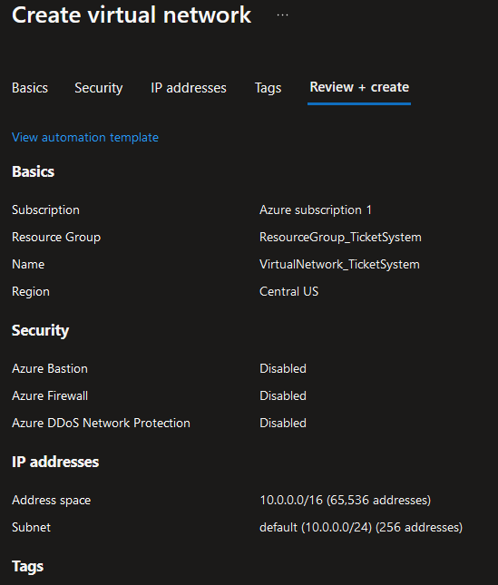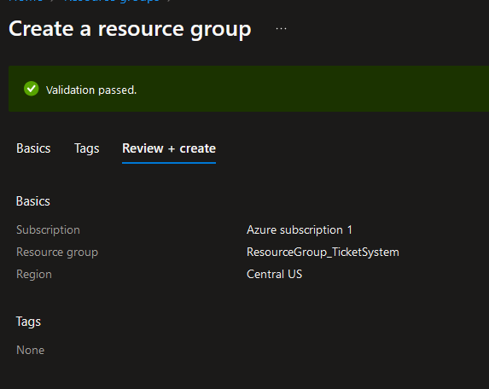

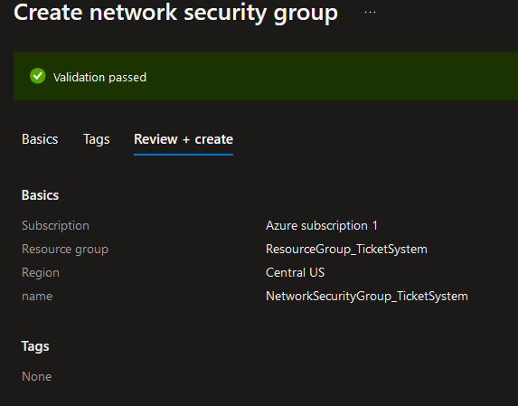

*Creating a* ***Resource Group****,* ***VNet****, and* ***NSG*** *before a* ***Virtual Machine*** *allows an organized and secure environment.*

* 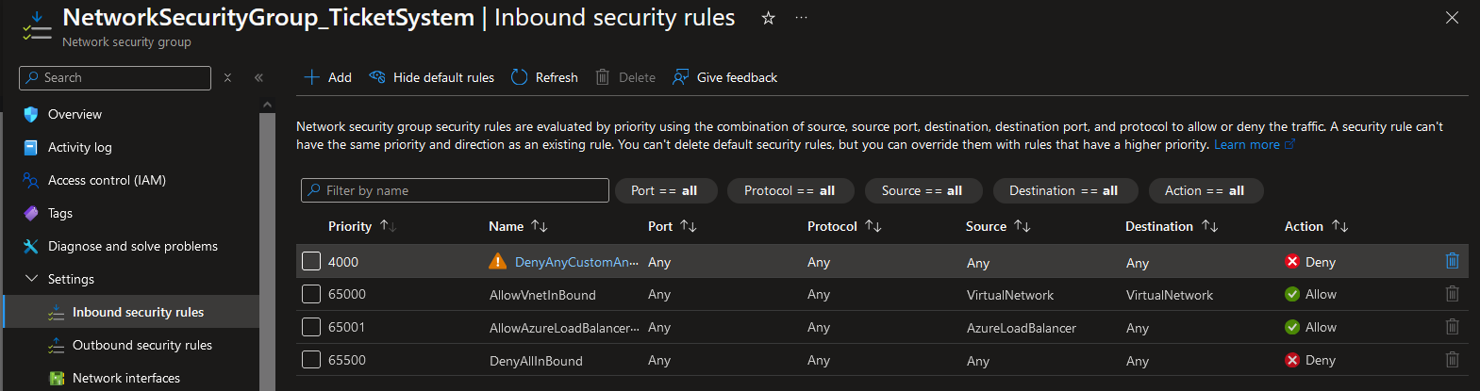Create Inbound Security Rule in NSG to Default-Deny all Inbound Traffic for better security in my VNet.

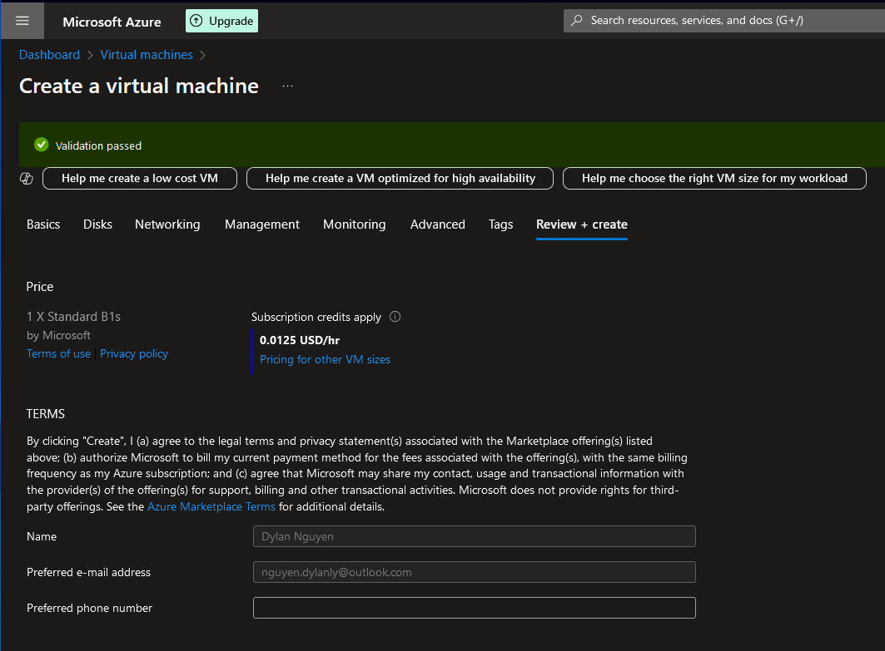Step 2. Create a Virtual Machine with SSH through my local machine public key authentication & assigned NIC to my Network Security Group.

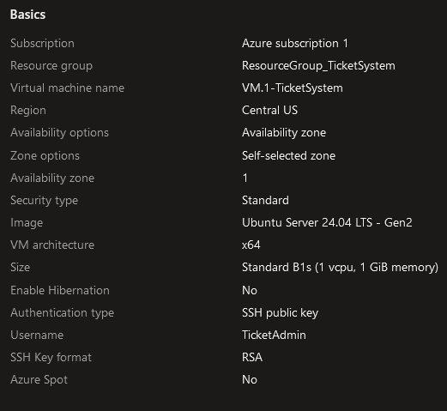

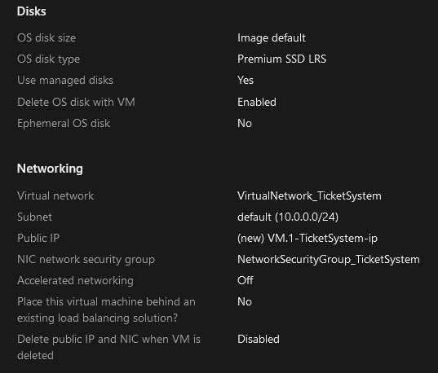

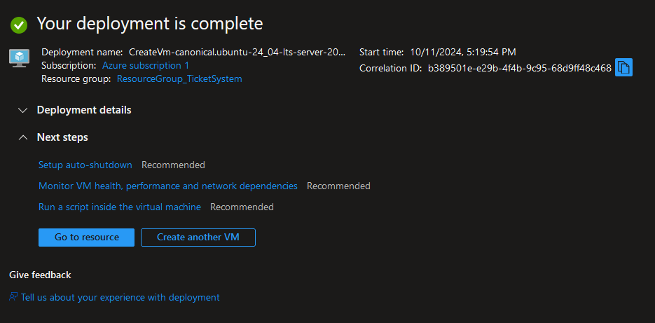

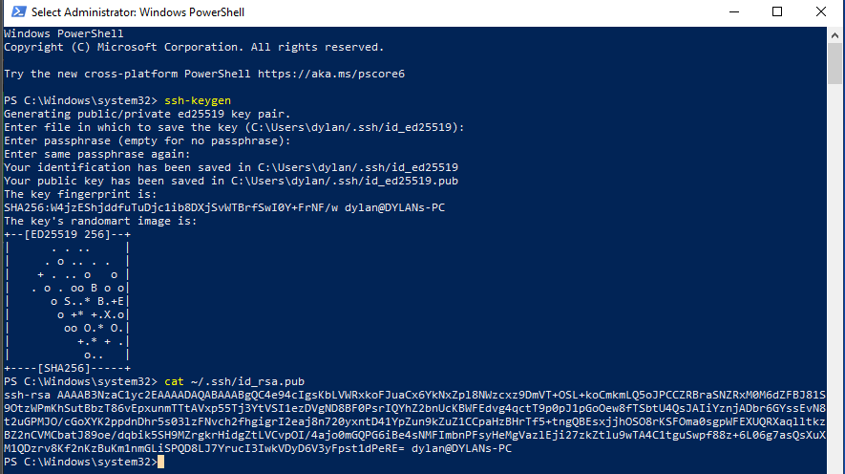

*I got my* ***SSH***

***key*** *pair via*

***PowerShell***

*by* ***ssh-keygen***

*command.*

Step 3. Create Inbound Security Rule in NSG to allow SSH connection from my IP Addresss. After, test SSH connection to my VM through PowerShell.

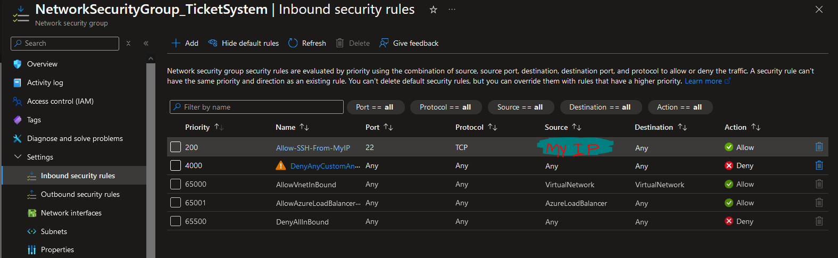

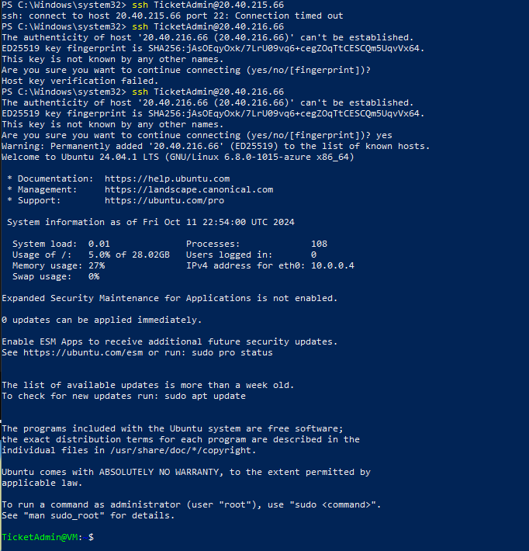

*I am now* ***connected*** *& in*

***control*** *of my* ***Azure***

***Virtual Machin****e via* ***SSH***

*on* ***PowerShell****. Apply*

***updates/upgrades*** *to the*

***VM system****.*

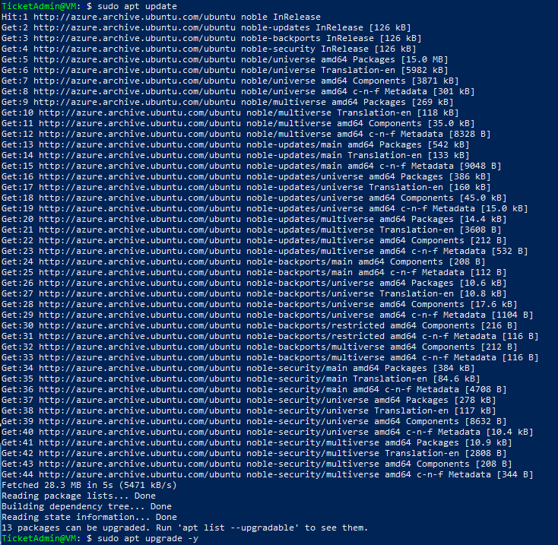



Step 4. Resize VM from Standard_B1s to Standard_B2s for better performance for GNOME (GUI) installation, connect SSH to VM via PowerShell, & check hardware specs to verify Standard_B2s size.





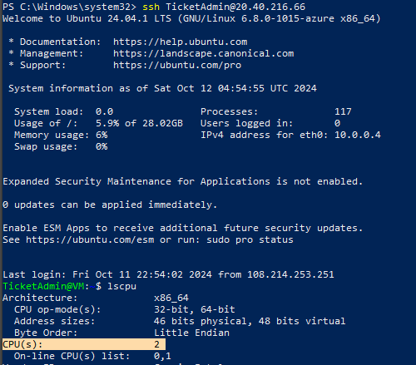



*Install GNOME Desktop (Ubuntu*

*Desktop). Installation takes a few*

*minutes due to other applications*

*& packages included in GNOME*

*Desktop.*

Step 5. Reboot system to enable GNOME desktop for a Graphical User Interface (GUI)

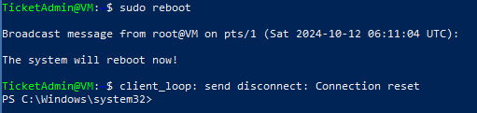

Step 6. **Generate Public SSH key via PowerShell from my laptop (not at my desktop at the time) and insert key in Azure VM public key source so I can continue project remotely from another device. **



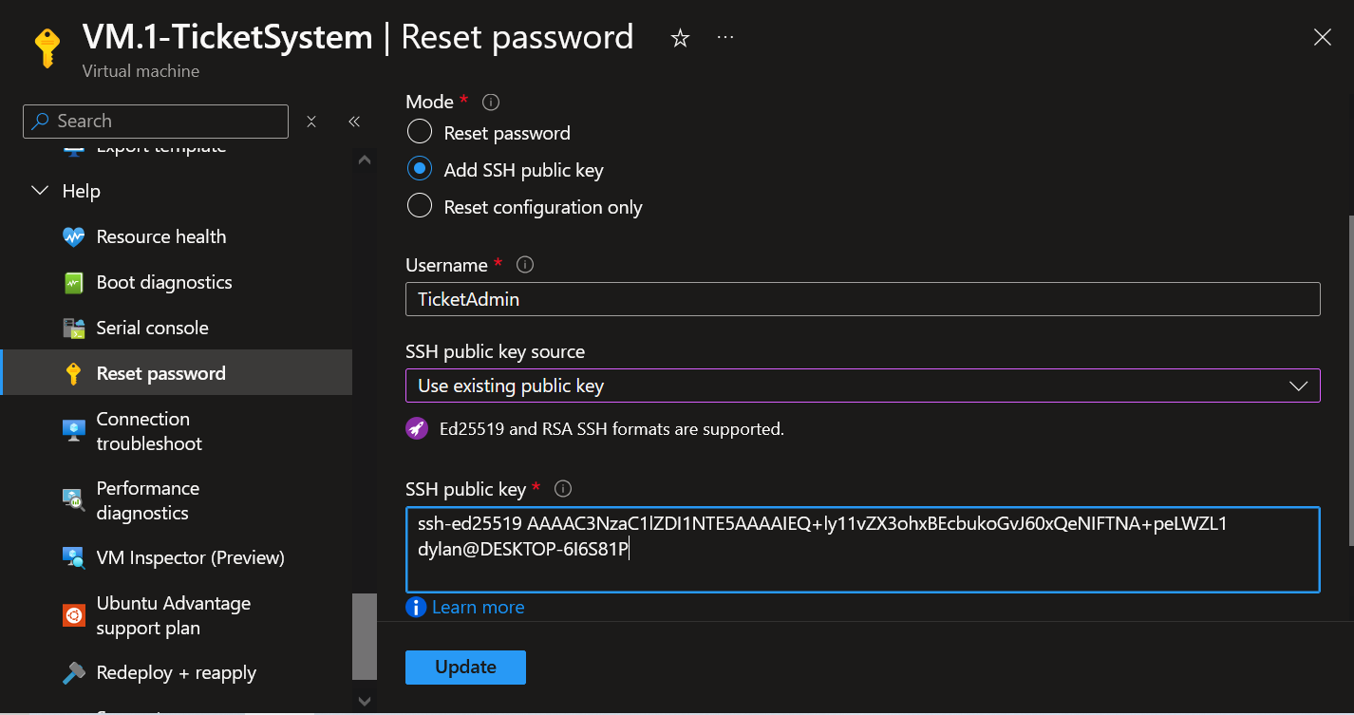

* Include Inbound Security Rule in NSG to allow my laptop’s IP Address SSH connection then test VM connection via PowerShell.

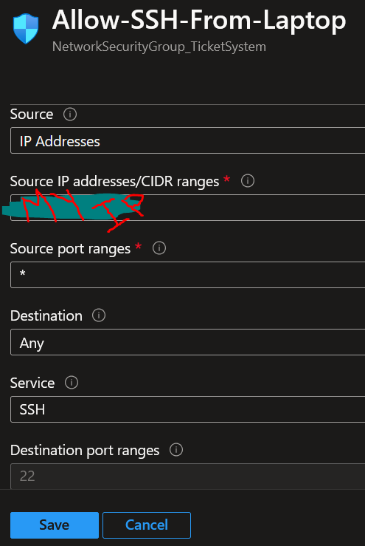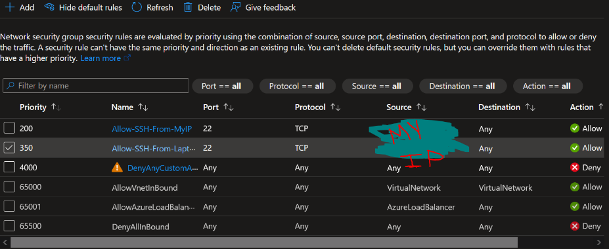

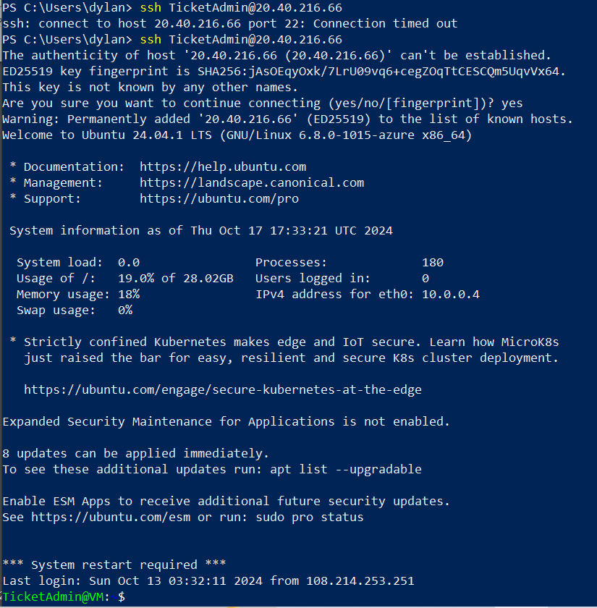

*I can now* ***SSH*** *connect to my*

***VM*** *via* ***laptop for flexibility.***

Step 7. After further research, resize Azure VM again from Standard_B2s to Standard_D2s_v3 to ensure efficient performance and operations for GNOME Desktop (GUI) environment, TeamViewer (RDP), osTicket (Ticket System), and mySQL database.

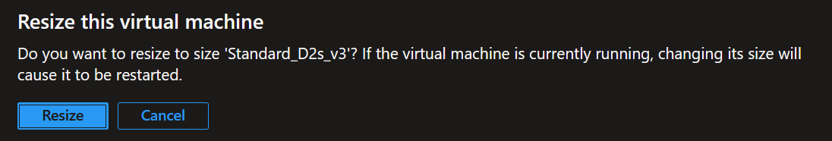

Step 8. Download then install Remote Desktop Protocol (RDP) application TeamViewer via PowerShell so I can enable a Graphical User Interface (GUI) on my Azure VM.









* Start, Enable, and check the Status of TeamViewer to ensure the RDP app is running.

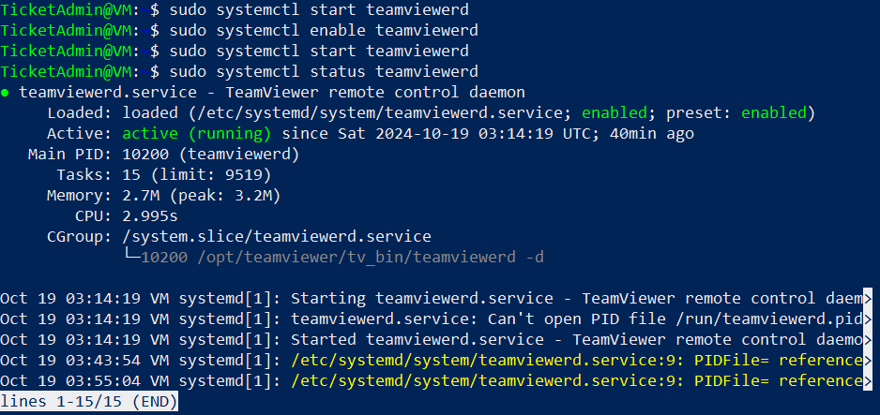

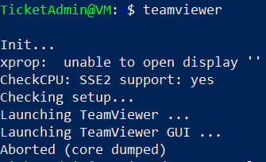Step 8. Run TeamViewer.

***TeamViewer*** *is not responding so I started to* ***troubleshoot*** *the application.*

Step 9. Troubleshoot a **GUI** on a **Linux Virtual Machine** via **PowerShell**.

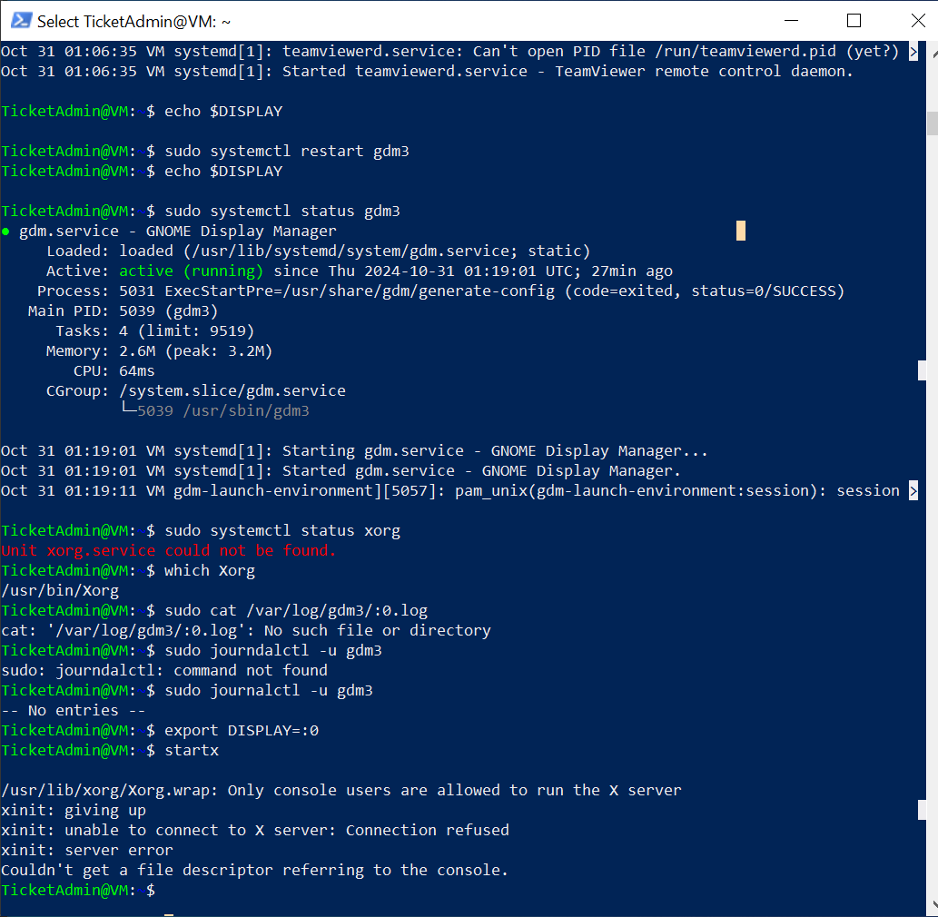

**Troubleshoot Steps**

* **echo $DISPLAY** – displays the value of the DISPLAY environmental variable (GUI), however, the output was blank, so no display server is running
* **sudo systemctl restart gdm3** – restarts the GNOME Display Manager
* **sudo systemctl status gdm3** – shows the current status of gdm3 service, the gdm3 service is active but TeamViewer is still unresponsive
* **sudo systemctl status xorg** – shows current status of xorg service
* **which Xorg** – finds location of Xorg executable
* **sudo cat /var/log/gdm3/:0.log** – displays content of log file created by the GNOME Display Manager
* **sudo journalctl -u gdm3** – display detailed log entries of the gdm3 service, the output was “no entries”
* **export DISPLAY=:0** – set the Display environment variable manually to :0
* **startx** – starts an X session manually

**Solution**

After troubleshooting steps, I figured out that TeamViewer will not be compatible due to TeamViewer relying on an X server (Xorg) where a physical display monitor is not present in an Azure Virtual Machine environment. Also, TeamViewer requires a console user (direct physical login) to start the X server where I am connecting with SSH via the PowerShell output “Only console users are allowed to run the X server.”

Therefore, I will be uninstalling TeamViewer & will install xRDP. xRDP can create a virtual display for remote access that does not require console user status login. xRDP does not rely on an X server, xRDP creates its own virtual display session where I can access the GNOME GUI. xRDP bypasses the need for a local display environment and a X server, this makes the RDP application optimal for cloud environments (Azure) where a physical display monitor is not present.

Step 10. Remove TeamViewer application from system with commands “sudo apt remove teamviewer -y” & “sudo apt autoremove -y”.





* Verify TeamViewer is uninstalled.

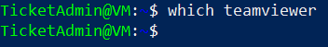

* Install xRDP and enable xRDP service to enable on boot.





* Ensure xRDP uses GNOME as the default desktop environment.



Step 11. Add Inbound Security Rule in my NSG via Azure to allow RDP (port 3389) from my local machine.

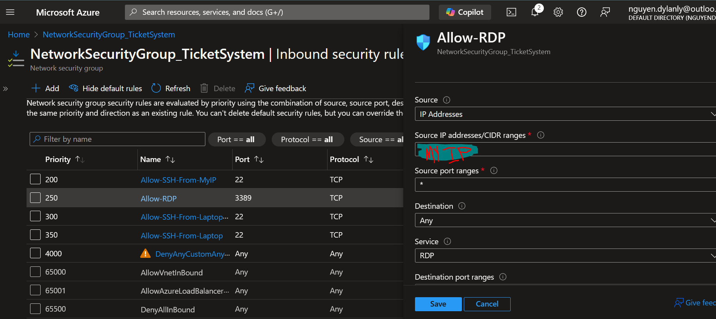

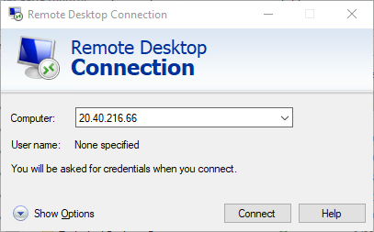Step 14. On my Local Machine, open “Remote Desktop Connection” and put my Azure VM’s public IP address.

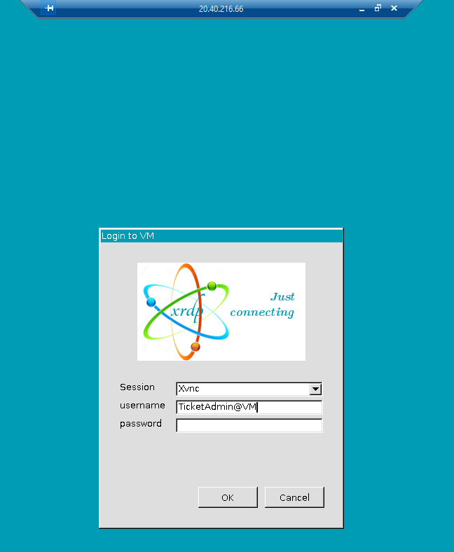

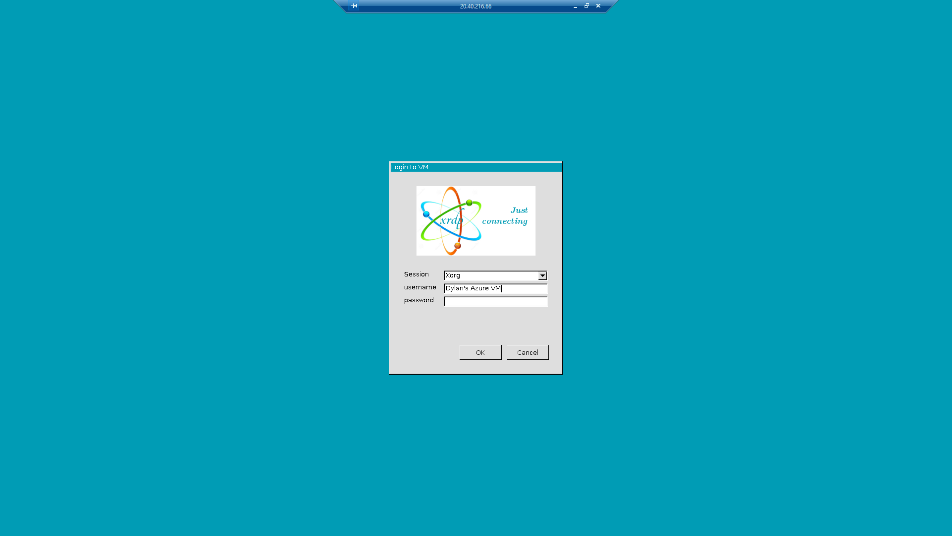

* 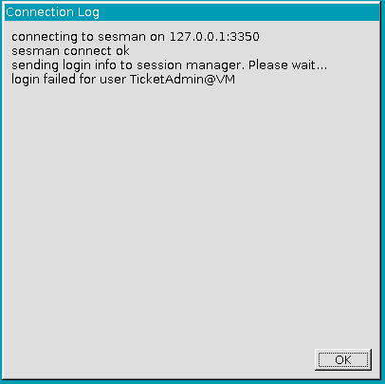Received login error, I will start to troubleshoot
* Type “sudo cat /var/log/xrdp-sesman.log” in PowerShell via Azure VM to see my logs.



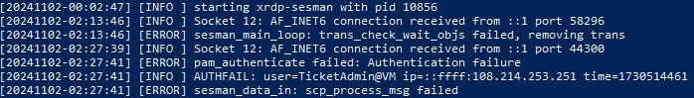

* 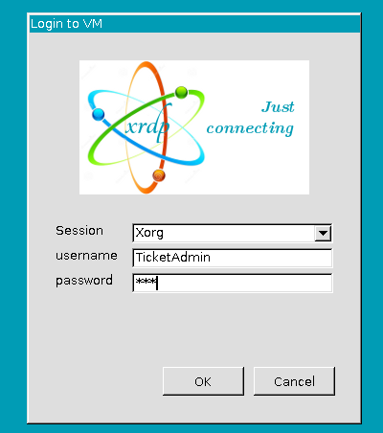After further research, I have to create a password for my “TicketAdmin” user as it is a requirement for xRDP. I did not need to create a password when creating my Azure VM because I connected SSH.

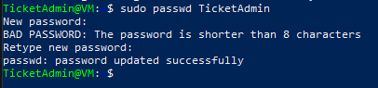

* Test RDP connection via Remote Desktop Connection from Local Machine

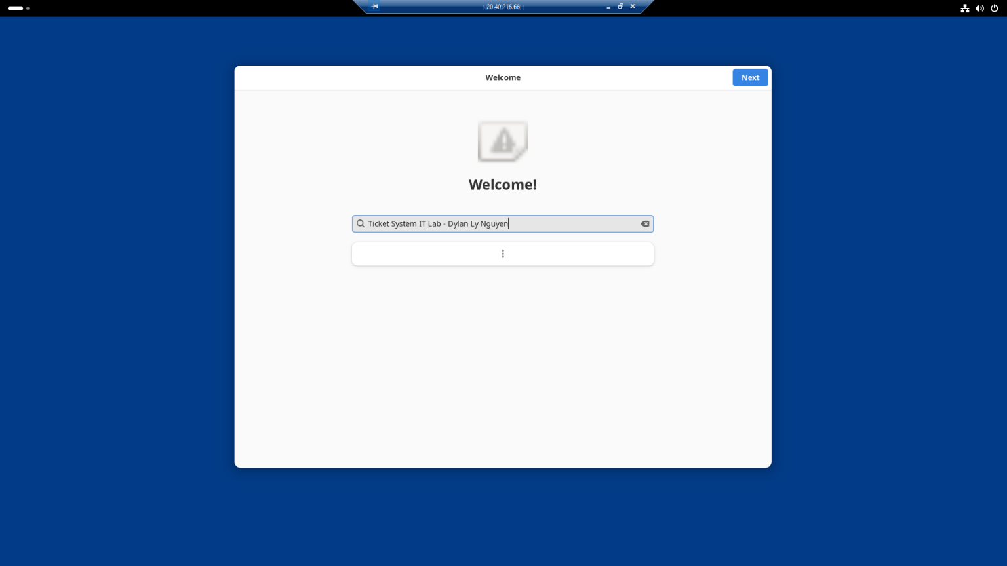

* Successful **GNOME GUI Display** on **Ubuntu** machine via **xRDP** from local machine.

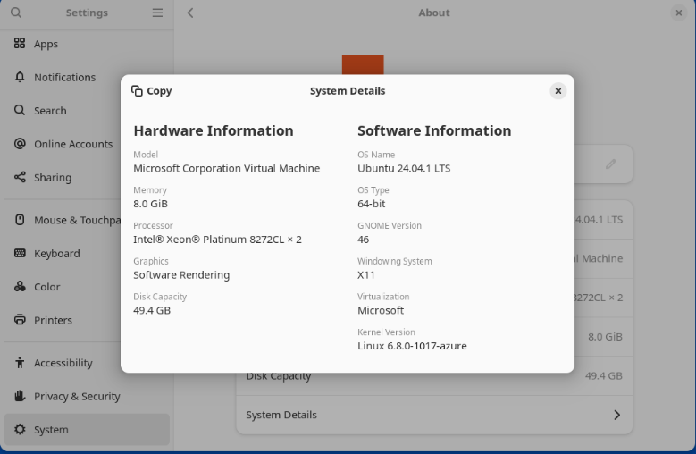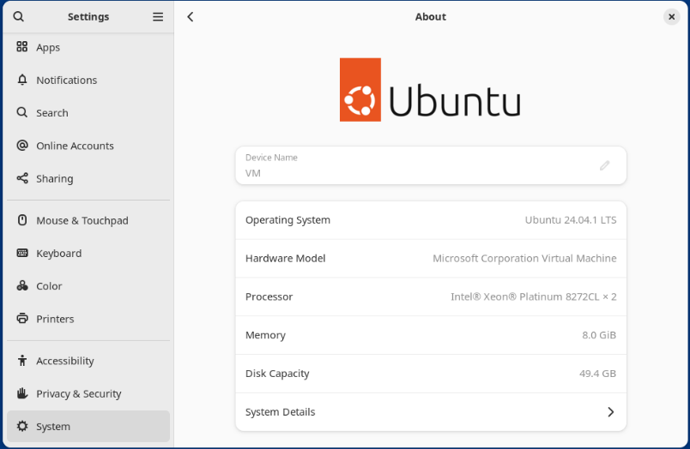

Step 15. Create a **second Virtual Machine** dedicated to host the **Web Server (Apache)**, **Server-Side Scripting Language (PHP)**, and **Database Server (MariaDB/MySQL).**

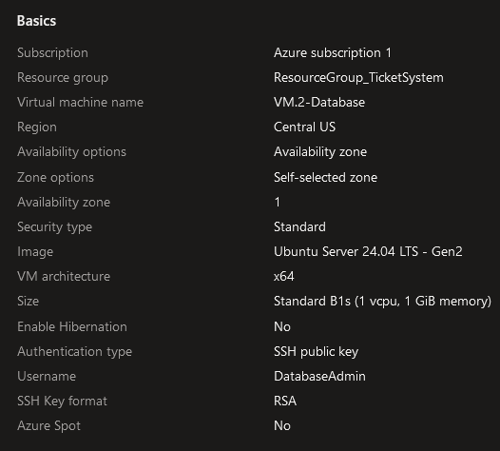

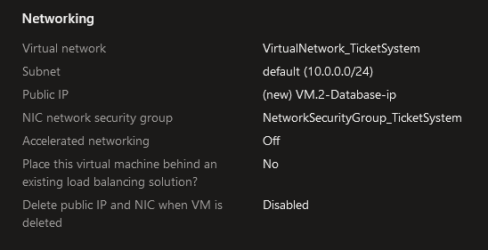

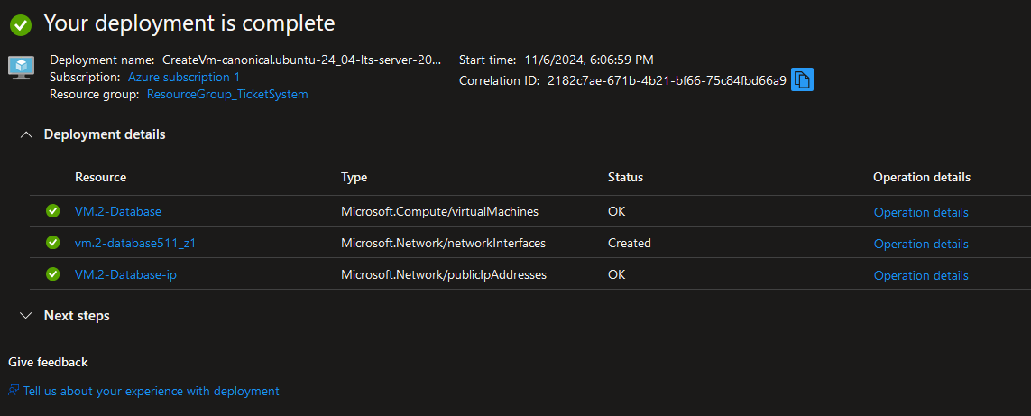

* Connected second **Azure VM** through **SSH** on **PowerShell** then update.

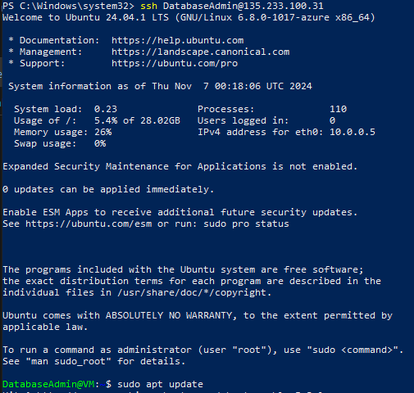

Step 16. Install, start, and enable **Apache (Web Server)**.

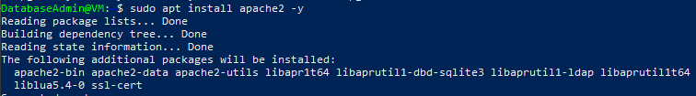

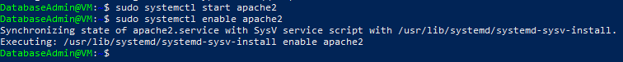

Step 17. Install **PHP (Server-Side Scripting Language).**

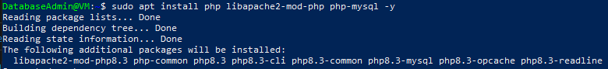

Step 18. Install, start, and enable **MariaDB (Database Server).**

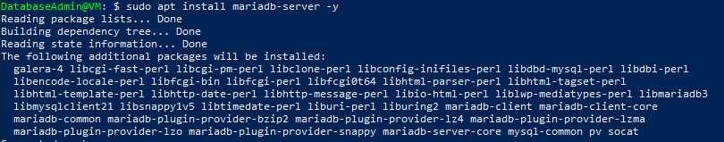



Step 19. Edit MariaDM Configuration rule to allow MariaDB to allow all connections in my Azure environment.





 





Step 20. Log into Maria DB and create a Database for osTicket for my first VM.

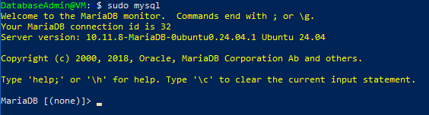

* Create dedicated Database in MariaDB for osTicket to store its data.

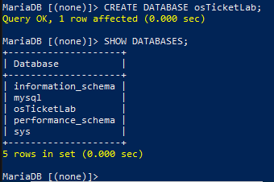

* Create dedicated User in MariaDB for osTicket to connect to during installation.



* Grant dedicated User full access to osTicketLab Database so osTicket can read from and write from it.



* Restart the privileges given.

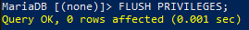

Creating a **MariaDB** user allows secure access to the database from the installation stage of osTicket. This user does not interact with **osTicket** directly but **enables osTicket** to **connect** to **Maria DB Database**. I researched that creating **Tables** in my **MariaDB Database** via **SQL** is **not needed** due to **osTicket** automatically **creating the tables** for me!

Also, I found out that I need **Apache Web Server** and **PHP Server-Side Scripting Language** on my **osTicket Application VM**, not my **Database** where I installed those two with **MariaDB**. I learned that a Database **does not** require a **Web Server (Apache)** or a **Server-Side Scripting Language (PHP)** to function as its purpose is to serve as a **Database** and **not a Web Application**.

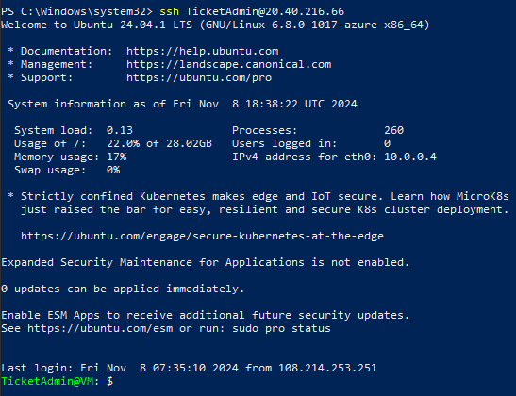Step 21. SSH back to VM-1 TicketSystem via PowerShell/ RDP back to VM-1 TicketSystem via Remote Desktop Connection/xRDP via GNOME GUI

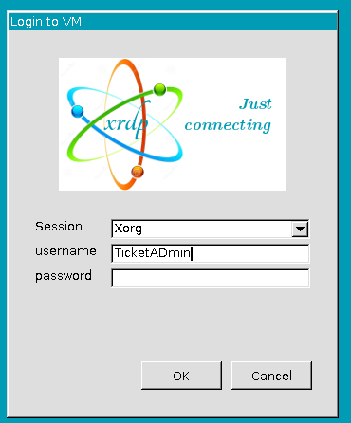

* Install Apache Web Server via PowerShell.
* sudo apt install apache2 -y

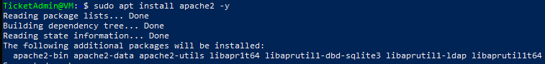

* Install PHP (Server-Side Script Language) and required extensions needed for osTicket to function correctly.
* sudo apt install php libapache2-mod-php php-mysql php-imap php-mbstring php-intl php-xml php-common php-gd php-cli -y

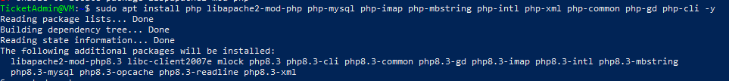

* Verify Apache and PHP are working via CLI and Web Browser with GUI
* http://20.40.216.66/

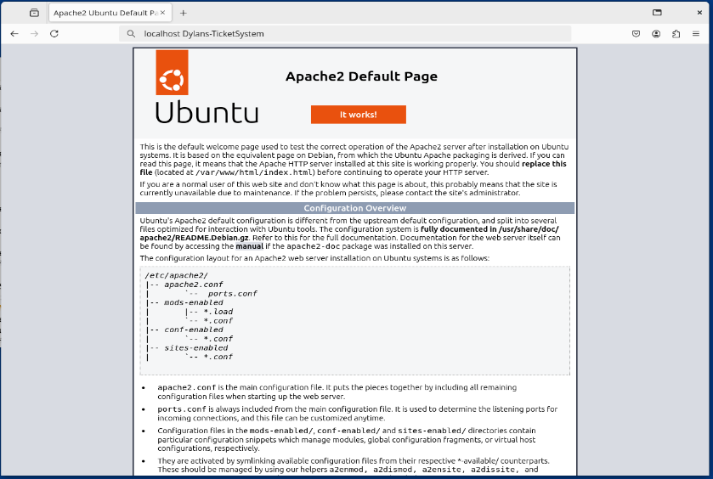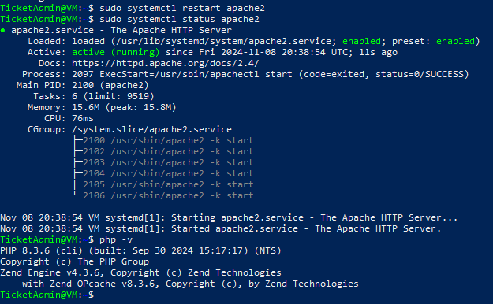

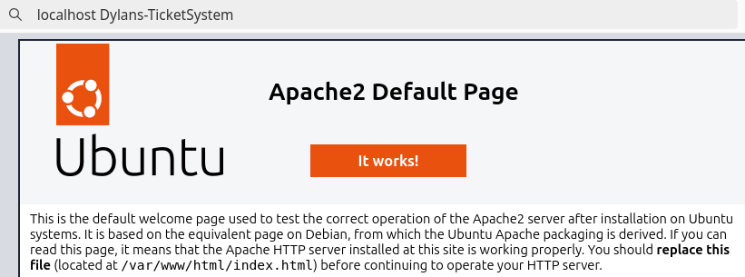

* On a web browser in GNOME GUI, navigate to <https://osticket.com/download>

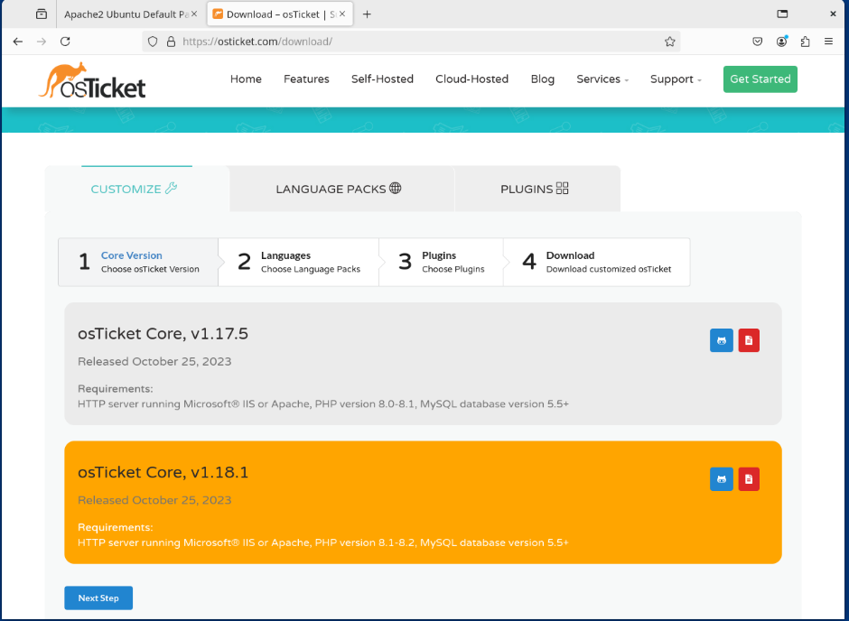

* Select my Plugins

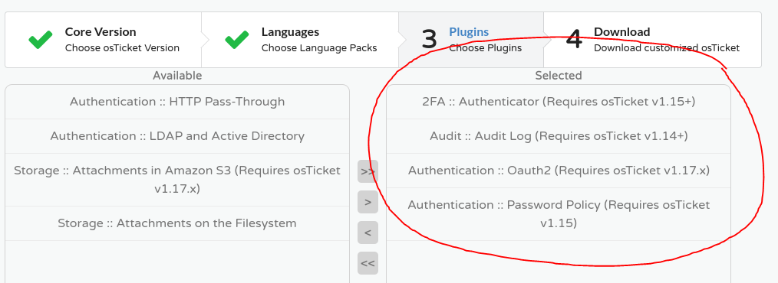

* Download osTicket

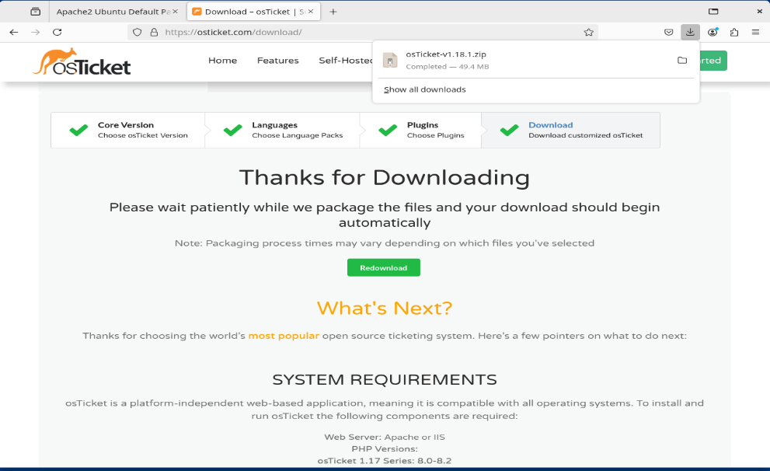

* Move the osTicket.zip file to the Apache root directory so osTicket can be accessed via the Apache Web Server of its root directory.
* sudo mv ~/Downloads/osTicket.zip /var/www/html

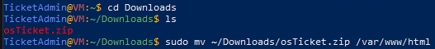

* Unzip the osTicket.zip file to folder /var/www/html/osticket with *-d* command in Apache root directory.
* sudo unzip /var/www/html/osTicketzip -d /var/www/html/osticket
* sudo unzip /var/www/html/osTicker-v1.18.1.zip -d /var/www/html/osticket

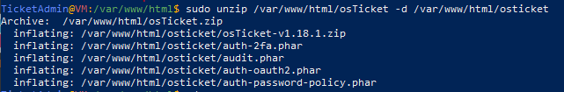

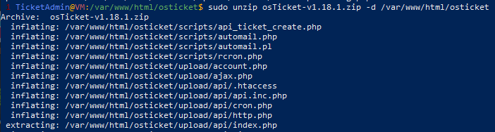

* Copy default configuration template file to a new file where we will preserve the default template in case we need to revert back; and to have a separate modified configuration file where we can configure settings on.
* sudo cp /var/www/html/osticket/upload/include/ost-sampleconfig.php /var/www/html/osticket/upload/include/ost-config.php





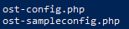

* Give ost-config.php file read and write permissions so it can save and store configuration details (database credentials) during setup process.
* sudo chmod 0666 /var/www/html/osticket/upload/include/ost-config.php



* Give Apache user (www-data) ownership to osTicket files so Apache can have the permissions to manage all osTicket files, execute scripts, and read/write in the osTicket directory.
* sudo chown -R www-data:www-data /var/www/html/osticket



* Give read and execute permissions to everyone in osTicket but write only to the owner (Apache/www-data)
* sudo chmod -R 755 /var/www/html/osticket

**Step 22.** Start the Web-Based osTicket Installation

* 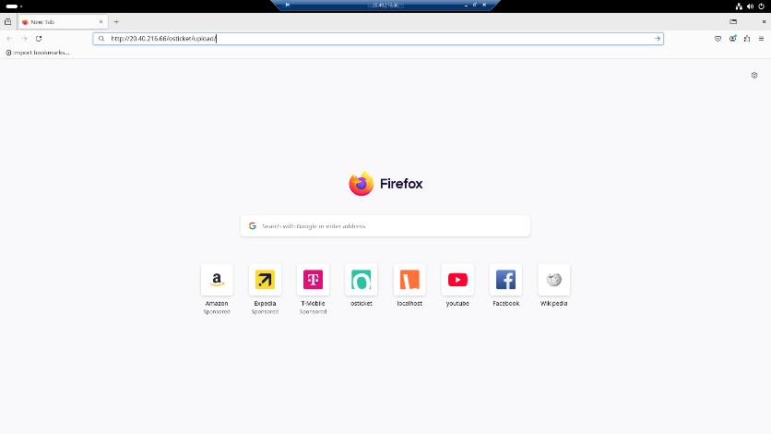http://20.40.216.66/osticket/upload/

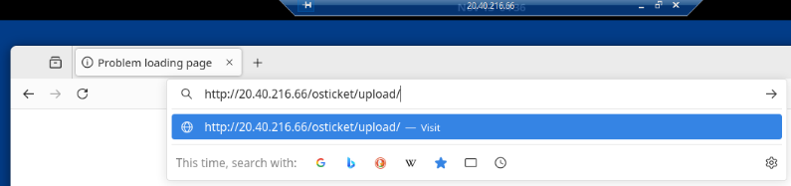

* I have connection errors so I will begin to troubleshoot and create a new Inbound Security Rule in my NSG to allow HTTP from my Azure TicketSystem VM

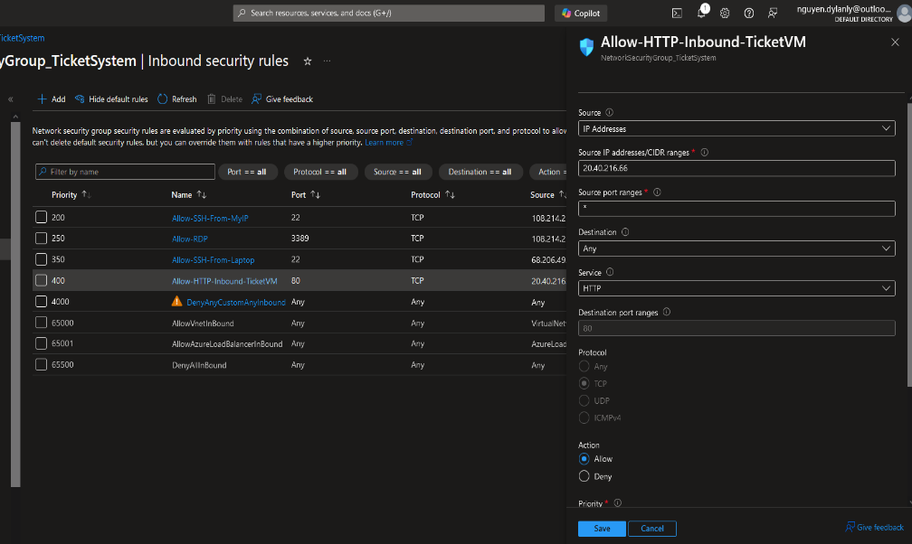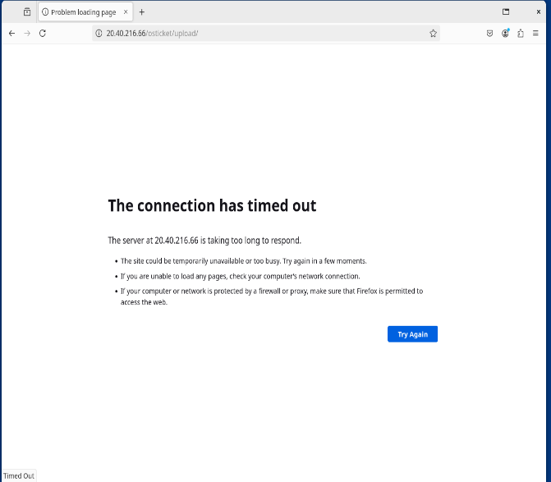

* Type <http://20.40.216.66/osticket/upload> in browser to begin osTicket installation.

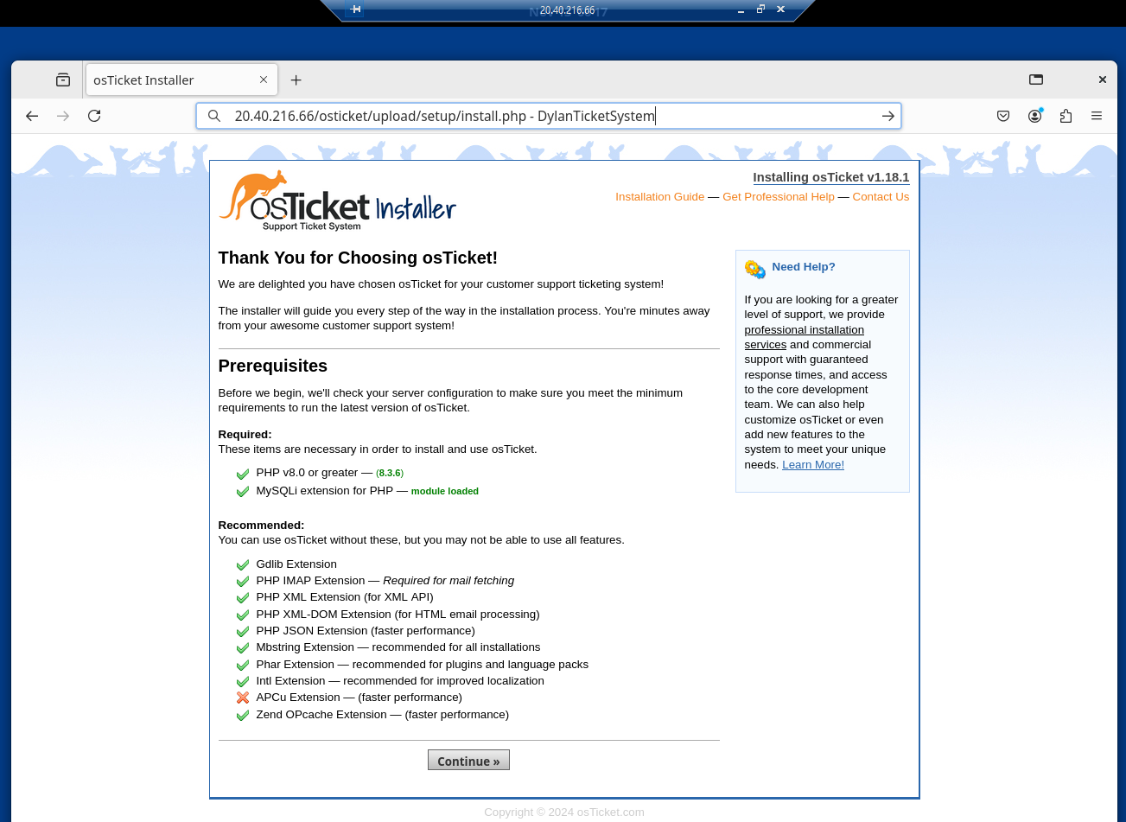

* Input relevant information regarding System Settings, Admin User, and Database Settings (MariaDB).

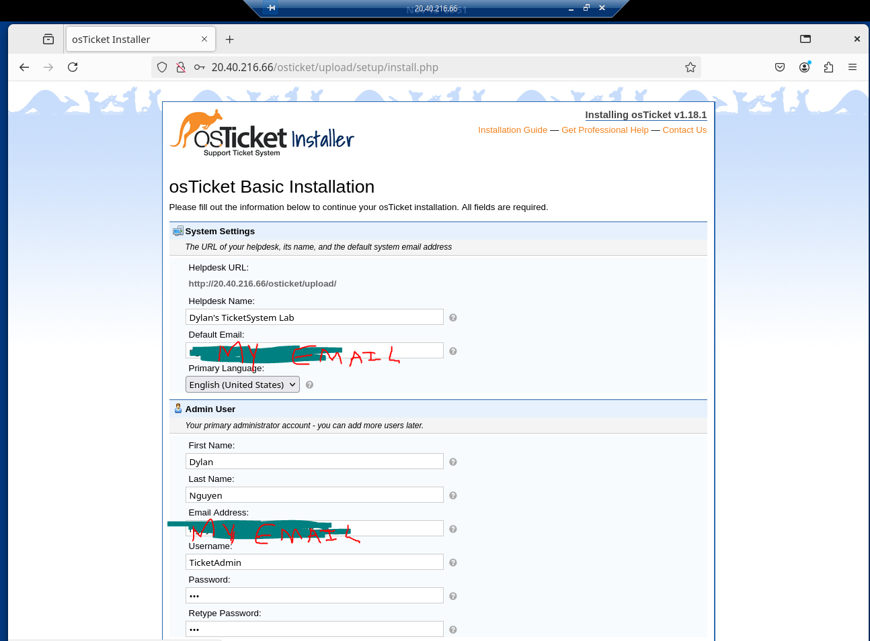

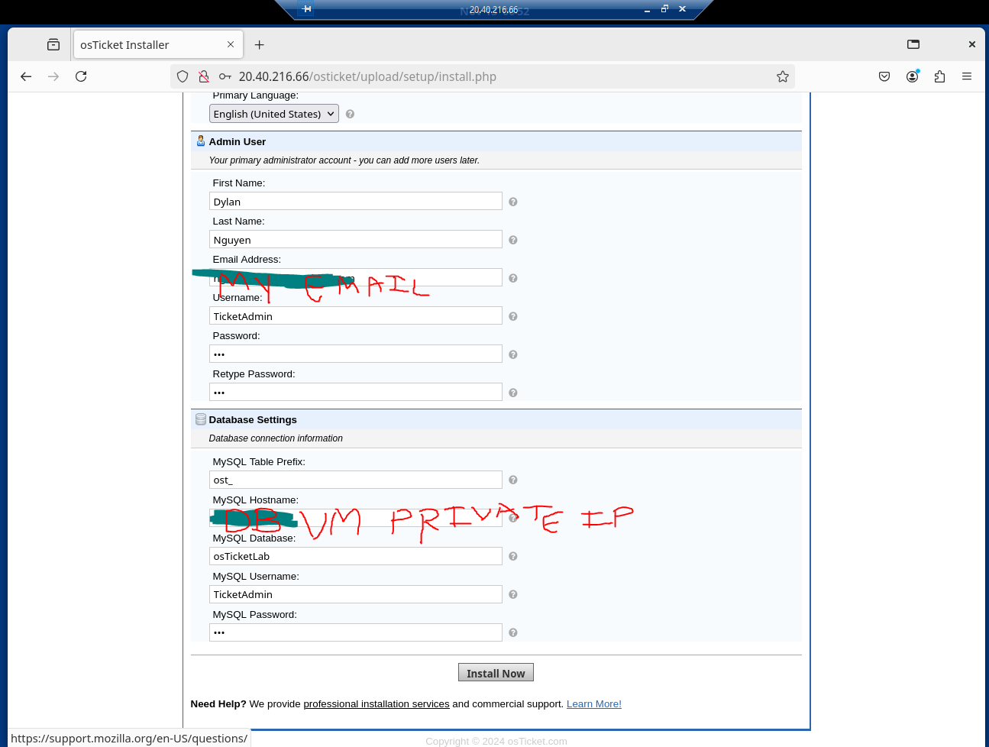

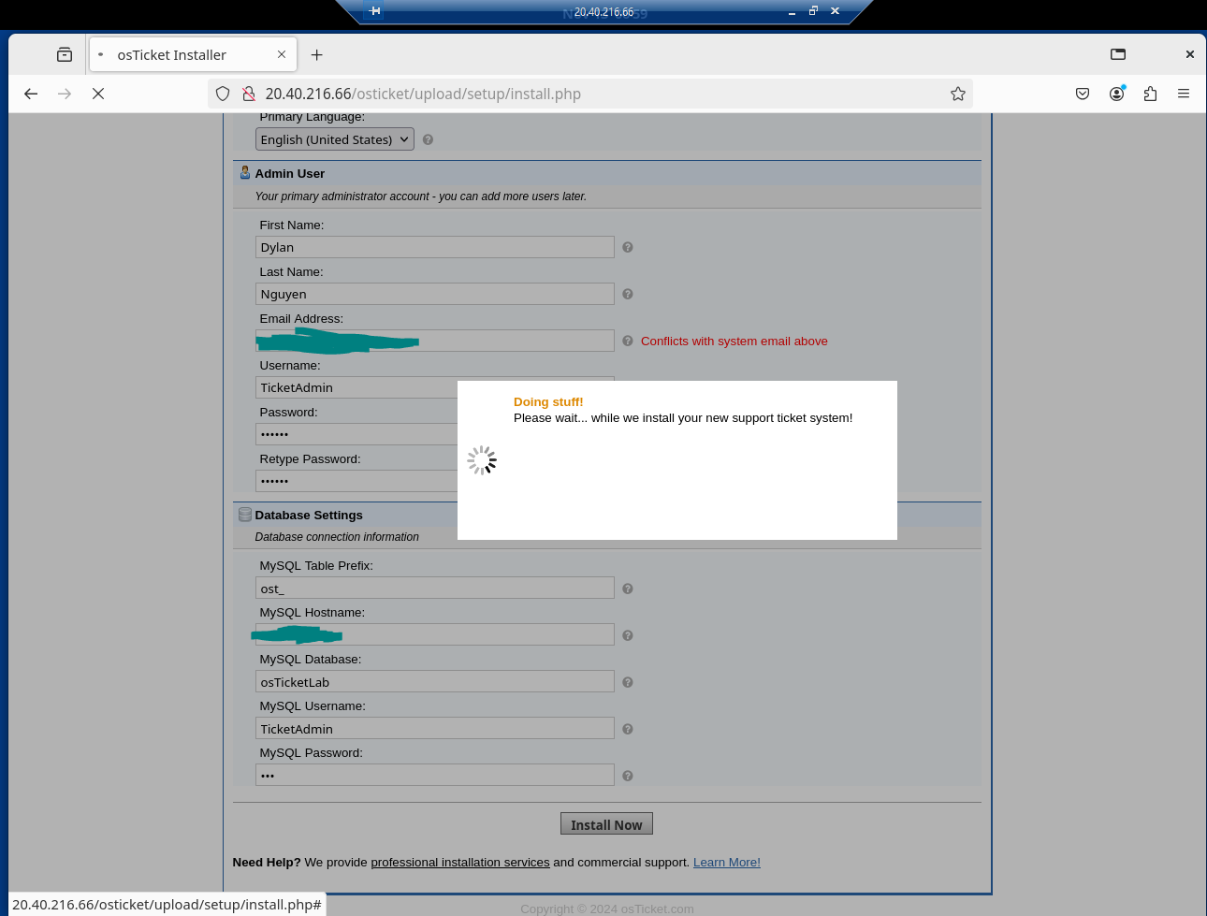

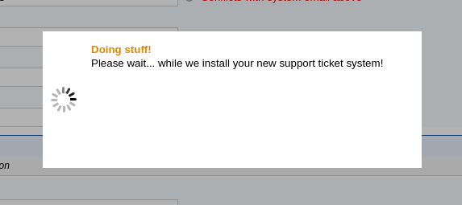

* A blank page shows after installation meaning that the installation wasn’t successful. I will begin to troubleshoot by checking Apache logs to find any errors.

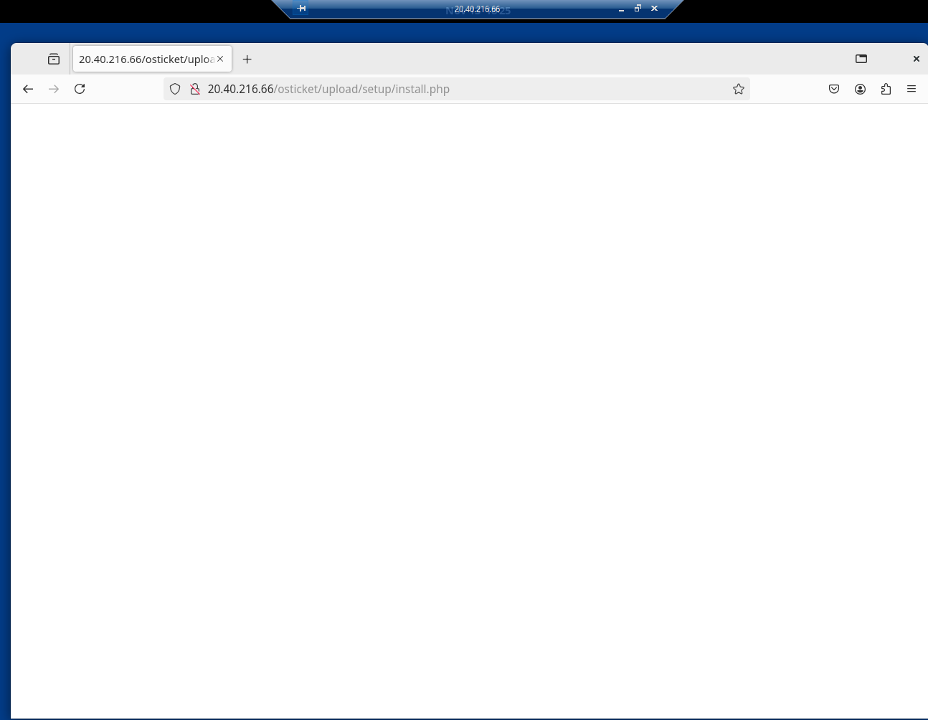

* sudo tail -f /var/log/apache2/error.log



* PHP Fatal Error: Connection timed out error in mysqli.php



* 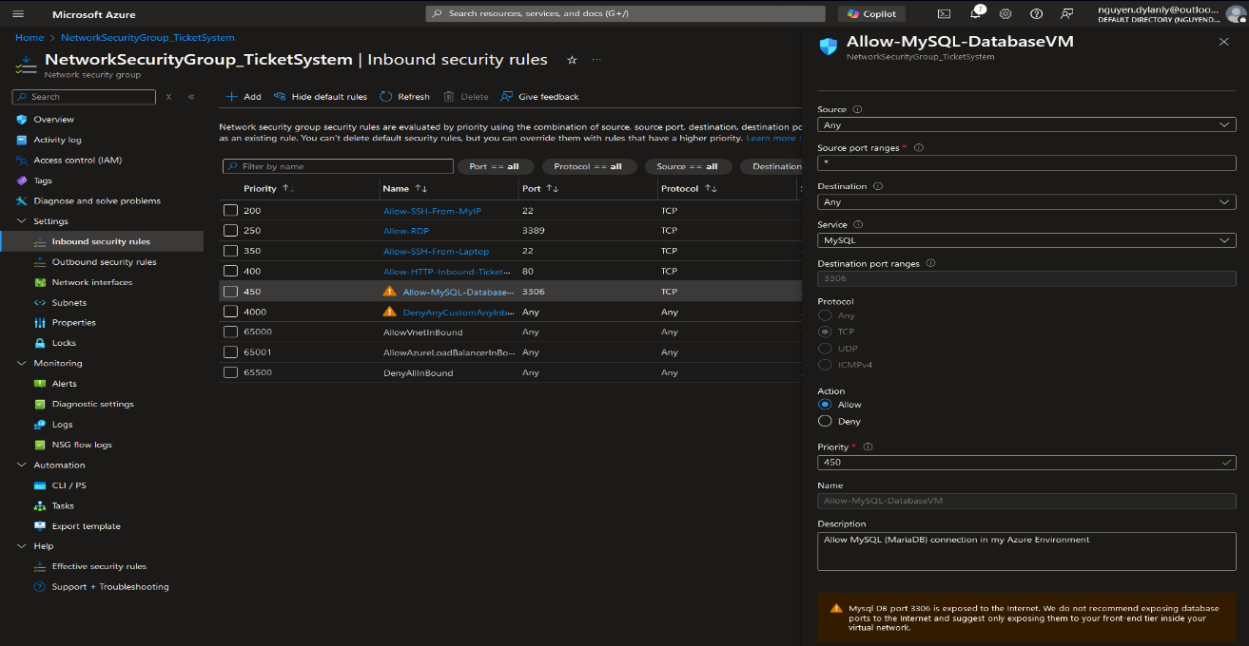Create new Inbound Security Rule in NSG to allow MySQL connection. Still have PHP Fatal Error when attempting to install but a different log appears in error.log
* PHP Fatal Error: Access denied for user ‘TicketAdmin’@’vm.internal.cloudapp.net’



* Go to Database VM to check on user settings for any misconfigurations, permissions grants, and to see if osTicket can access MariaDB Database via SQL.
* sudo mysql -u root -p
* SELECT user, host FROM mysql.user
* SHOW GRANTS FOR ‘TicketAdmin@%’@’%’;



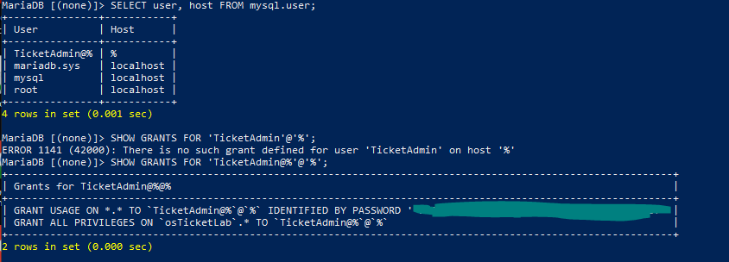

* Turns out the privileged user I made in MariaDB is ‘TicketAdmin@%’ and not ‘TicketAdmin’. I will delete this user and create an appropriate user with the granted permissions necessary and better SQL syntax.
* DROP USER ‘TicketAdmin@%’@’%’;
* CREATE USER ‘TicketAdmin’@’%’ IDENTIFIED BY ***;

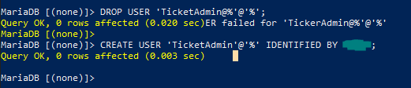

* GRANT ALL PRIVILEGES ON osTicketLab.* TO ‘TicketAdmin’@’%’;
* SHOW GRANTS FOR ‘TicketAdmin’@’%’;

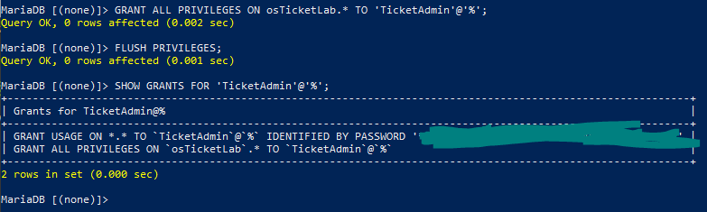

* Retry osTicket Web Installion… Congratulations! Troubleshooting was correct. 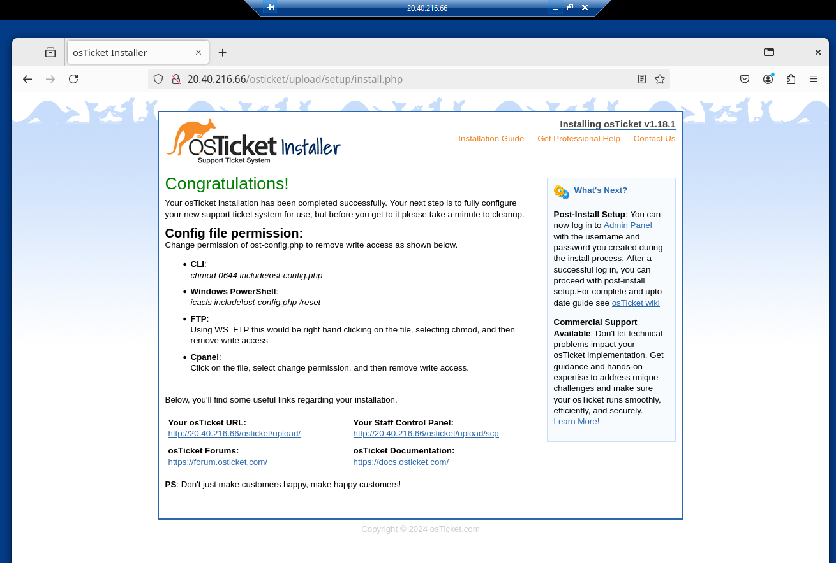
* After installation, change permissions of “ost-config.php” file back to read from write as write permissions were necessary during installation. Also, remove installation setup directory for extra security.
* sudo chmod 0644 /var/www/html/osticket/upload/include/ost-config.php
* sudo rm -rf /var/www/html/osticket/upload/setup/

**Step 23.** Open the Web Browser of my Ubuntu GNOME GUI and navigate to the Admin Panel/URL then login.

* <http://20.40.216.66/osticket/upload>
* <http://20.40.216.66/osticket/upload/scp>

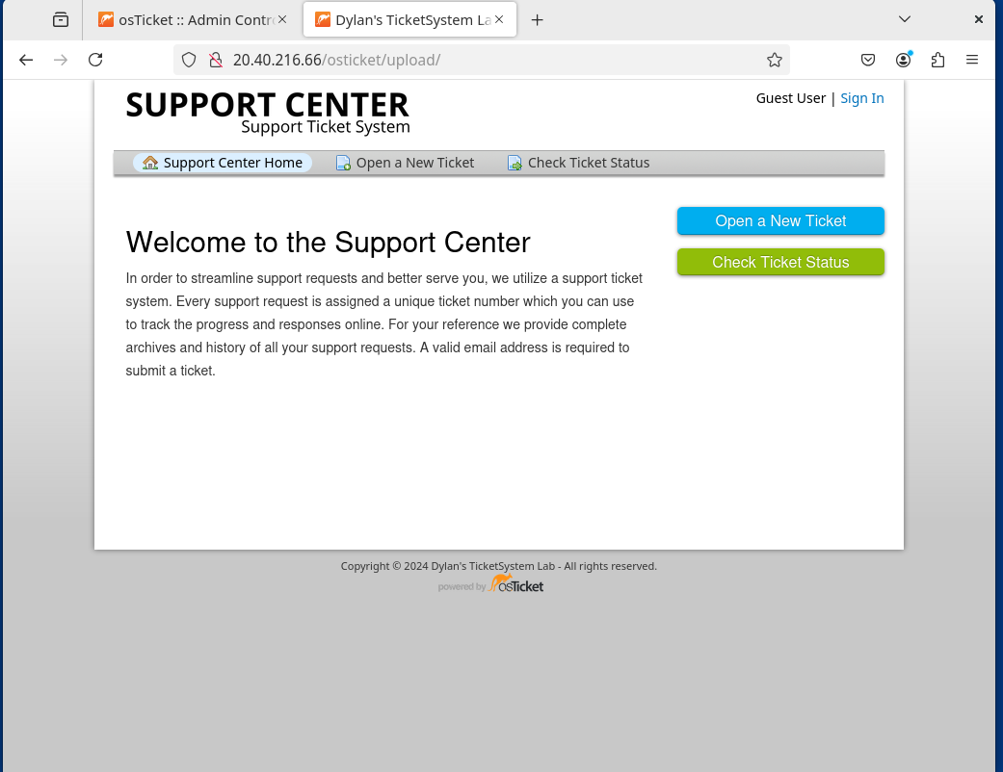

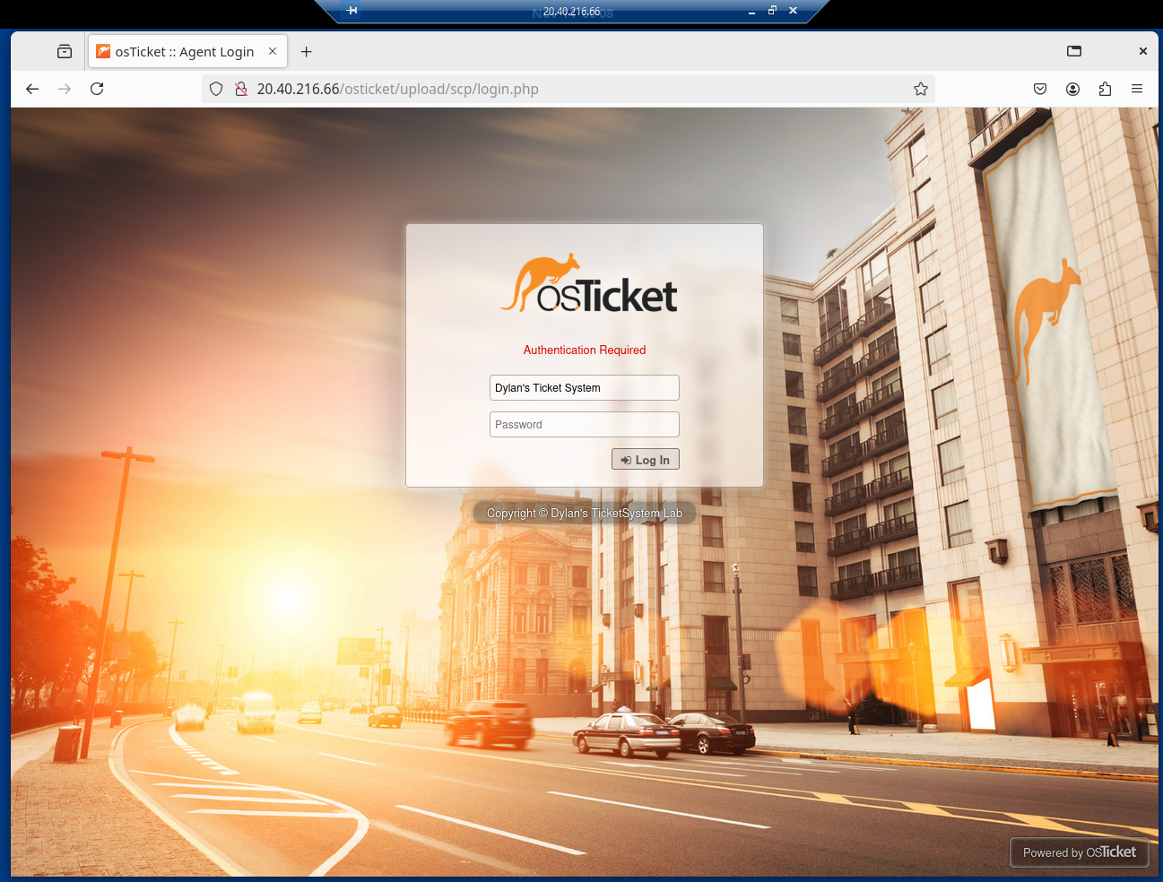

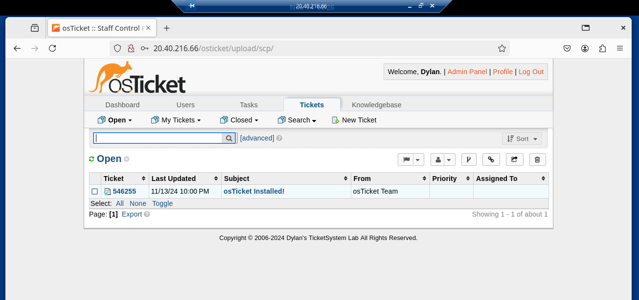

**Step 24.** Register for a domain name for my osTicket application to later then implement HTTPS instead of HTTP to my domain with SSL certification.

* Go to GoDaddy.com to register for a domain name suitable for my ticket lab. dylanosticketlab.online

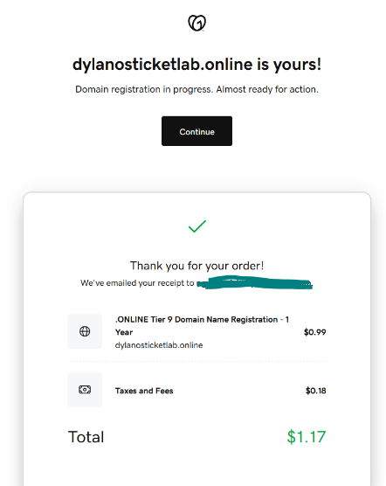

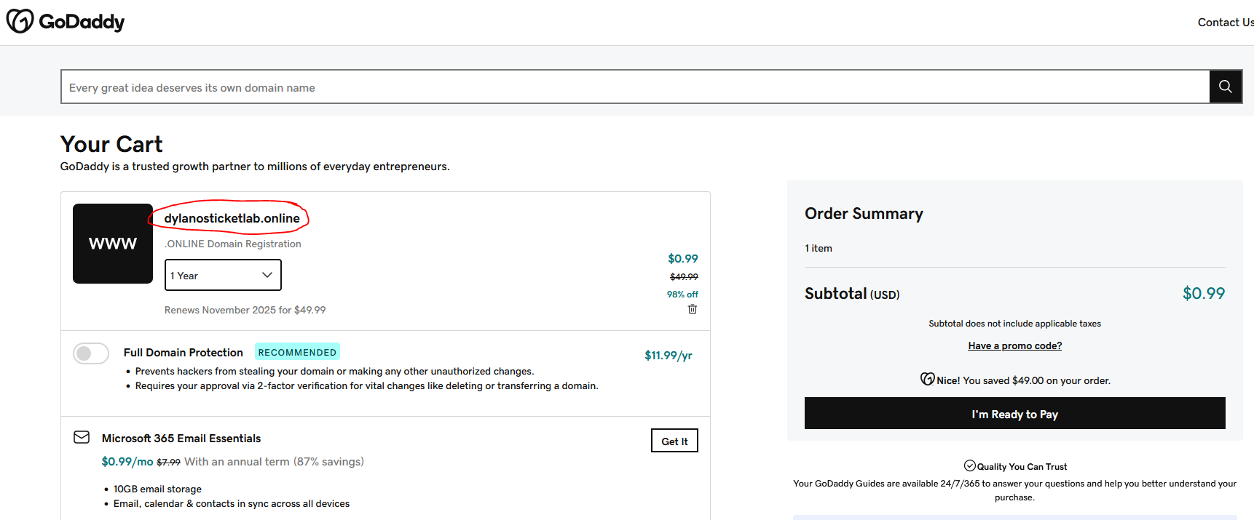

* Create an **A Record** that will point my domain to my osTicket application VM public IP

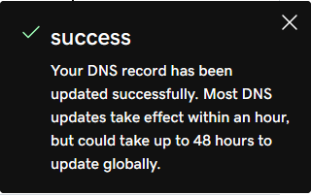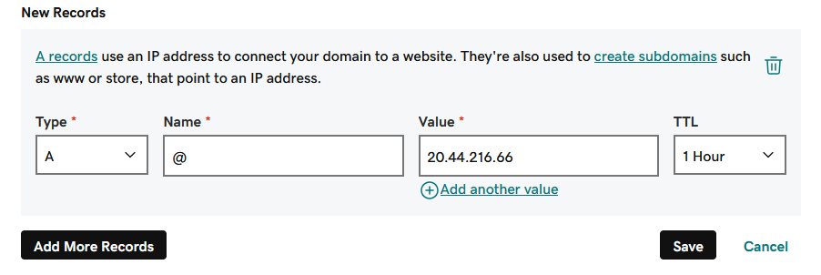

* Create a Virtual Host File on Apache on my osTicket VM that will direct domain web browser requests to my osTicket web applicatipn.
* sudo nano /etc/apache2/sites-available/dylanosticketlab.online.conf



* Configure Virtual Host File using Apache Configuration Language (ACL) by applying structured syntax designed for Apache
* <VirtualHost *:80>

ServerName dylanosticketlab.online

DocumentRoot /var/www/html/osticket/upload

<Directory /var/www/html/osticket/upload>

AllowOverride All

Require all granted

</Directory>

ErrorLog ${APACHE_LOG_DIR}/error.log

CustomLog ${APACHE_LOG_DIR}/access.log combined

</VirtualHost>

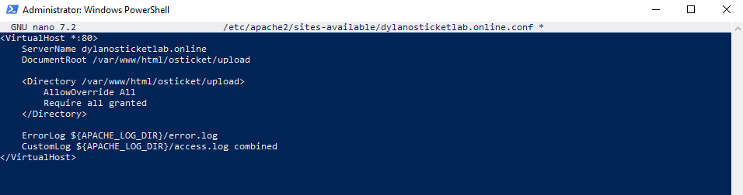

* Enable Virtual Host
* sudo a2ensite dylanosticketlab.online.conf

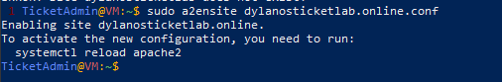

* Restart Apache
* sudo systemctl restart apache2



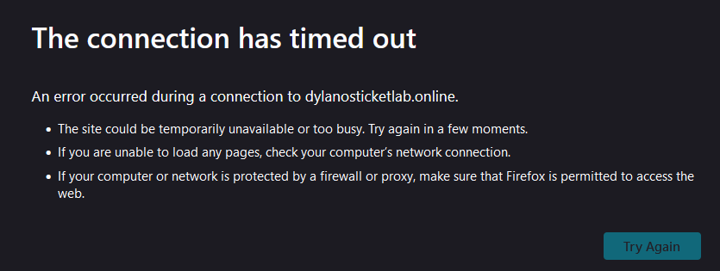

An error occurred where my domain, https://dylanosticketlab.online, did not direct to the web application of osTicket. After research, I believe the issue is that I configured a Virtual Host File on Apache to handle HTTP (port 80) where I need to create a Virtual Host File for HTTPS (port 443). To have my domain only direct HTTPS traffic, I will install **Certbot**, a command-line tool that automates obtaining and renewing SSL/TLS certificates for websites from **Certificate Aurhority (CA)**, **Let’s Encrypt**. I will begin to troubleshoot.

**Step 25.**

* Install Certbot with Python plugin to enable Certbot to detect and configure Apache Virtual Host File configuration for SSL certification.
* sudo apt install certbot python3-certbot-apache -y

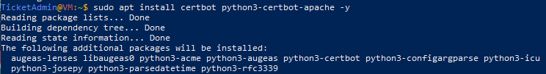

* Request an SSL Certificate
* sudo certbot --apache -d dylanosticketlab.online

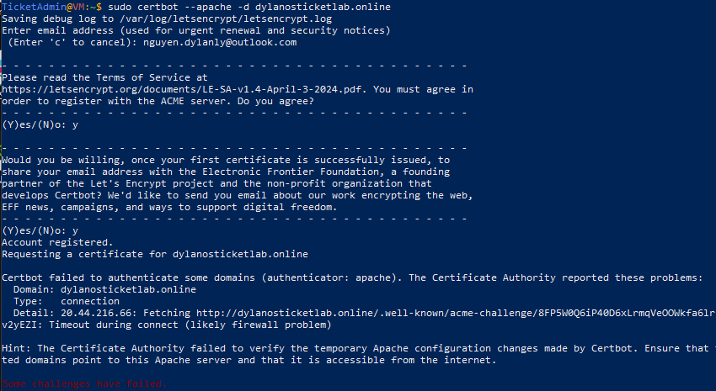

* Error occurred. Check logs to find the issue.
* sudo cat /var/log/letsencrypt/letsencrypt.log





* In NSG, create Inbound Security Rule where HTTP inbound traffic is allowed on port 80 to allow access from internet.

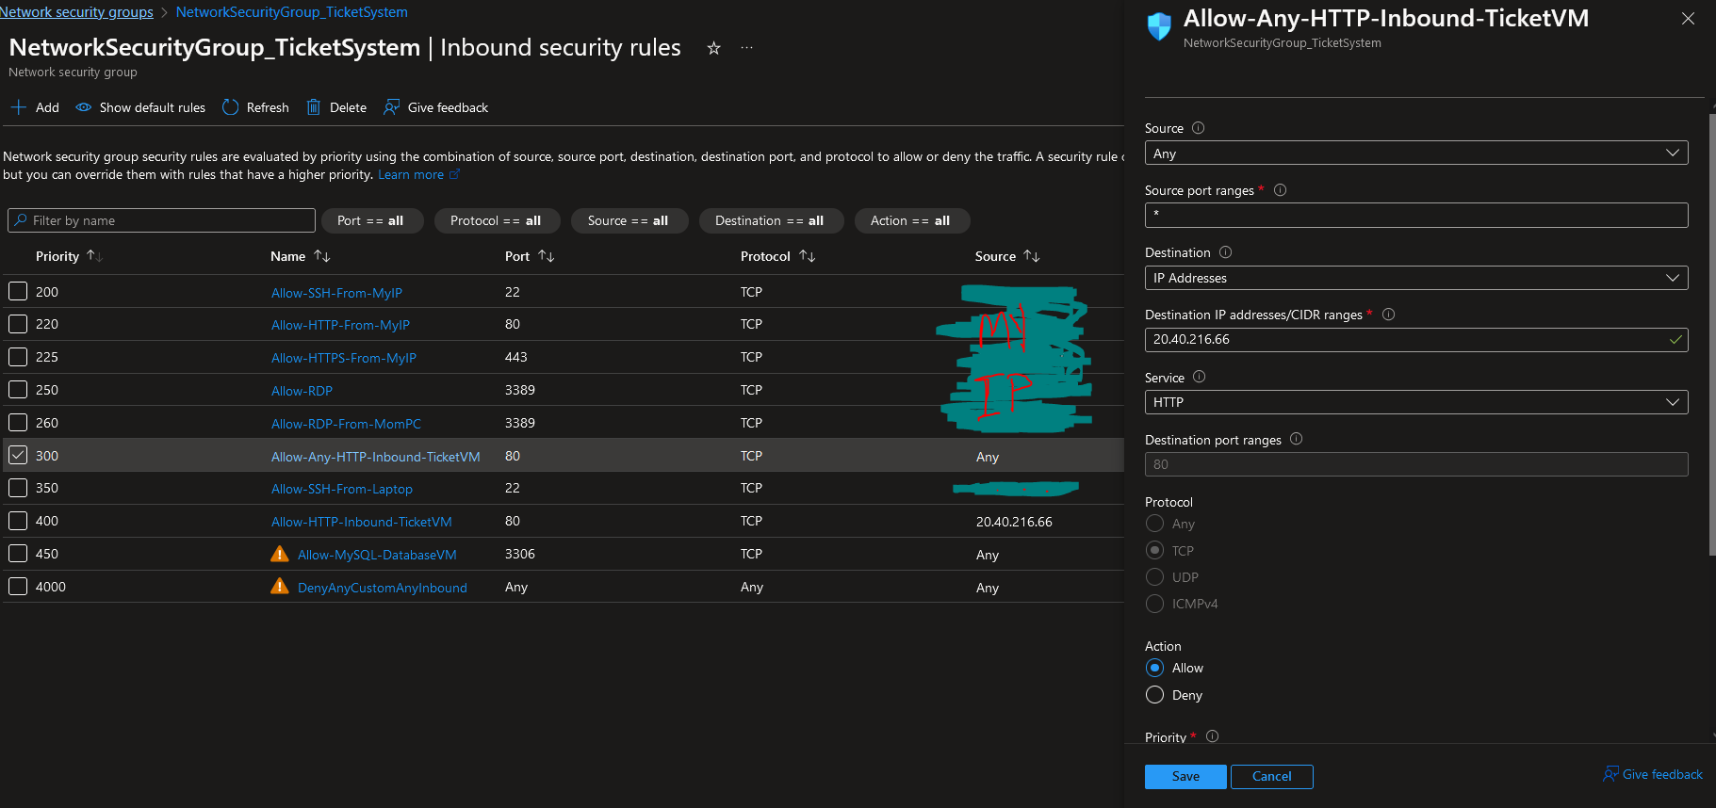

* Update osTicket Helpdesk URL system settings with new domain <https://dylanosticketlab.online> from <http://20.40.216/osticket/upload> through the admin panel.

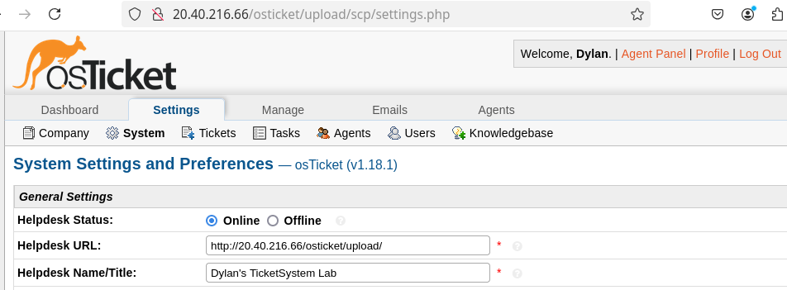

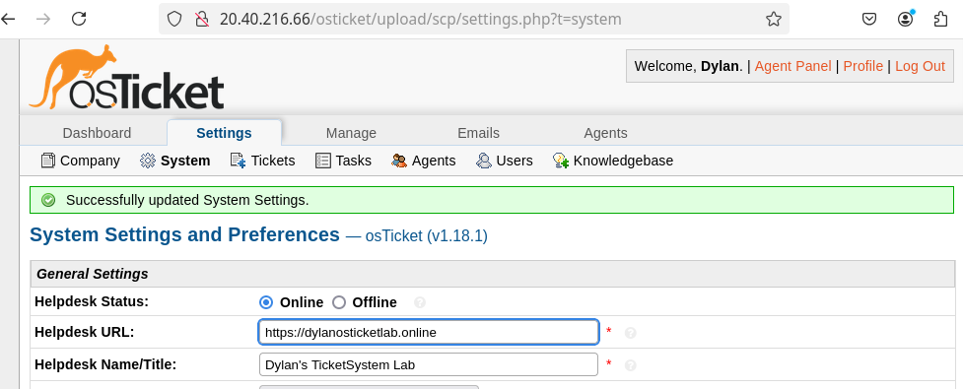

* Clear DNS record and Web Browser cache to remove the old DNS record and to fetch the new updated DNS record.

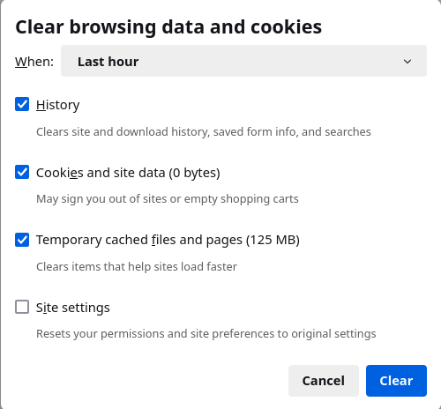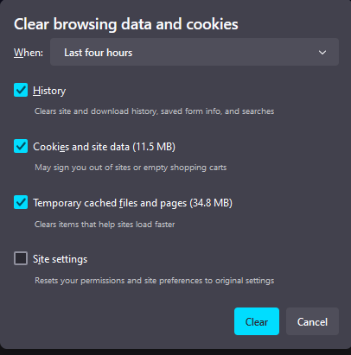

* Verify my domain dylaonosticketlab.online directs traffic to my osTicket web app.

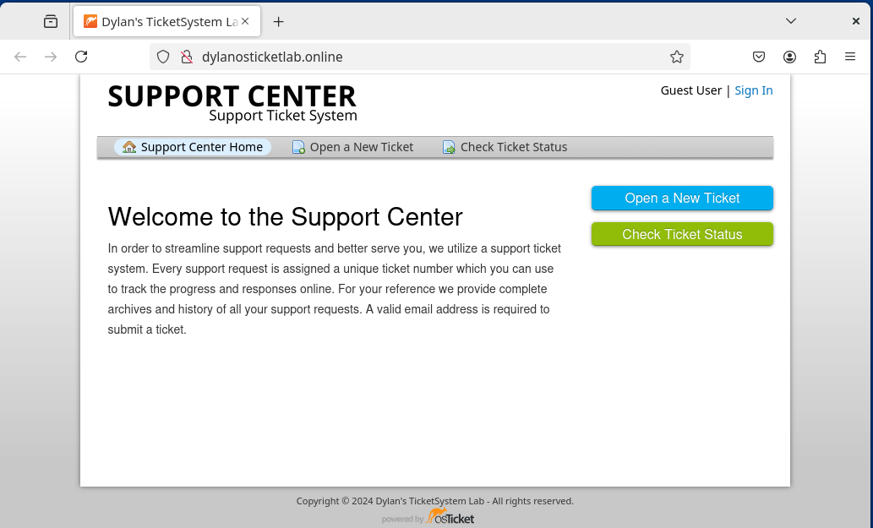

* Request SSL Certificate with Certbot
* sudo certbot –apache -d dylanosticketlab.online

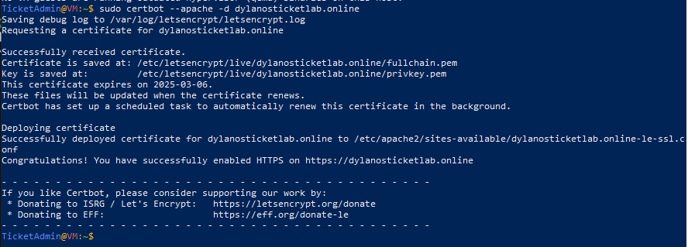

* Confirm HTTPS/SSL Certificate is implemented on my domain
* sudo ls /etc/apache2/sites-enabled/
* sudo cat /etc/apache2/sites-enabled/dylanosticketlab.online-le-ssl.conf

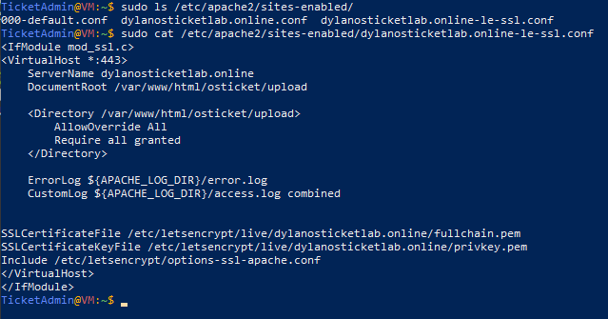

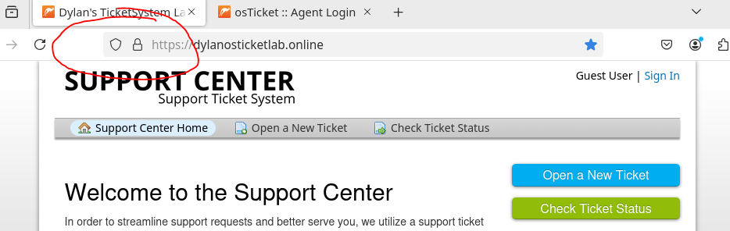

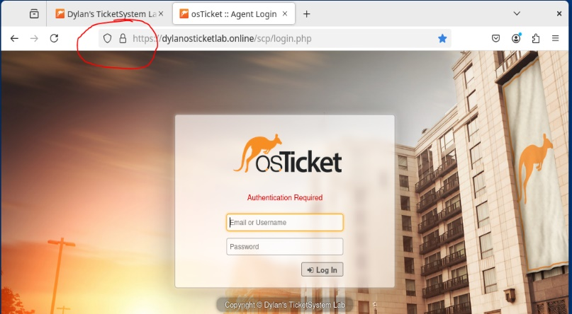

* Make a directory folder for installed plugins (audit.phar , auth-2fa.phar , auth-oauth2.phar , auth-password-policy.phar) to access it on osTicket web application.

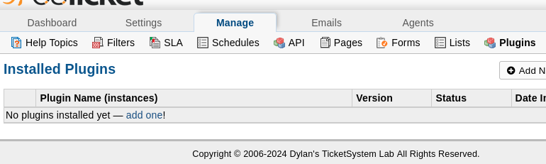

* sudo mkdir -p /var/www/html/osticket/upload/include/plugins





* sudo mv /var/www/html/osticket/*.phar /var/www/html/osticket/upload/include/plugins



* Give the plugin files correct permissions for osTicket to access them
* sudo chown -R www-data:www-data /var/www/html/osticket/upload/include/plugins/
* sudo chmod -R 755 /var/www/html/osticket/upload/include/plugins/



* 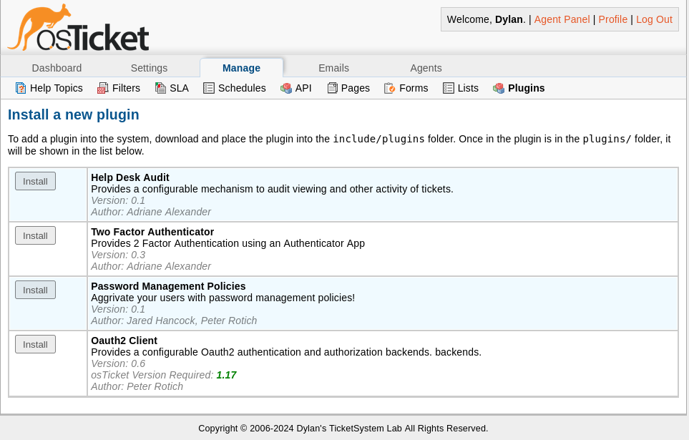Verify through osTicket Admin Panel

**Step 27.** Install and Enable OAuth2 Plugin in osTicket Admin Panel. My goal is to integrate Azure Active Directory (Microsoft Entra ID) as my identity provider for osTicket.

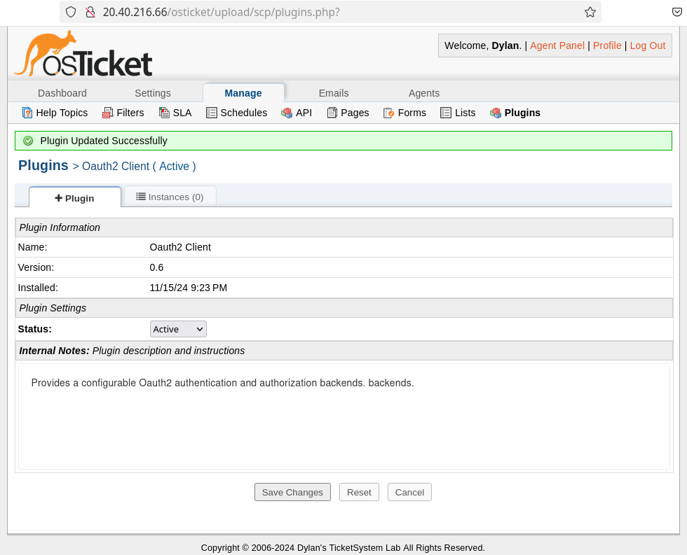

* In Azure Web Portal, navigate to Microsoft Entra ID (Azure Active Directory) then scroll the Manage column and click App registrations

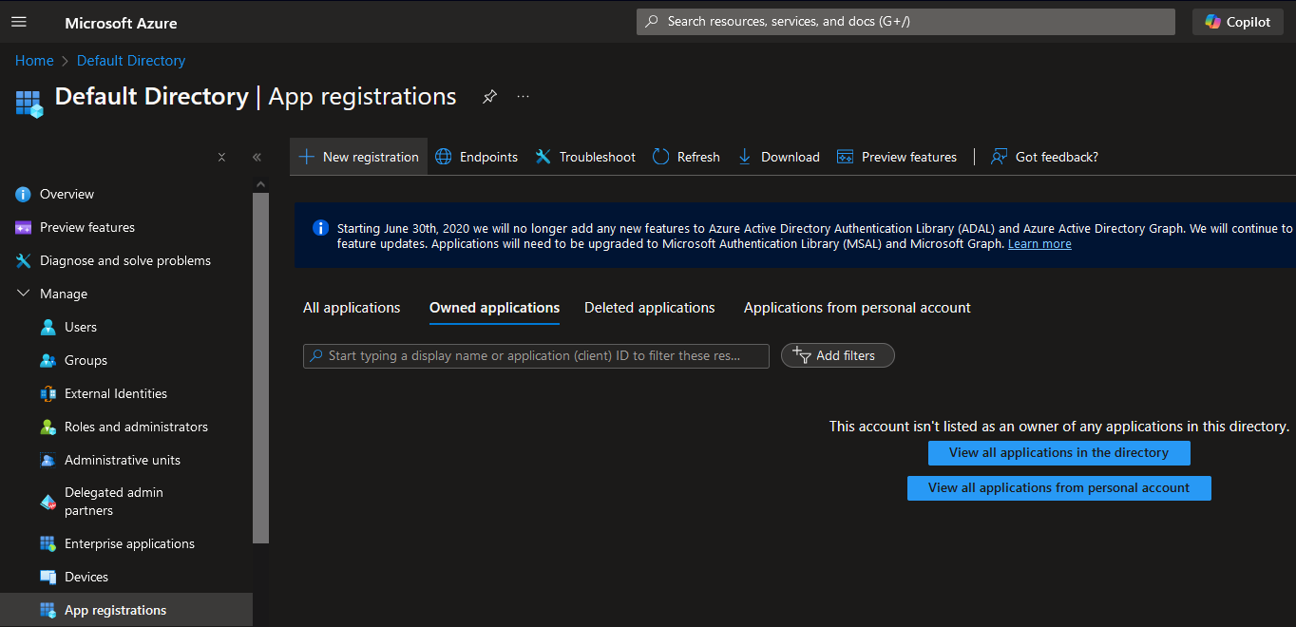

* Register my osTicket Web Application with authentication response
* URI (Uniform Resource Identifier), <https://dylanosticketlab.online/api/auth/ext/oauth2/callback>, through osTicket API backend routing via scripts through .php
* <https://dylanosticketlab.onle/api/auth/ext/oauth2/callback>

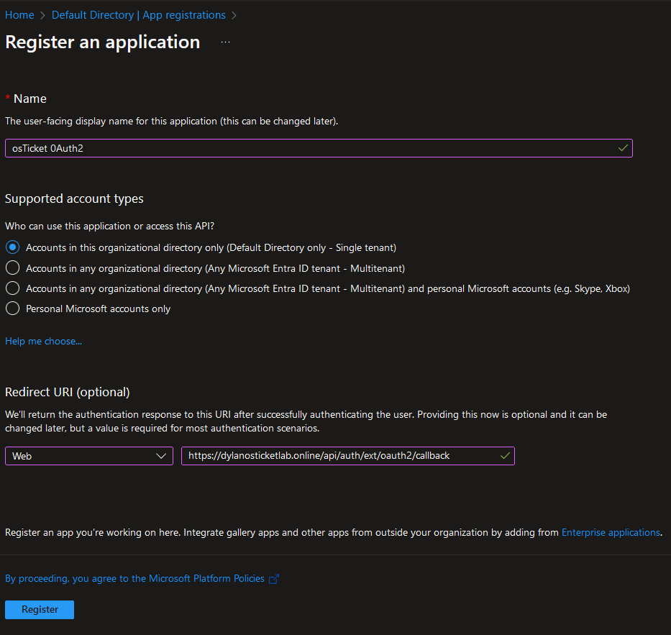

* Navigate to API Permissions > Microsoft Graph > Delegated Permissions, then add OpenID permissions email, openid, and profile then update permissions.

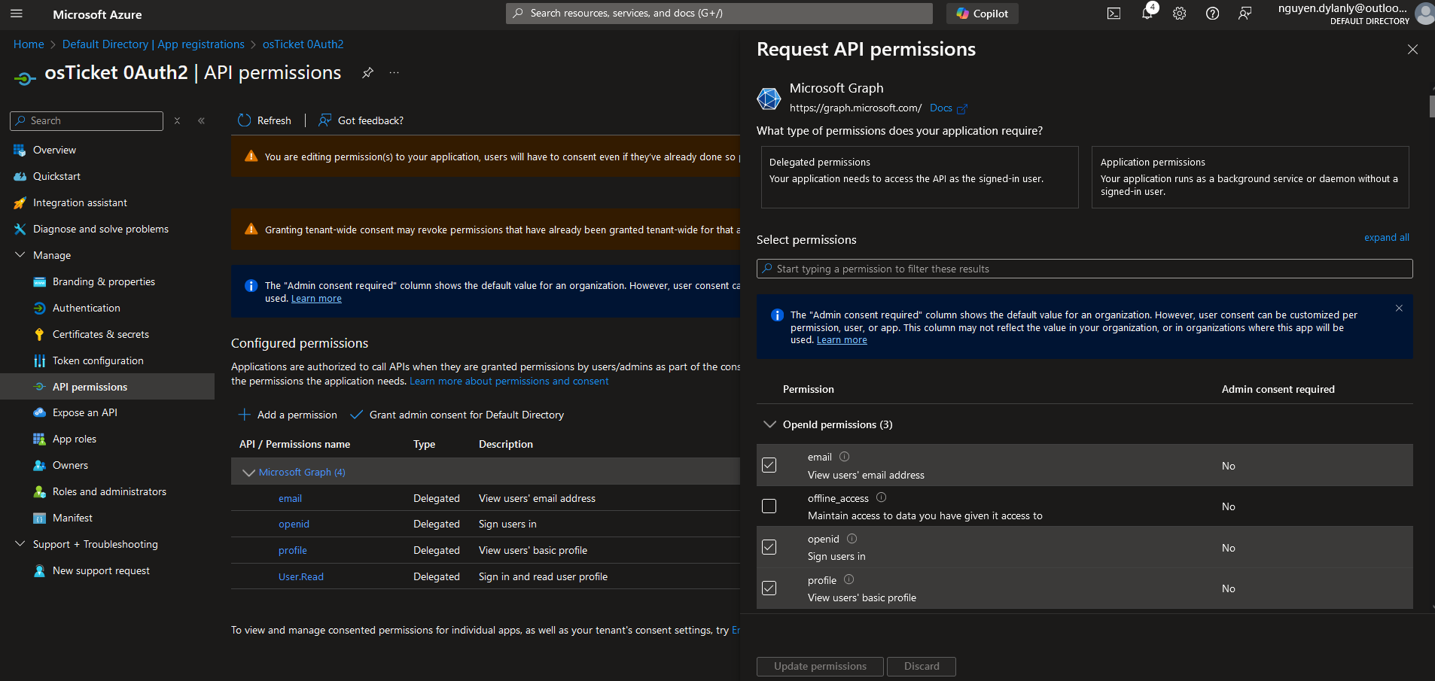

* Navigate to Certificates & Secrets then create a New Client Secret to generate/copy Client Secret Value and Client Secret ID.

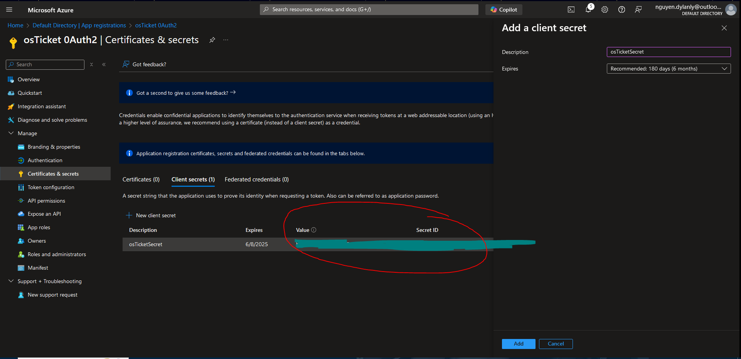

* On the Admin Panel of osTicket, navigate to Manage > Plugins > Instances/ Add New Instances/ Microsoft.

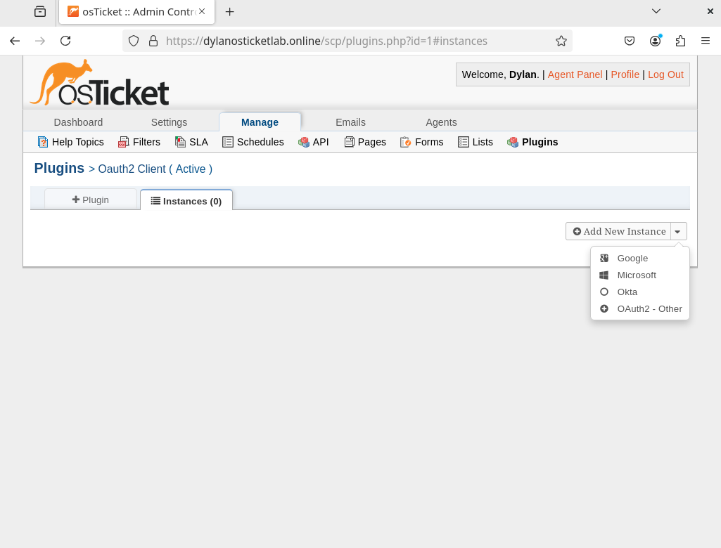

* Configure and create my identity provider Microsoft 0Auth2 instance on osTicket.

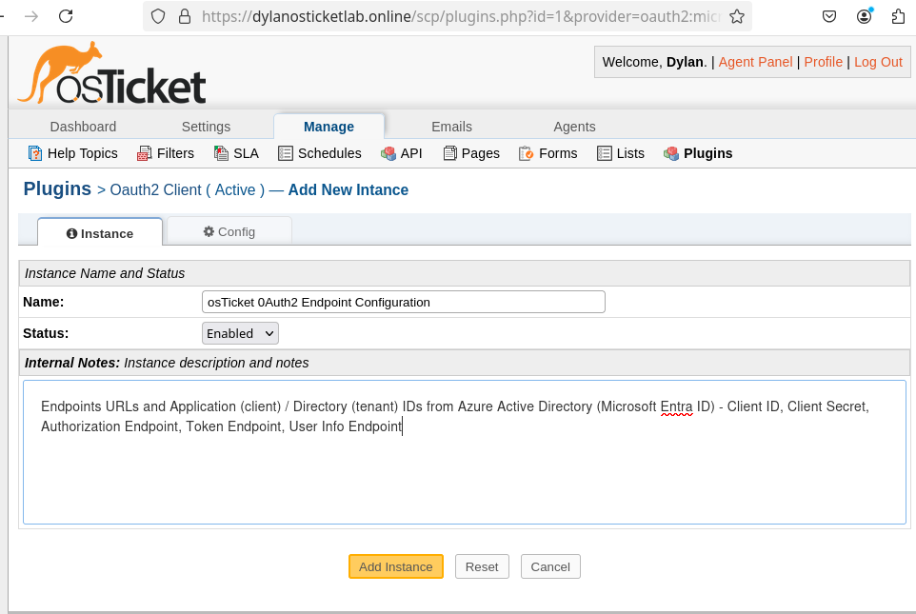

* 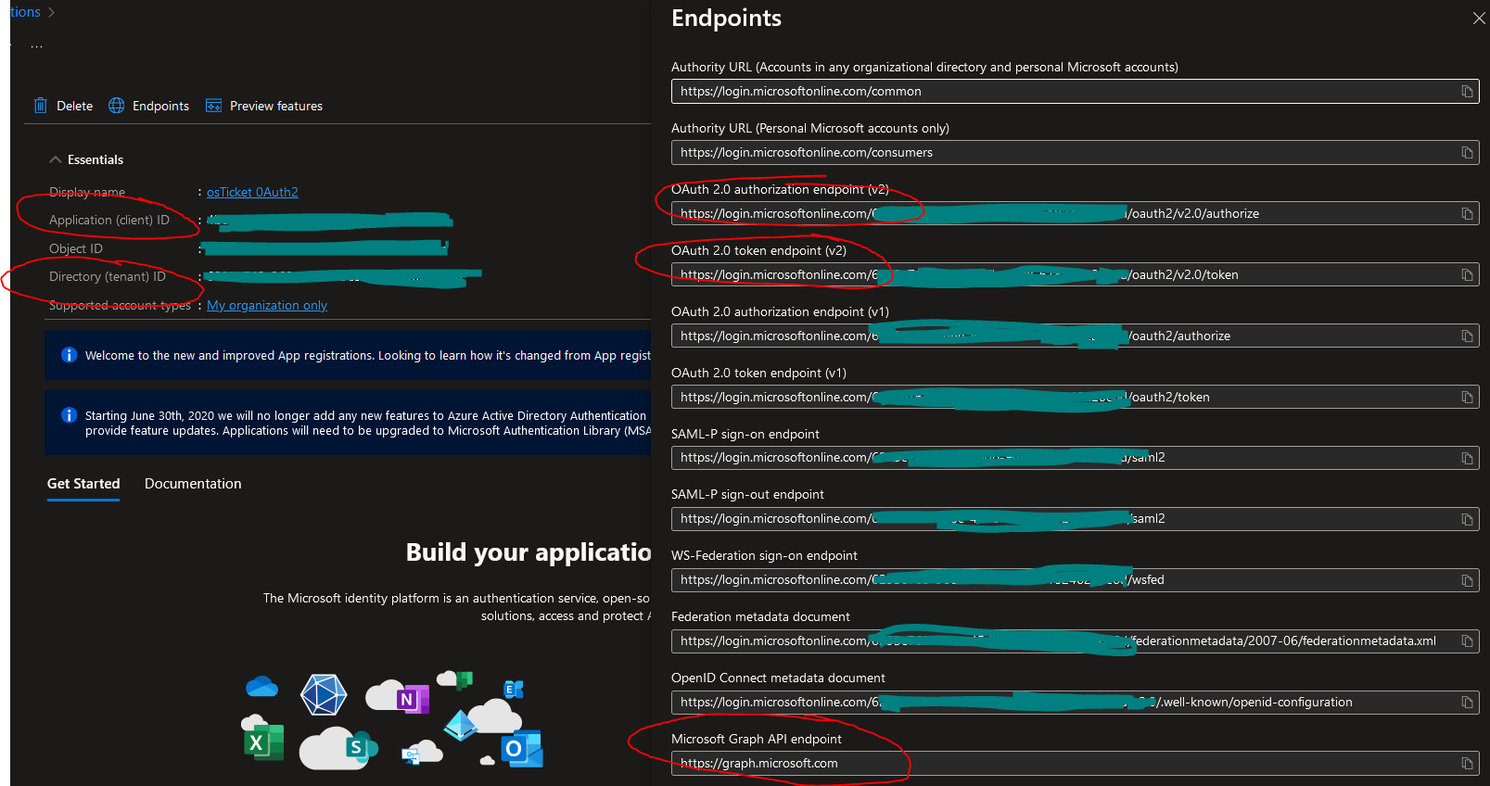Copy and paste URI Callback Endpoint, Client Identifier (ID), Client Secret, Authorization URL, Access Token URL, User Details URL (Microsoft Graph), and Scopes from Azure Active Directory (Microsoft Entra ID) to osTicket 0Auth2 Plugin Configuration.

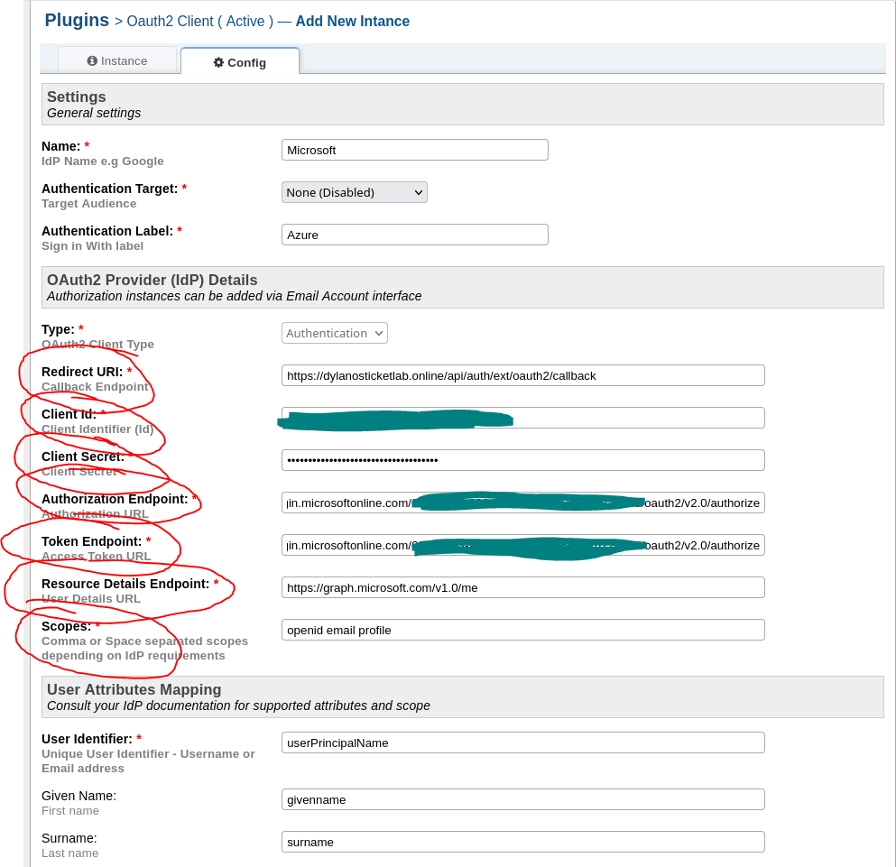

* Error occurs stating invalid API Endpoint. I will start to troubleshoot.



* Navigate to <https://dylanosticketlab.online/api/auth/ext/oauth2/callback> on a web browser.

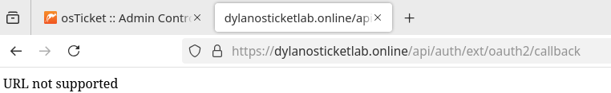

* curl -I <https://dylanosticketlab.online/api/auth/ext/oauth2/callback>

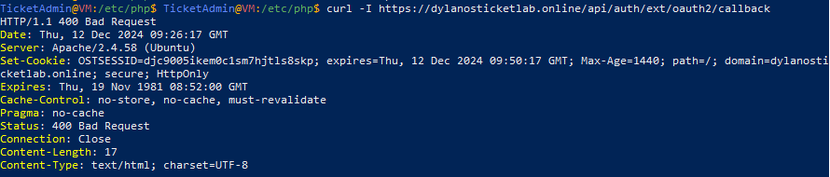

The *400 Bad Request* error indicates that the osTicket API endpoint is rejecting the request to the callback URL. The *400 Bad Request* for the callback URL means the request is reaching my server but is not being handled correctly. This can happen if the expected endpoint logic isn't triggered or misconfiguration is present in osTicket, 0Auth2 Plugin, Azure or Apache Web Server.

After research and with the help of the *osTicket Community Support* forums (<https://forum.osticket.com/d/102101-osticket-and-oauth2-plugin>), I discovered that the issue stemmed from Apache not processing the *.htaccess file* in the osTicket directory, which contains crucial *rewrite rules* needed to properly *route API requests*, including those for the callback URL. The *.htaccess file allows directory-level configuration overrides in Apache*, enabling settings like URL rewrites without modifying the main server configuration files. While my *Apache Virtual Host* was already configured with *AllowOverride All* for the osTicket directory, the .htaccess file itself was not being utilized due to the global Apache configuration in */etc/apache2/apache2.conf*, where *AllowOverride* was still set to *None* for the /var/www/ directory. Updating this to *AllowOverride All* allowed Apache to *apply the .htaccess rules*, enabling the necessary logic for handling the callback URL dynamically and *resolving* the *400 Bad Request error*.

* Update configuration in Apache Web Server from AllowOveride None > AllowOveride All to allow osTicket to apply .htaccess rules for URI/URL Endpoint backend routing.
* sudo nano /etc/apache2/apache2.conf



* Update <Directory /var/www/> block from AllowOverride None to AllowOverride All

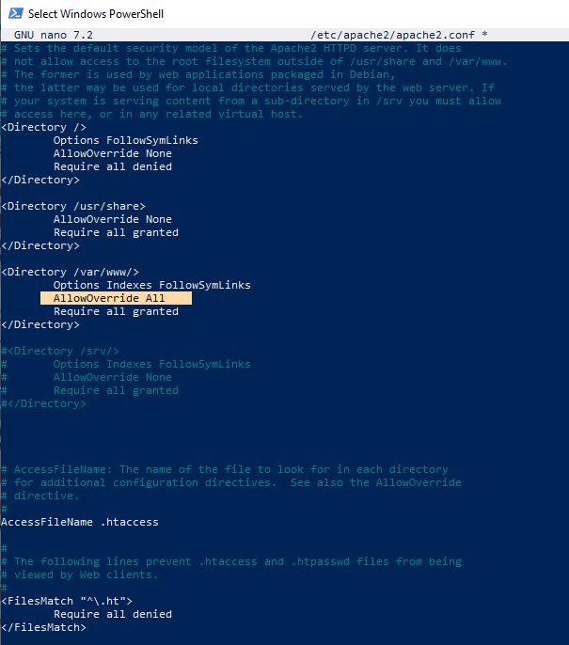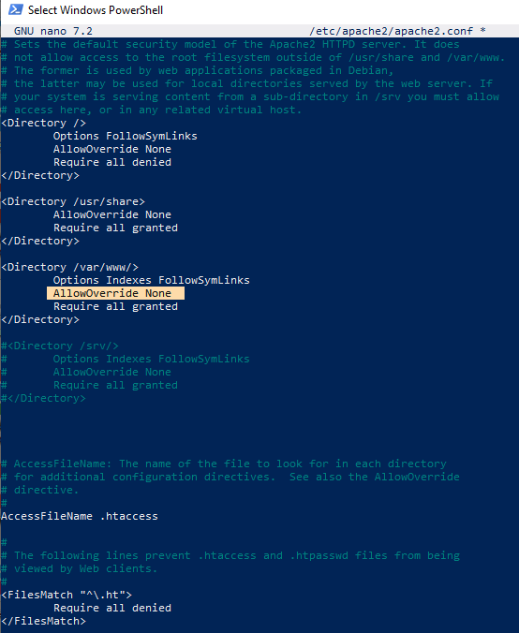

* Restart Apache to apply changes 🡪 sudo systemctl restart apache2



* Test OAuth2 Plugin instance installation. Success!

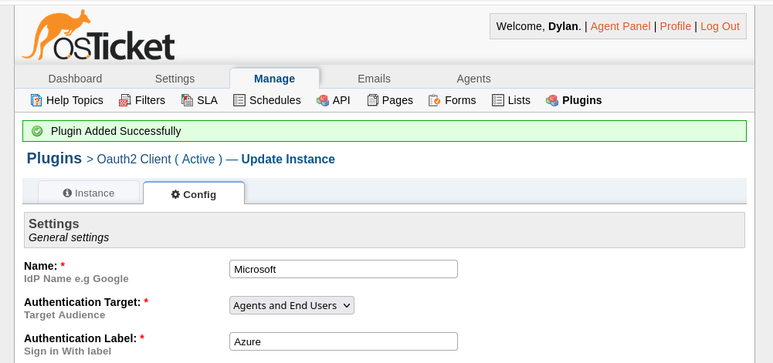

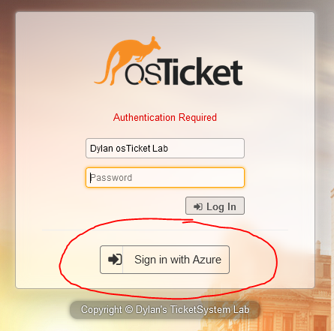

**Step 28.** Create test Outlook email to configure Email settings in osTicket Admin Panel to send outgoing email via SMTP (port 587) and receive incoming email via IMAP (port 993).

* Create test outlook email, dylanosticketlab@outlook.com

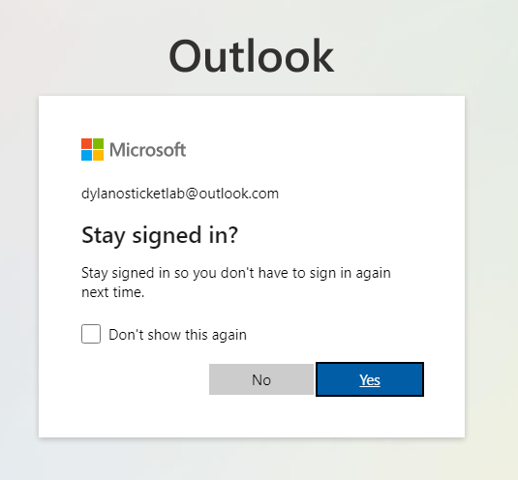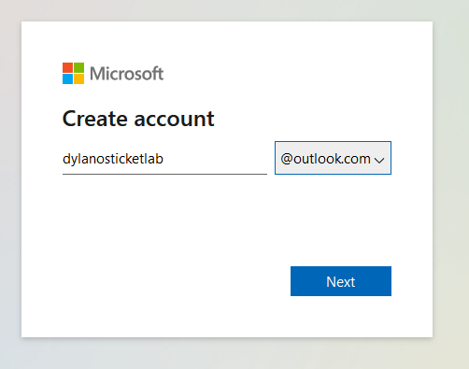

* Add new email address (dylanosticketlab@outlook.com) in osTicket Admin email panel and configure it to support department.

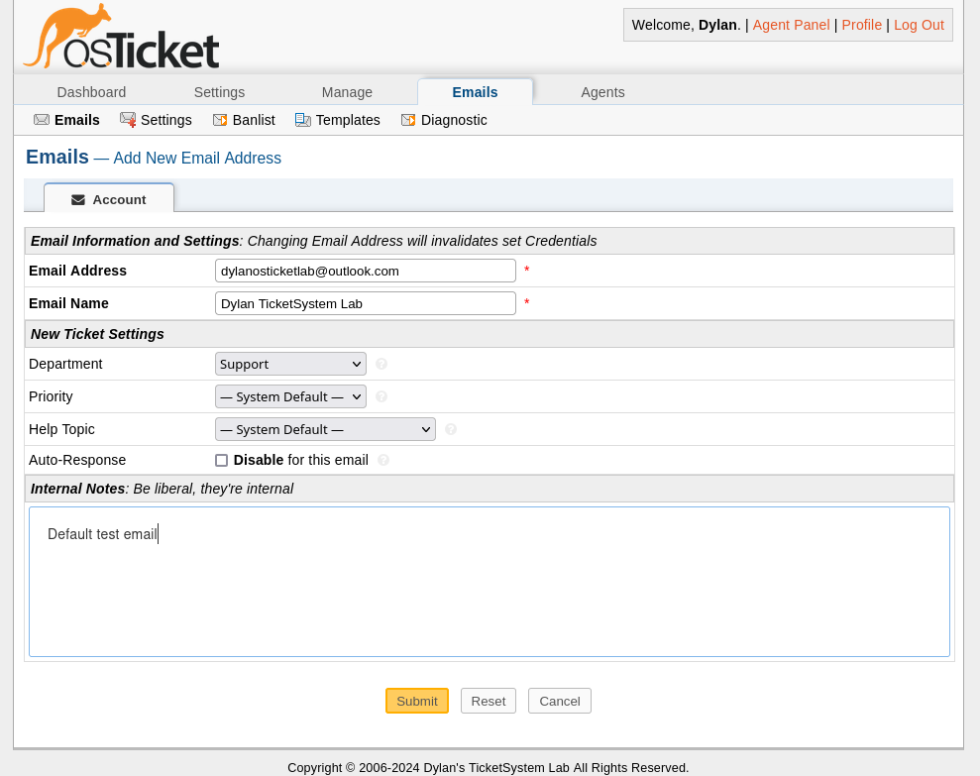

* IMAP & SMTP Outlook server/port settings (<https://support.microsoft.com/en-us/office/pop-imap-and-smtp-settings-for-outlook-com-d088b986-291d-42b8-9564-9c414e2aa040>)

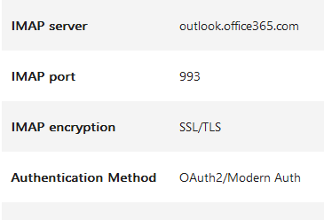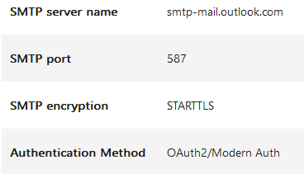

* Configure Remote Mailbox (IMAP) and Outgoing (SMTP) in Admin Panel email settings

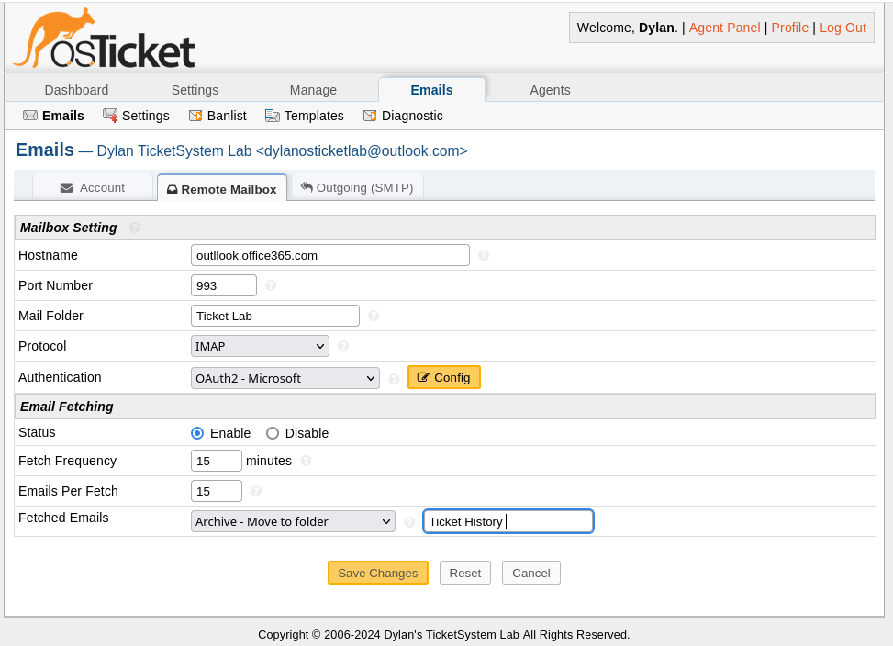

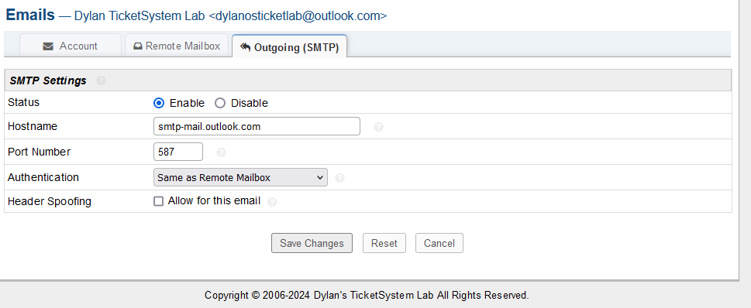

* Just found out about Oauth2 for IMAP/SMTP. I will create an App Registration on Azure Active Directory (Microsoft Entra ID) to apply it.
* Azure Portal > Microsoft Entra ID > App Registration > New Registration > Redirect URI - <https://dylanosticketlab.online/api/auth/oauth2> > Register

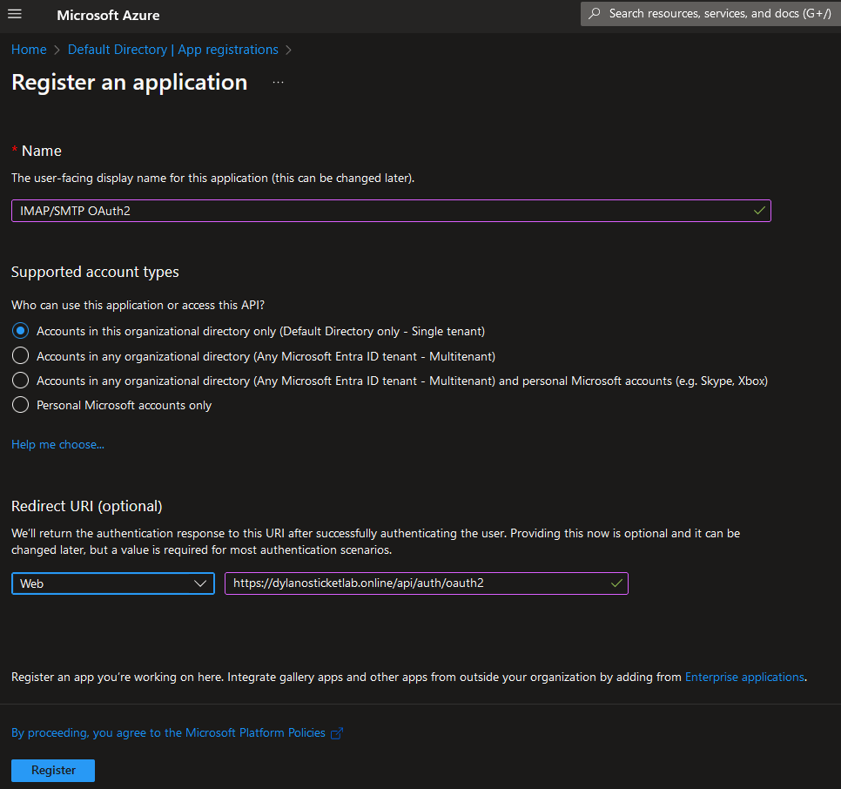

* API Permissions > Add a permission > Microsoft Graph > Delegated Permissions > Add permissions - IMAP.AccessAsUser.All, SMTP.Send, offline_access > Grant admin consent

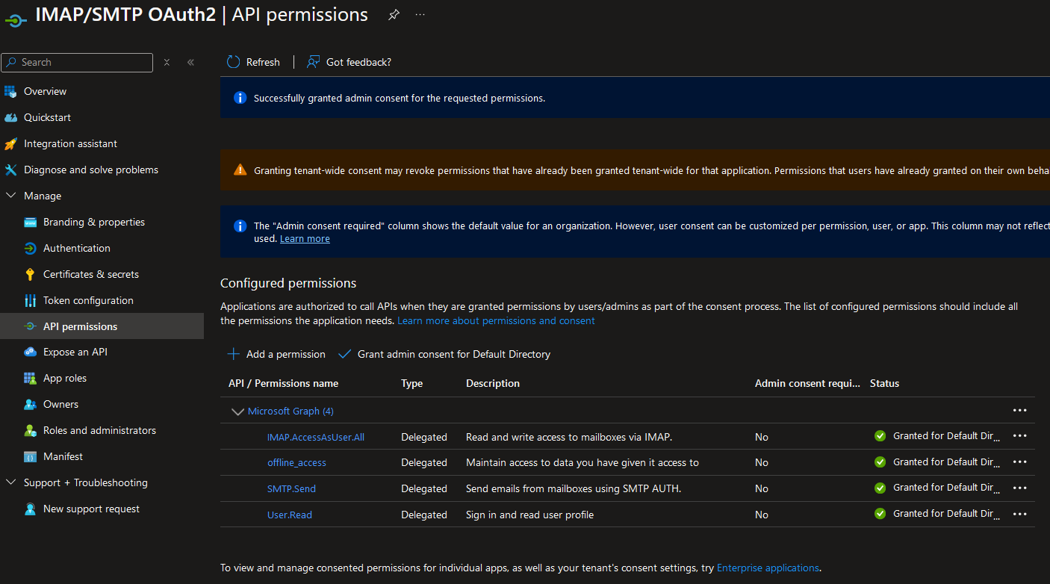

* Certificates & secrets > New client secret > Add client secret > Save secret value

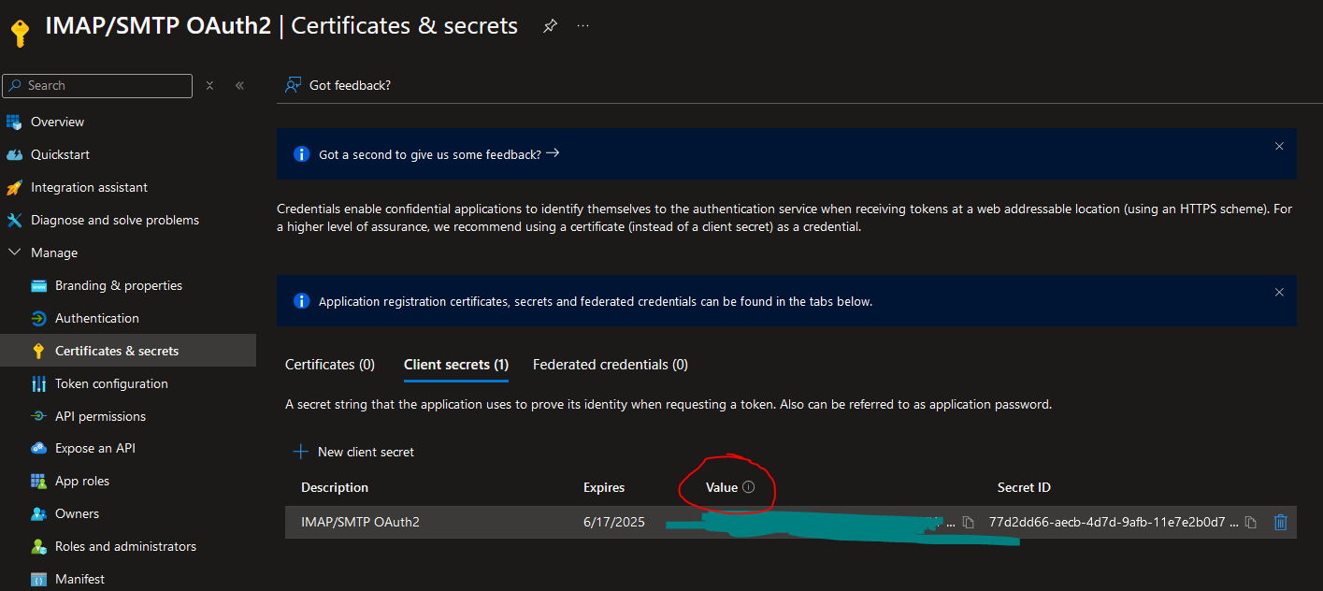

* Transfer Auth/Token Endpoint, Client ID, Secret Value, Outlook Scopes to osTicket IMAP OAuth2 email configuration

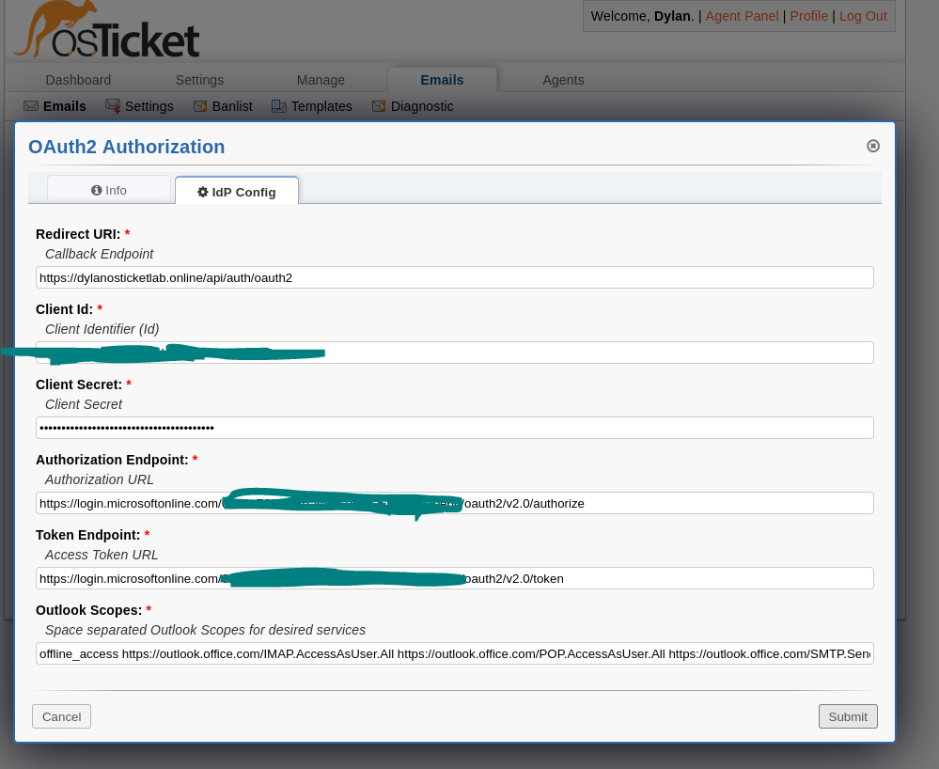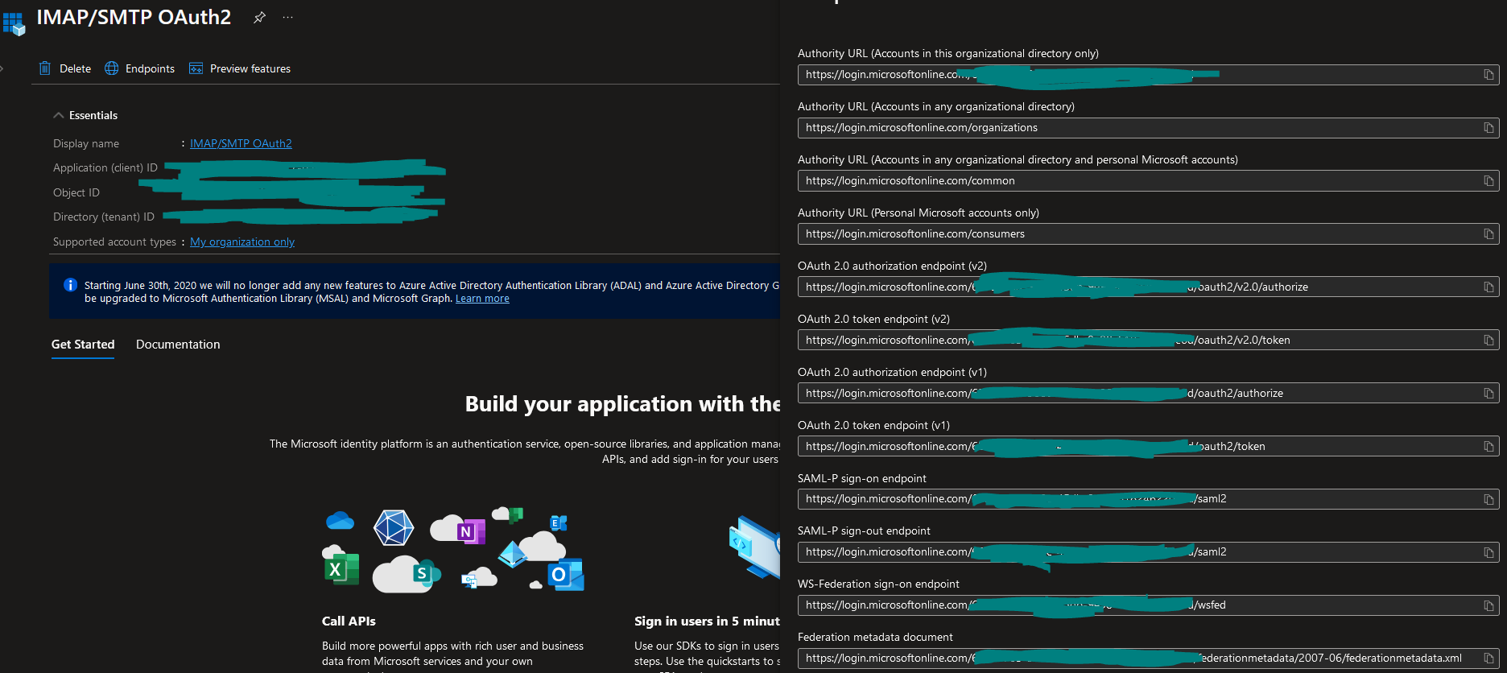

* After submit, complete OAuth2 process by signing into Outlook ticket email

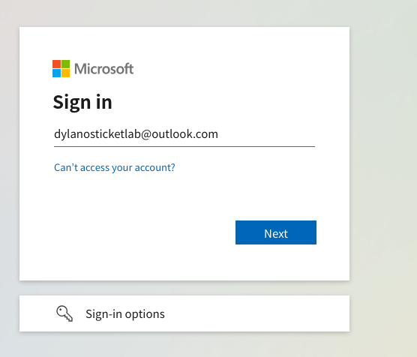

* Encountered an error where an authentication issue occurred due to my ticket email not being a user in my Azure Active Directory tenant. Will add user to fix.

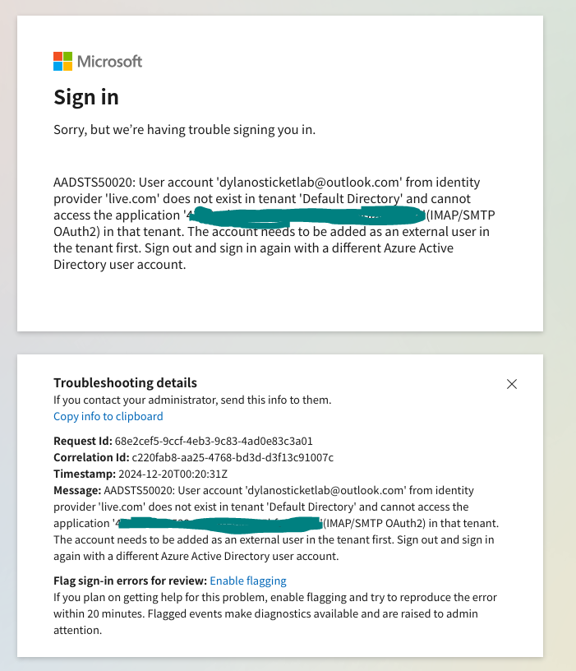

* Microsoft Entra ID > Add > User – Invite external user > [dylanosticketlab@outlook.com](mailto:dylanosticketlab@outlook.com) > User type – Member > Review + Invite

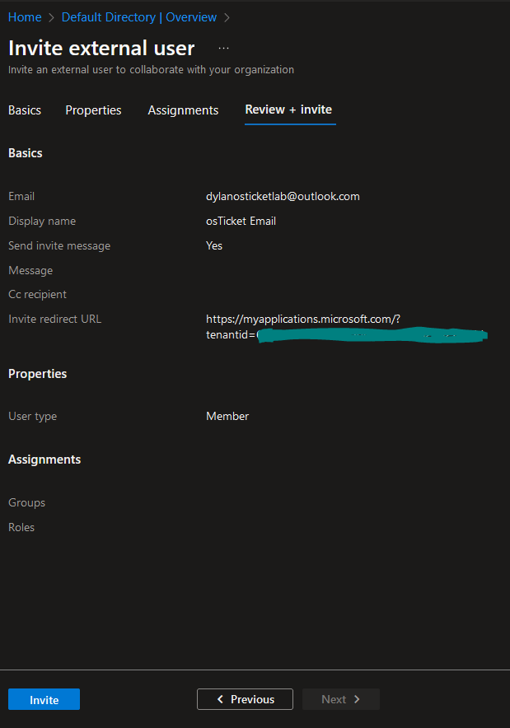

* 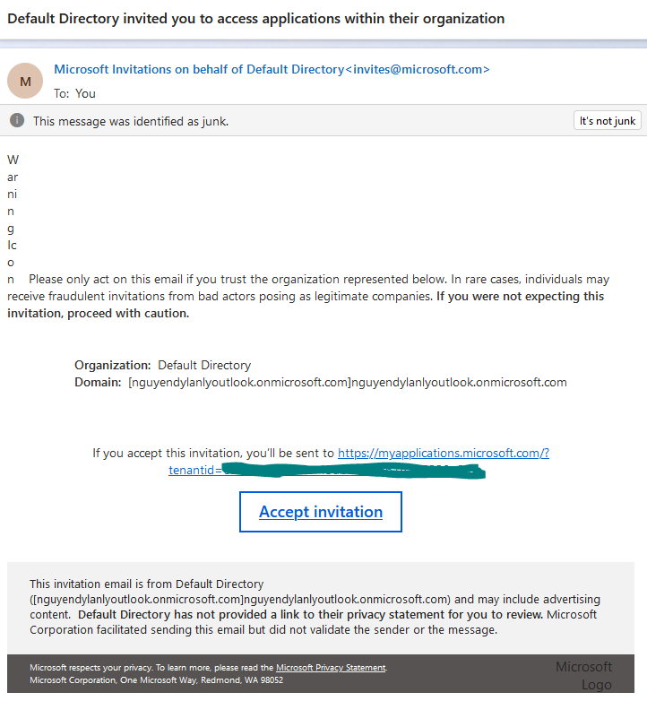In Outlook, accept invitation
* Accept permissions for Azure tenant member

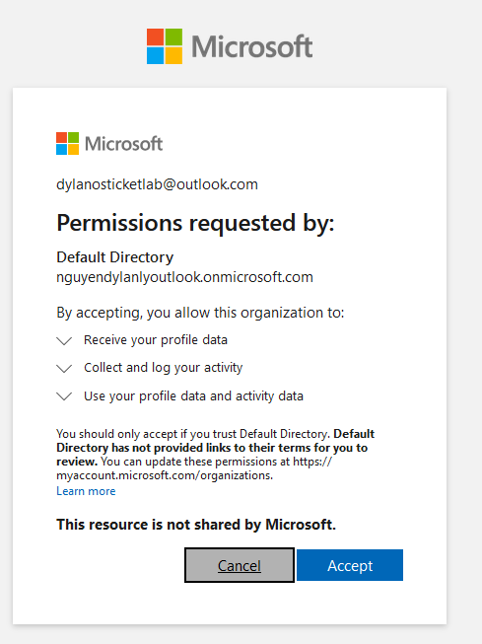

* Reattempt OAuth2 IMAP/SMTP config > Accept permissions for IMAP/SMTP OAuth2

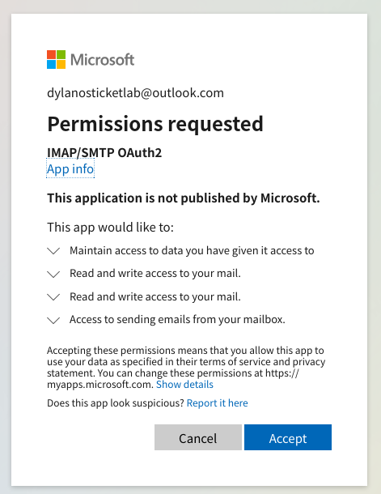

* New error occurs, further troubleshooting.



* Disable Strict Matching for testing.

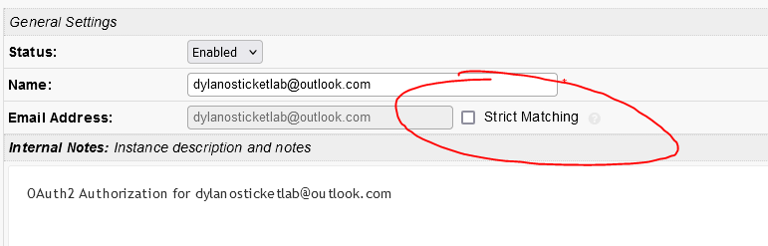

* Attempt again, OAuth2 succesful

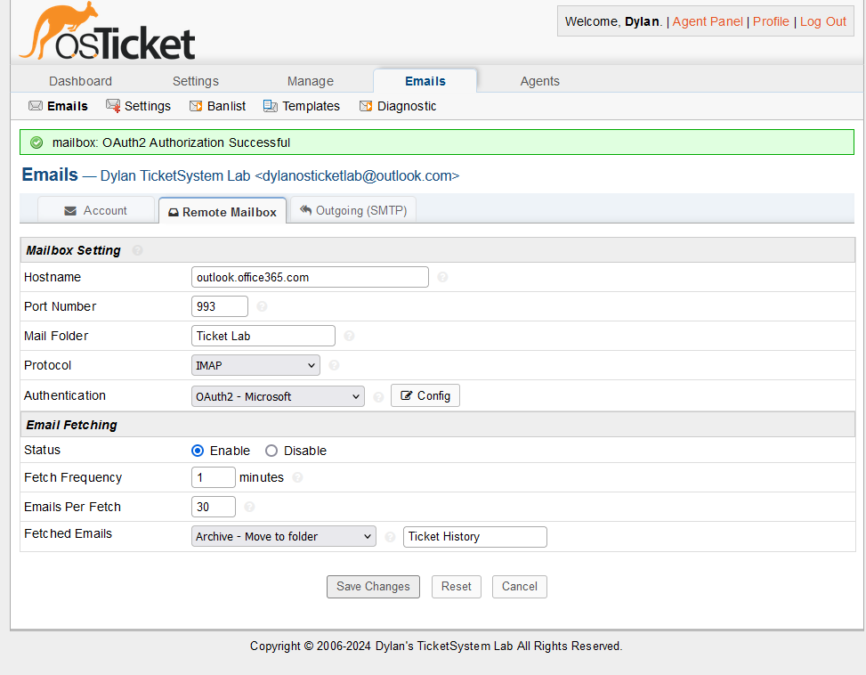

* Error occurs when I try to Save Changes, further troubleshooting.
* 5.7.3 Authentication unsuccessful [DM5PR08CA0032.namprd08.prod.outlook.com 2024-12-21T01:29:36.552Z 08DD1EBE53AB1BCE]

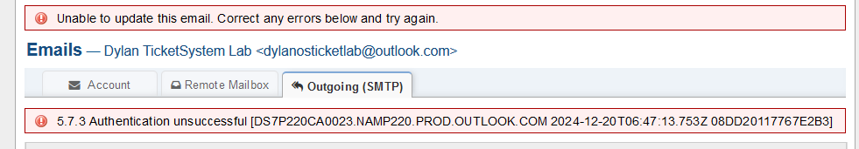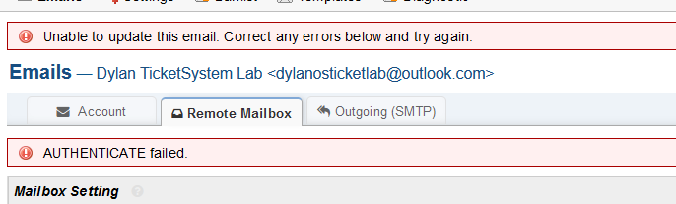

* Unfortunately, I was not able to troubleshoot OAuth2 IMAP/SMTP error 5.7.3 Authentication unsuccessful [DM5PR07CA0059.namprd07.prod.outlook.com 2024-12-31T02:06:28.041Z 08DD27F8C132FAE5]. I will provide articles that pertain to this error. Although it is less secure, I will opt for Basic Authentication (Legacy) by using an App Password via Microsoft Outlook for IMAP/SMTP to further develop my testing lab as it isn’t an actual production lab.
* <https://forum.osticket.com/d/101655-573-authentication-unsuccessful-ch2pr05ca0066namprd05prodoutlookcom/12>
* <https://howtohelpdesk.com/how-to-setup-oauth-on-osticket-using-microsoft-365/>
* 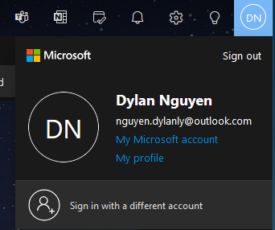Navigate to Microsoft Outlook Account settings > Security > Additional security options

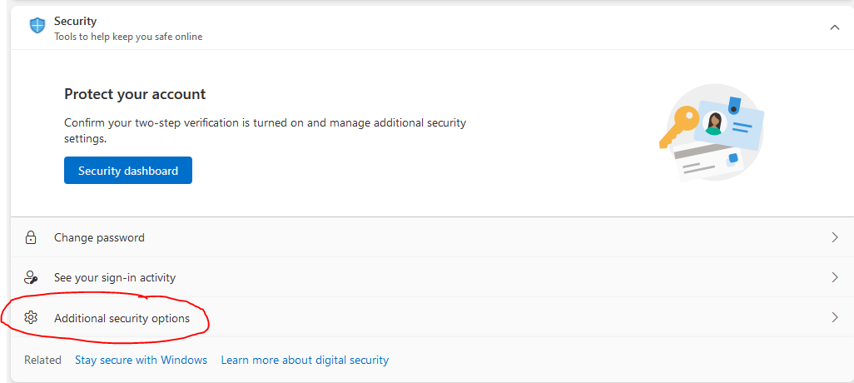

* Ensure Two-step verification is on > Generate an App password > Copy password

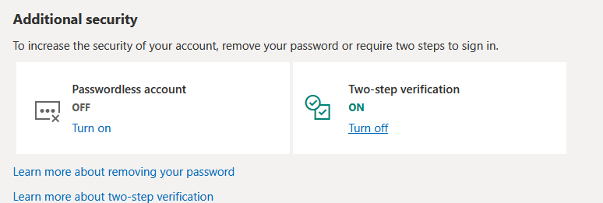

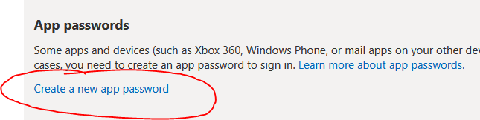

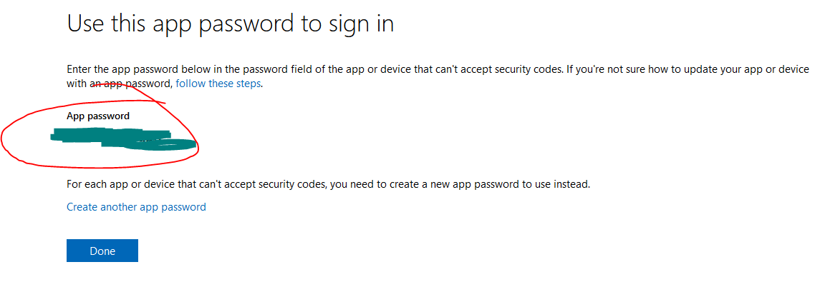

* 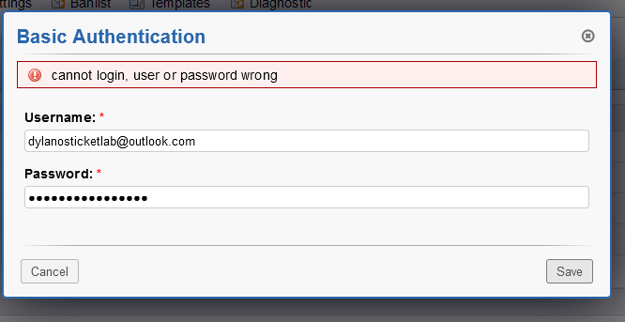Error occurred. However, I believe I found the issue and think its my NSG not having an inbound rule to allow IMAP/SMTP. Very common and silly mistake.
* Navigate to Azure Web Portal > Network Security Groups > Inbound Security Rules > Add Inbound Rule for IMAP/SMTP (Port 993/587)

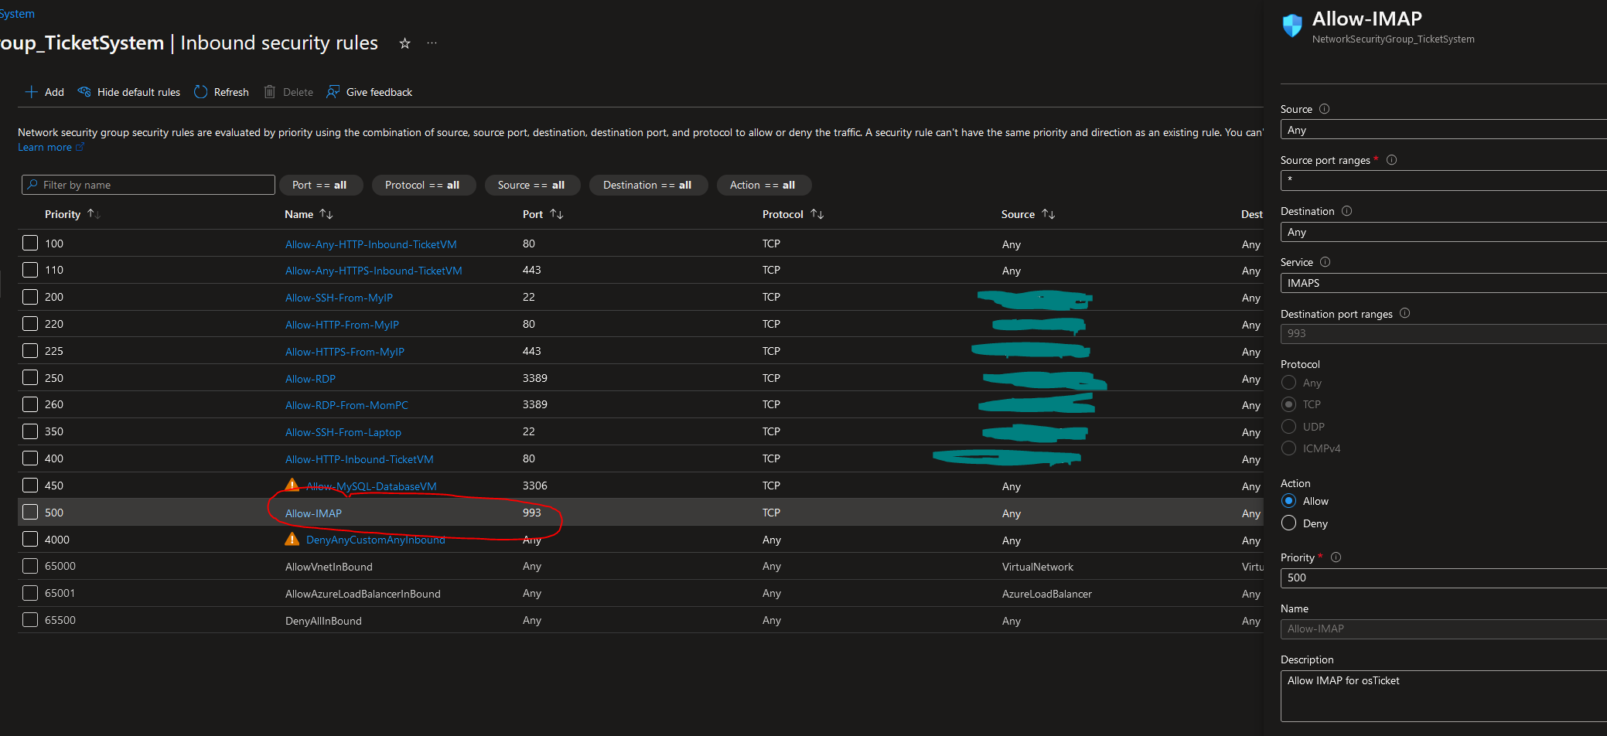

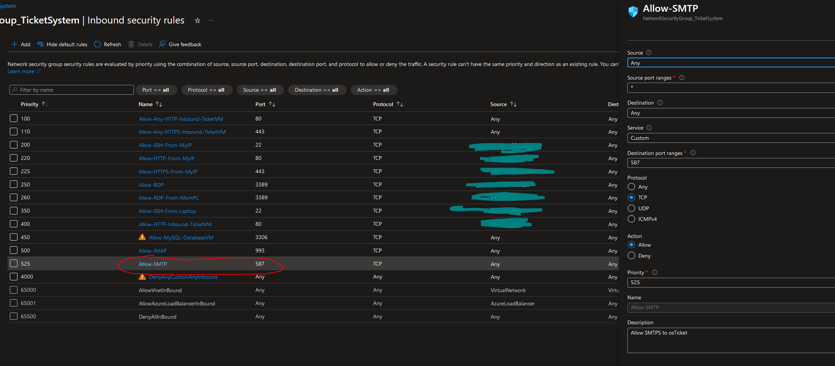

* 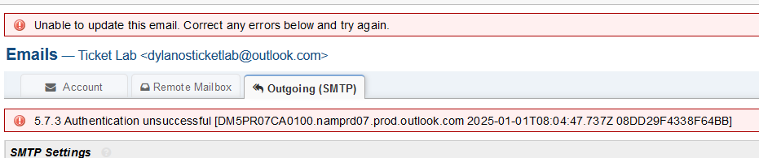Error still popped up. Enable debug mode in osTicket Admin Panel to see more logs

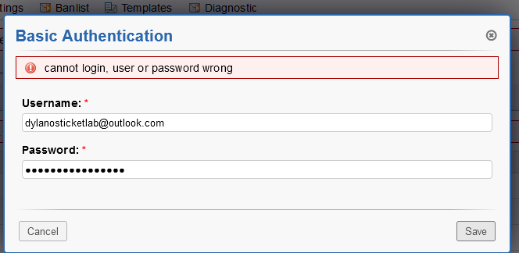

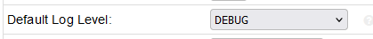

* Going to attempt OAuth2 with a Google Mail (Gmail) since I keep getting errors with Microsoft Outlook
* Navigate to Google Cloud Console with created personal Gmail and click “Select a project”

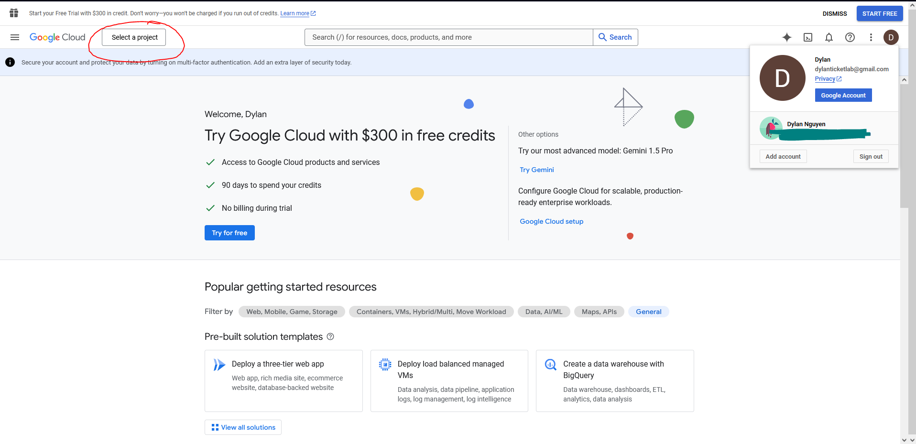

* New Project

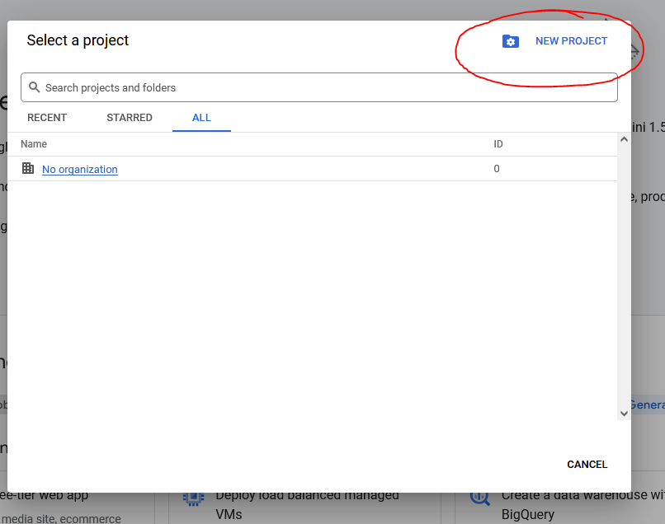

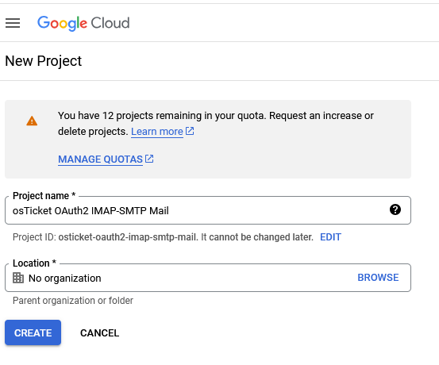

* Navigation Menu > APIs & Services > Library

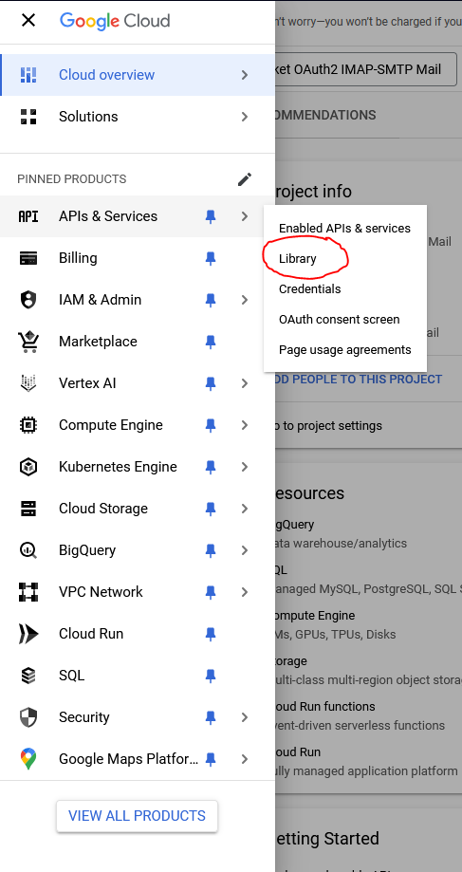

* Gmail API in search bar of API Library

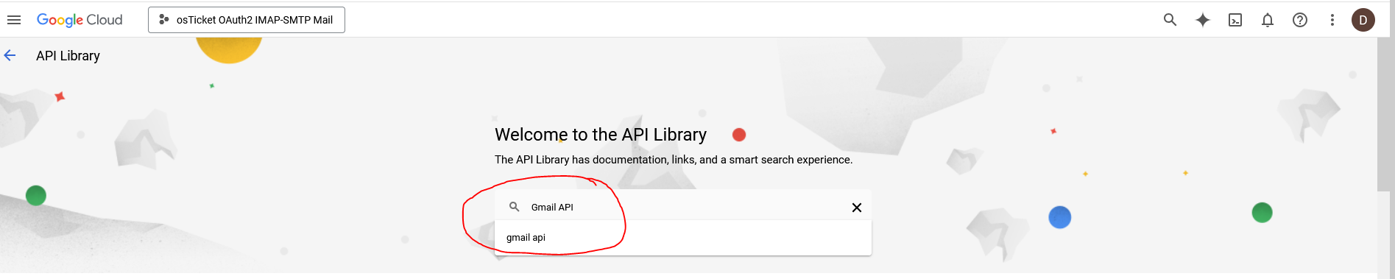

* Click Gmail API > Enable > OAuth2 consent screen > External

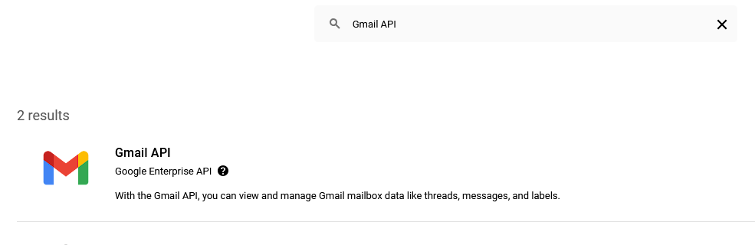

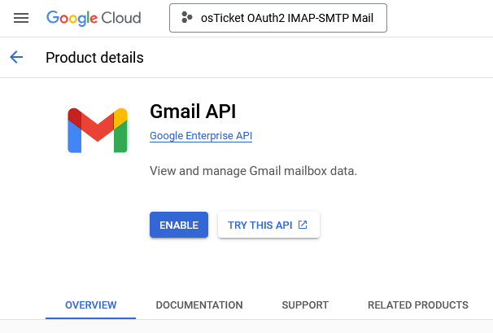

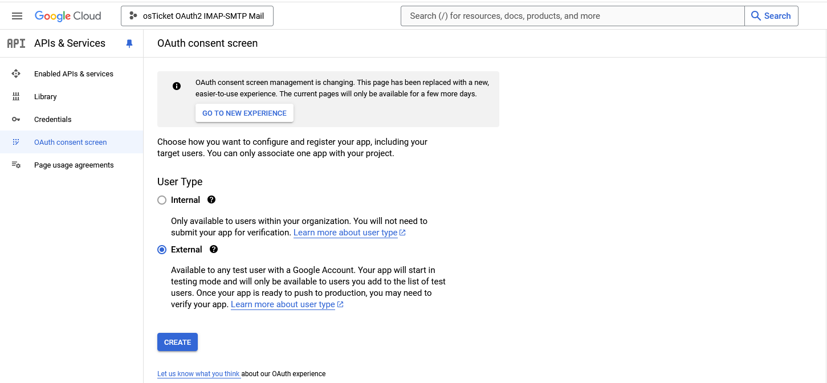

* Edit app registration and Add Gmail API scope https://mail.google.com/

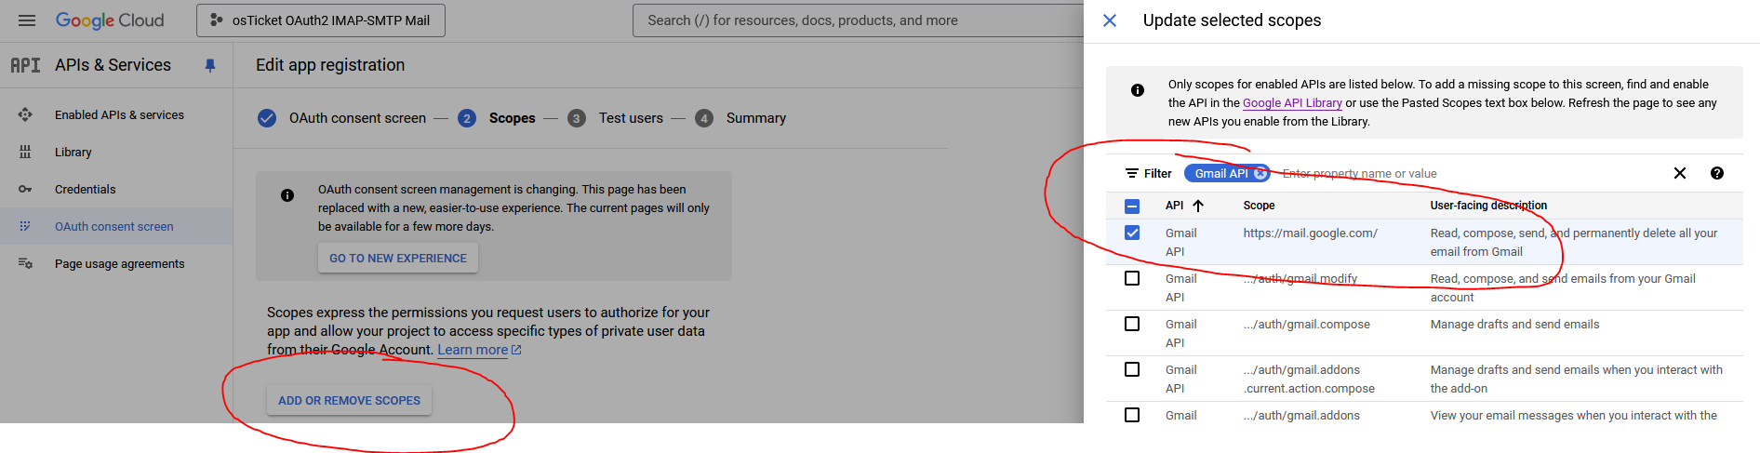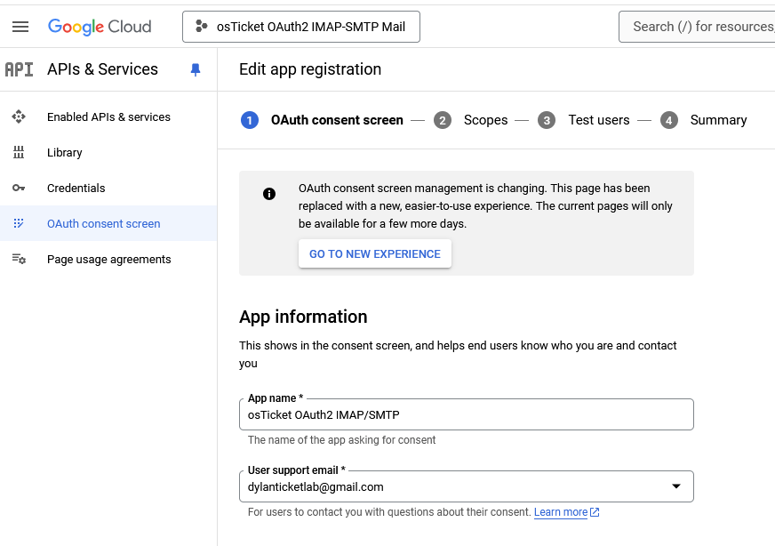

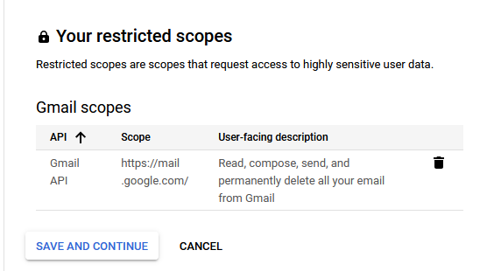

* Add my ticket lab Gmail account as a Test User and check Summary

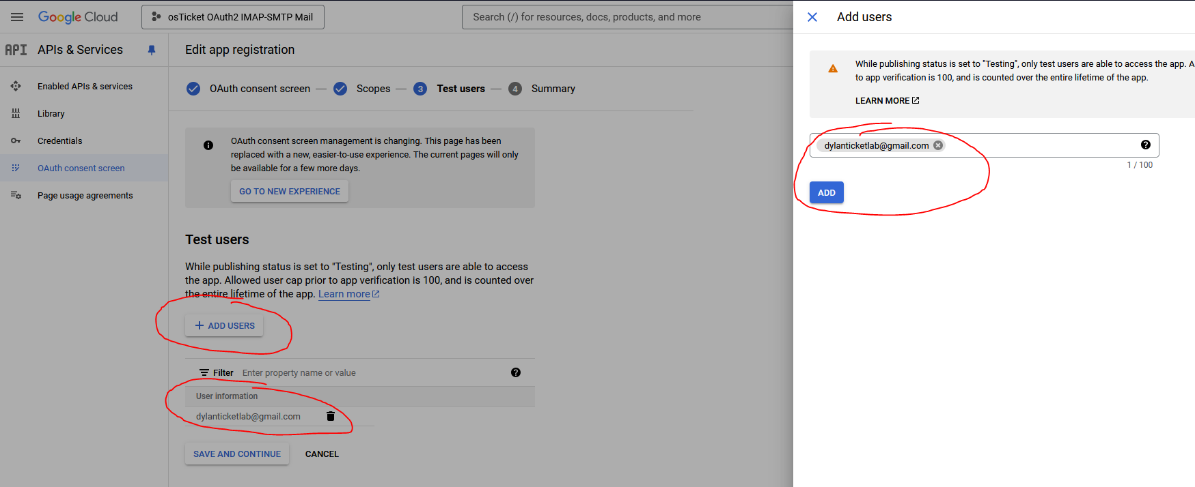

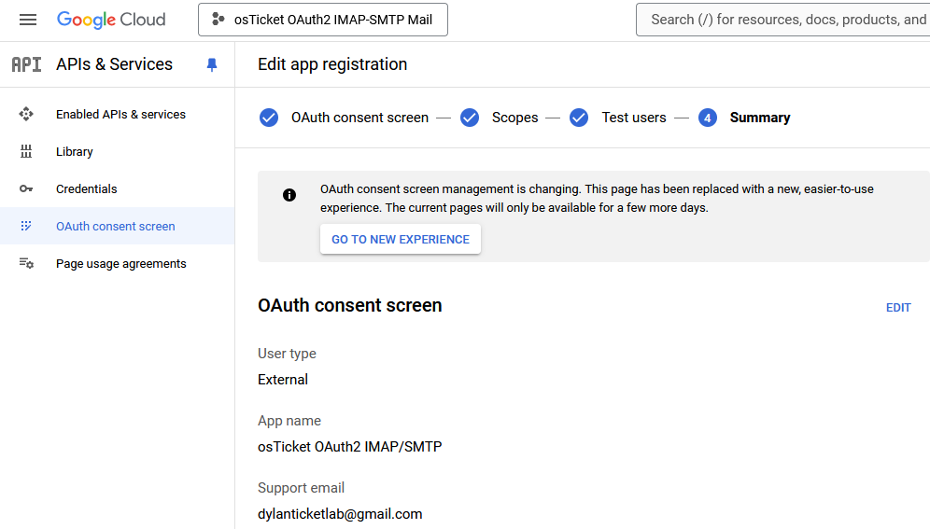

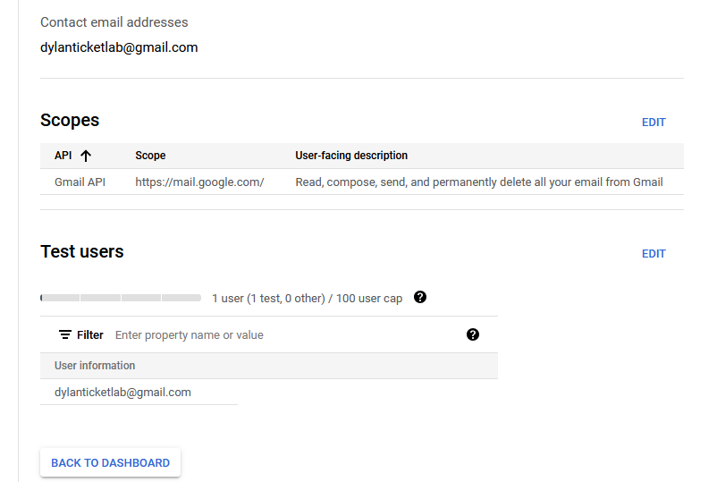

* Navigate to APIs & Services > Credentials > Click +Create Credentials > Click OAuth client ID

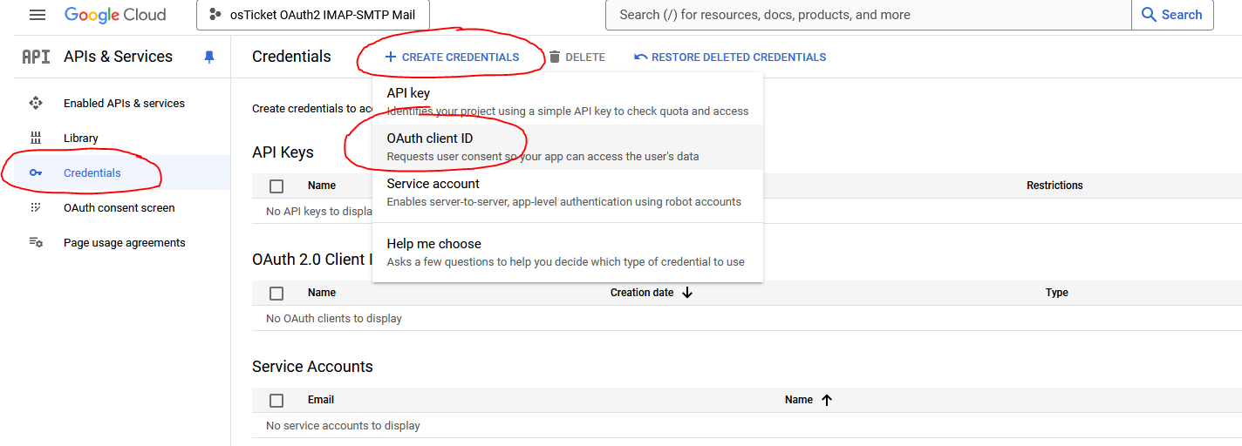

* Application Type is Web Application > Add Name to “osTicket OAuth2 IMAP/SMTP” > Add [*https://dylanosticketlab.online/api/auth/oauth2*](https://dylanosticketlab.online/api/auth/oauth2)in Authorized Redirected URIs > Create

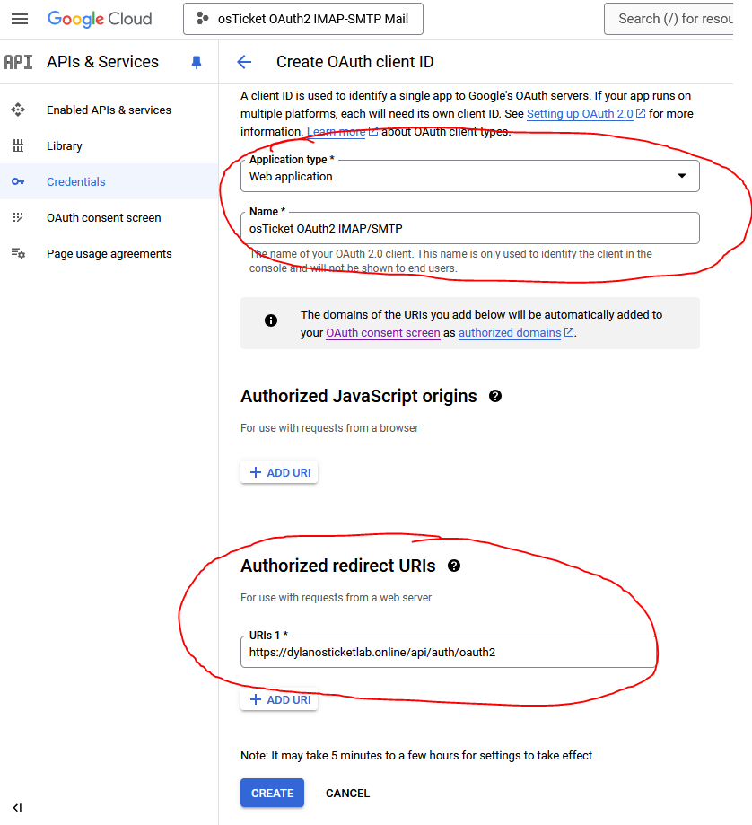

* Once OAuth2 Client is created, copy the generated Client ID and Client Secret as these value strings will be needed to copy/configure in OAuth2 in the osTicket web application.

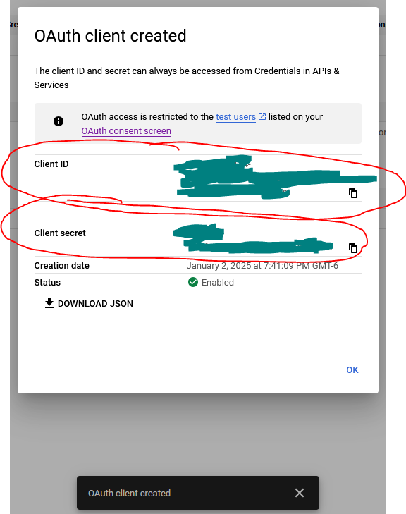

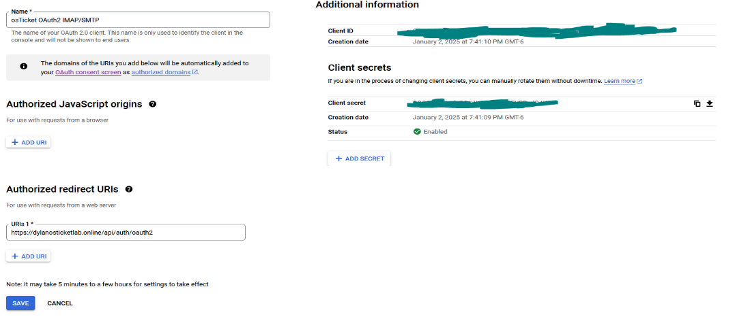

* Add Gmail account *dylanticketlab@gmail.com* in osTicket Admin Panel and configure it to be default system email

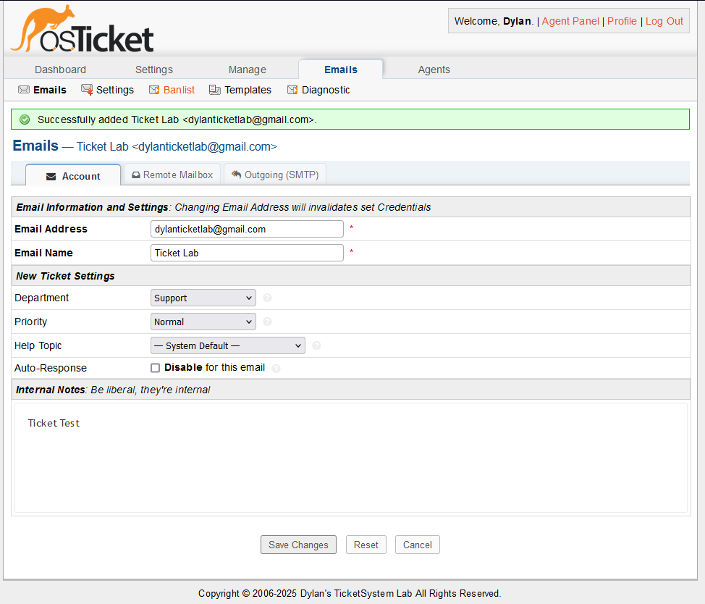

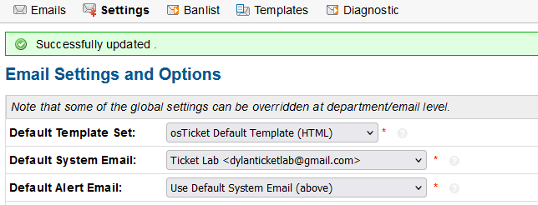

* Click on [dylanticketlab@gmail.com](mailto:dylanticketlab@gmail.com) email address and configure the Account, Remote Mailbox (IMAP), and Outgoing (SMTP)

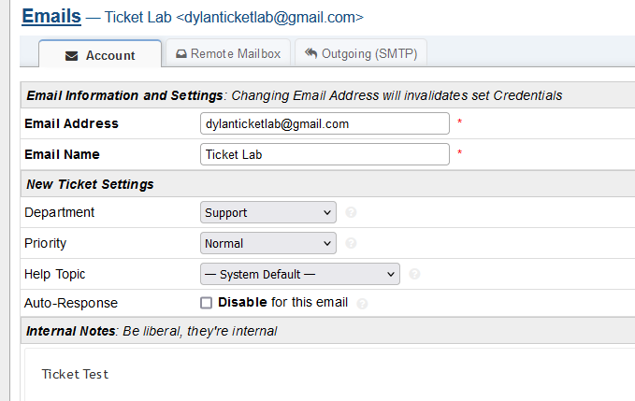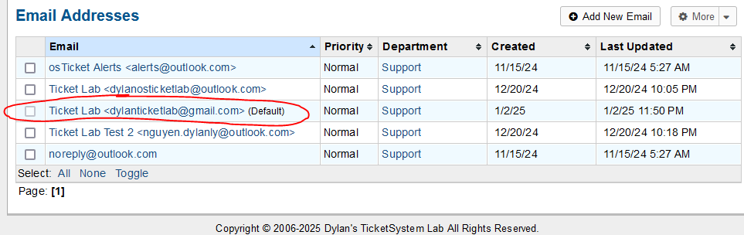

* 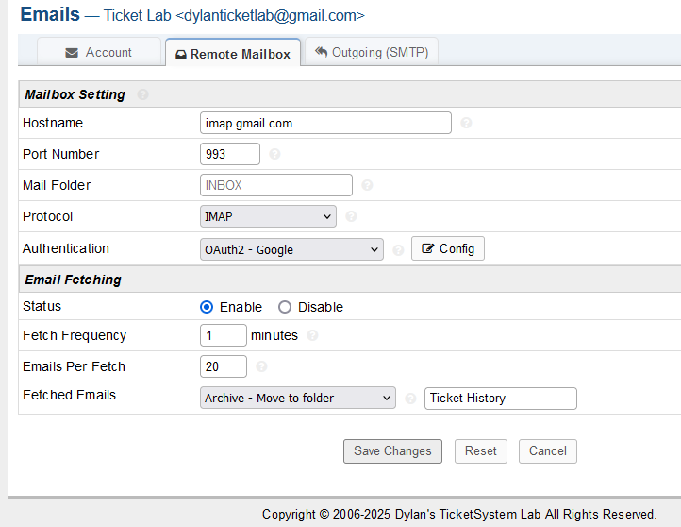Hostnames: IMAP – imap.gmail.com:993 / SMTP – smtp.gmail.com:587

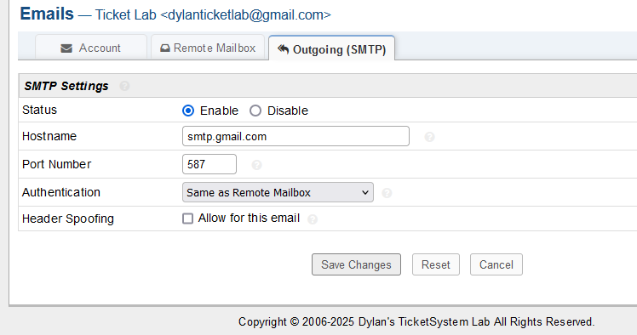

* Configure Authentication for OAuth2 – Google and allow access for dylanosticketlab.online to access data to my Gmail dylanticketlab@gmail.com

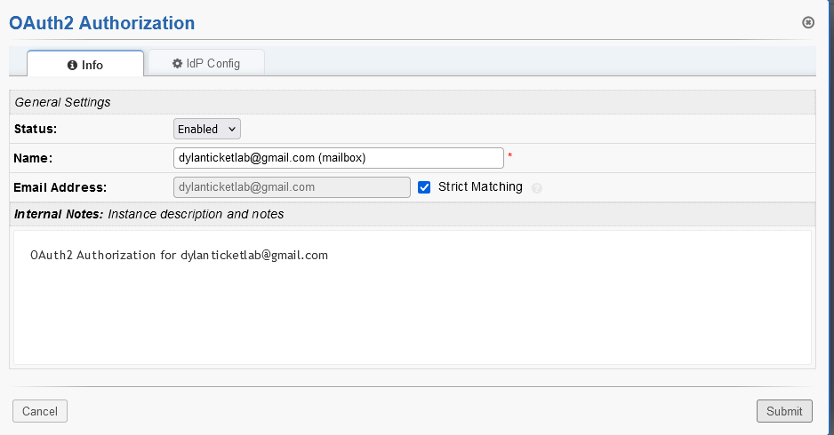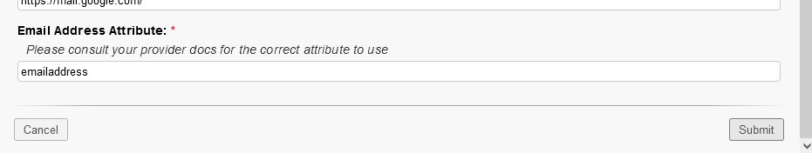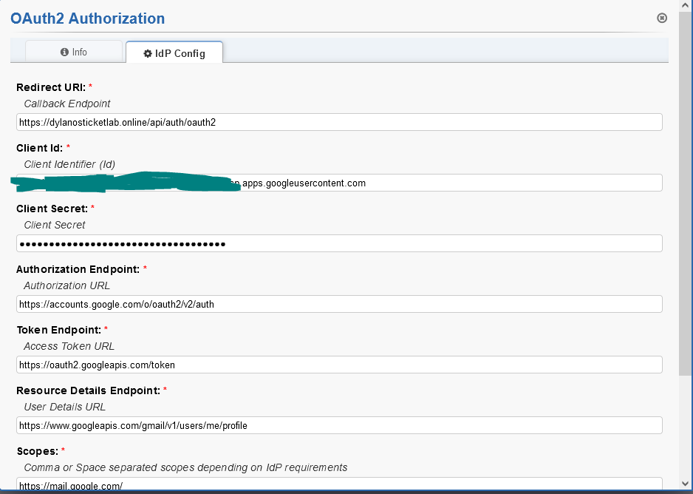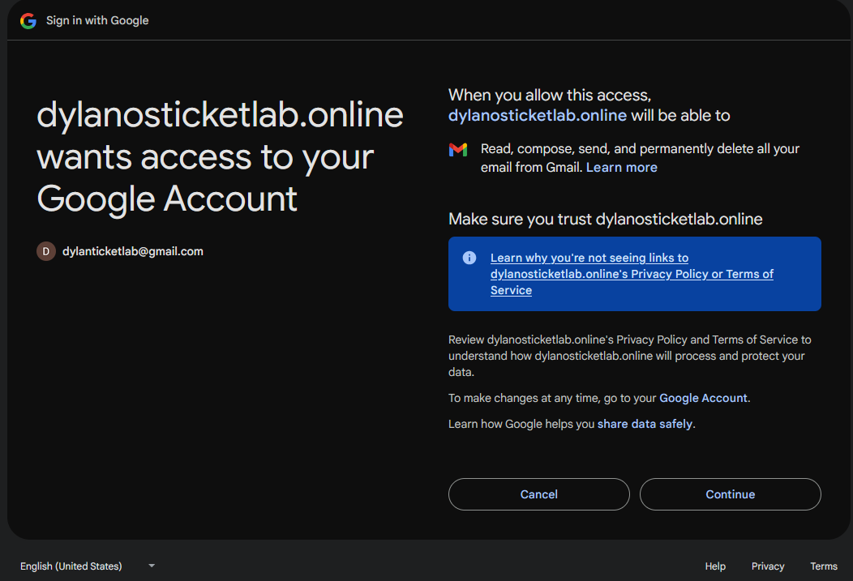

* Submit OAuth2 configuration changes and save changes. It works! The error was likely that Outlook had more compatability issues with osTicket and Microsoft overall stricter security measures on smaller applicaions like osTicket. OAuth2 with Gmail was sucessful as it seems oftern easier and more reliable for small-scale setups like osTicket labs because of Google’s simplified API and broad compatibility.

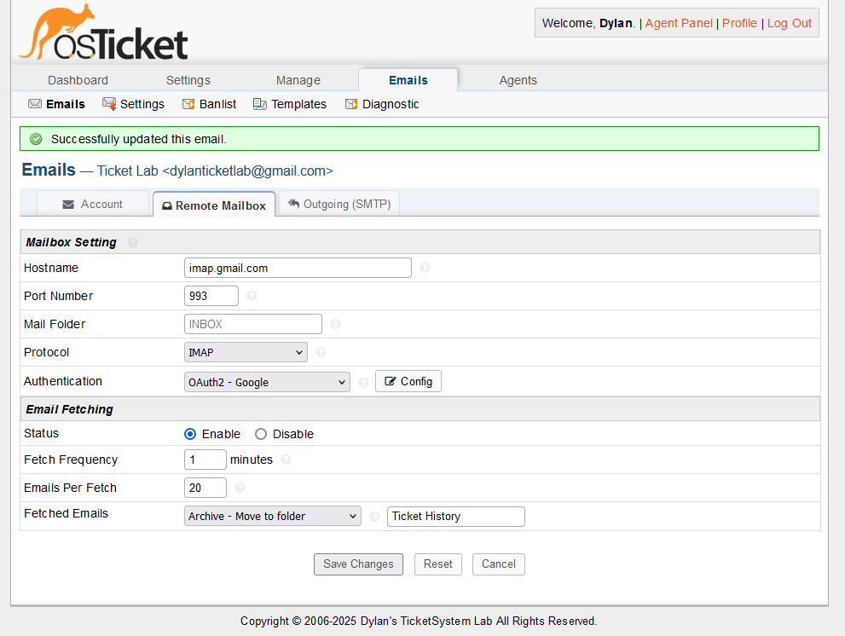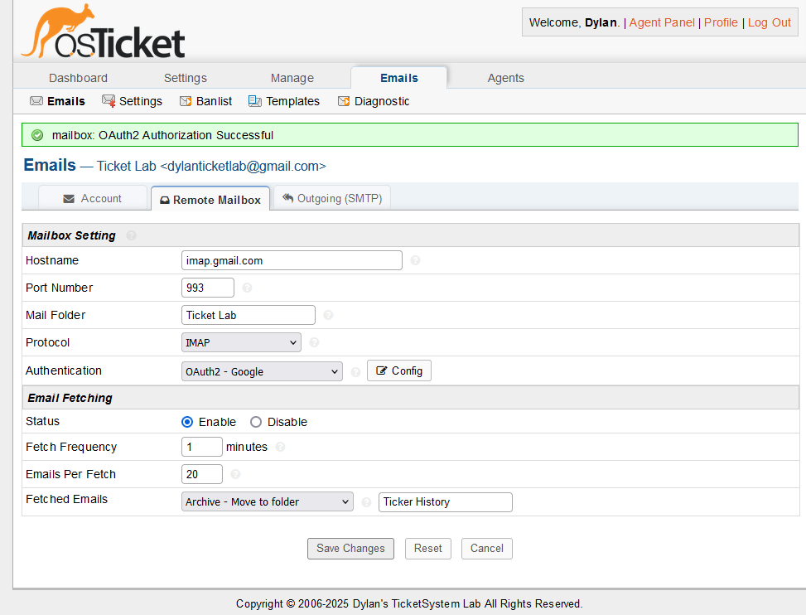

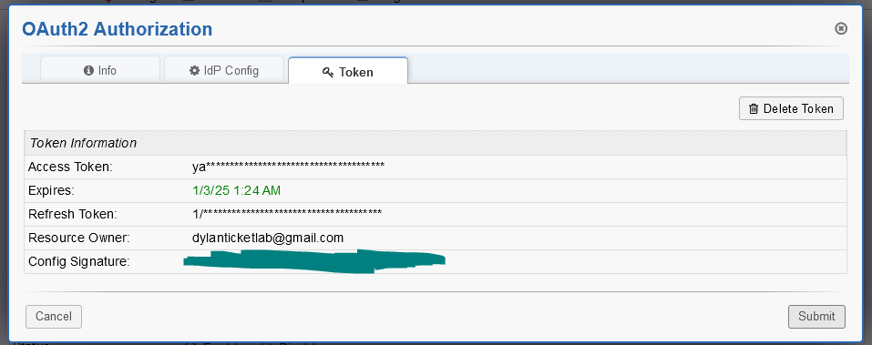

* Now that OAuth2 for IMAP/SMTP is implemented. I will create test users to test OAuth2 staff sign in. (I know that it would have made more sense to test OAuth2 staff sign right after I implemented that part instead of testing after I implmented OAuth2 on IMAP/SMTP.)
* Create Test Users in Microsoft Azure > Microsoft Entra ID > Users > + New user > Create new user

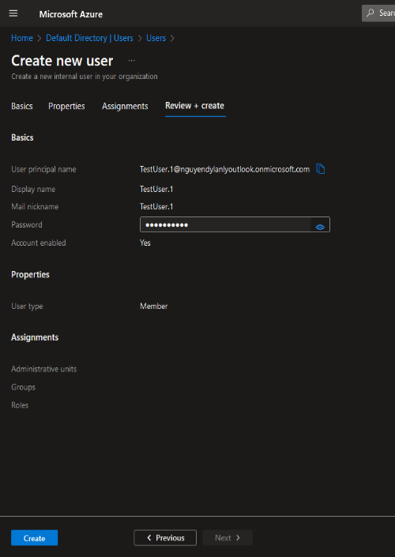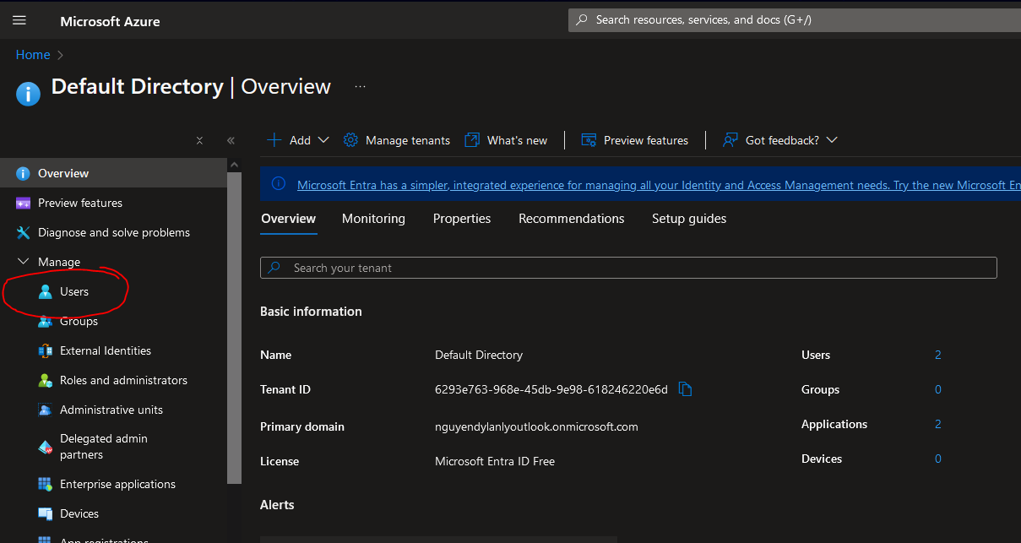

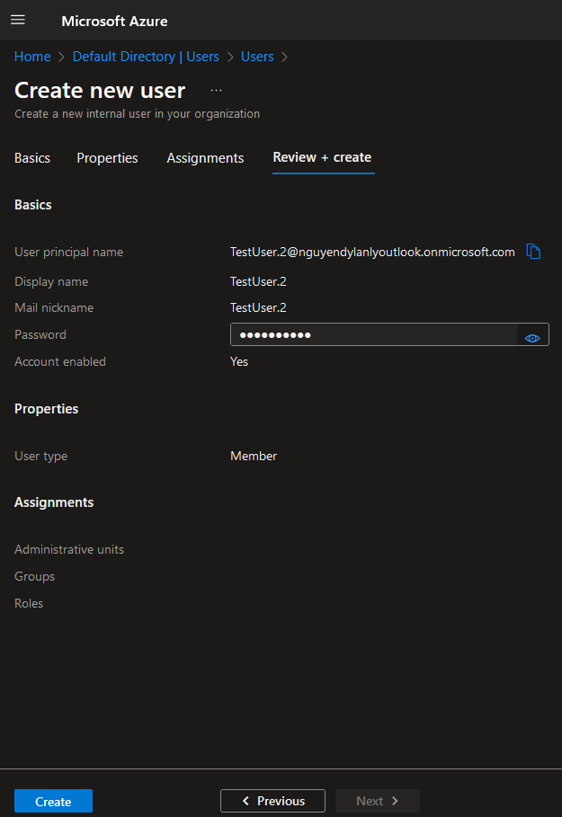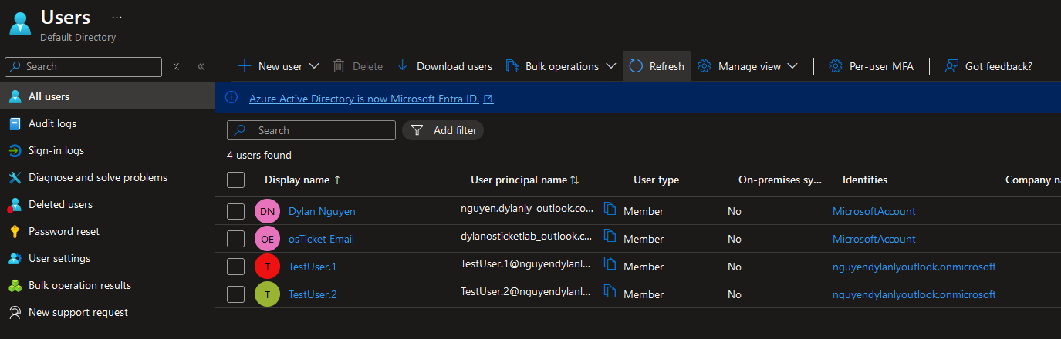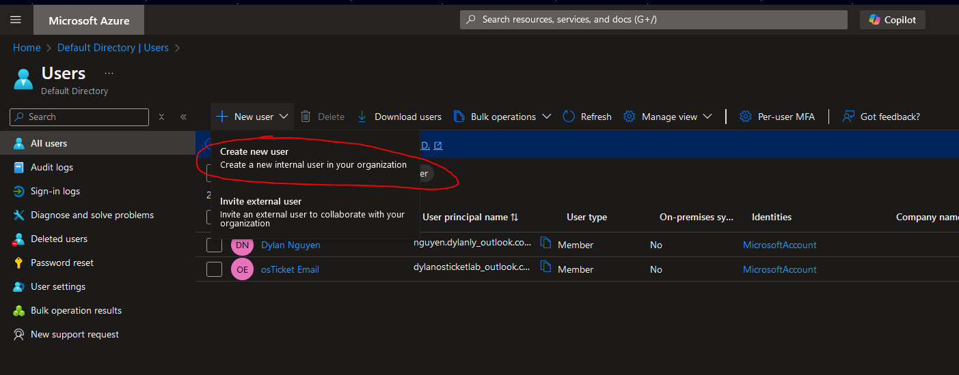

* 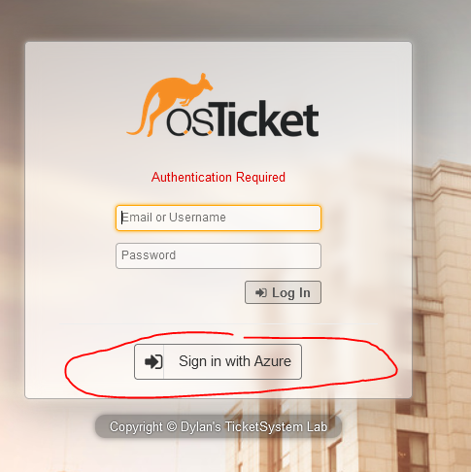Test OAuth2 Azure sign in on <https://dylanosticketlab.online/scp>. Error occurs where I press the “Sign in with Azure” directs me to <https://dylanosticketlab.online> end user page, will start to troubleshoot.

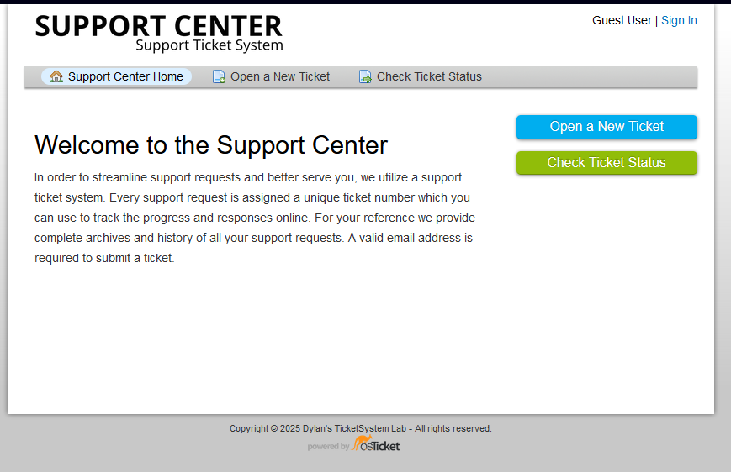

* After looking around, I believe the issue stems from misconfigurations in my osTicket OAuth2 plugin and Azure AD App Regisration/Authentication. I updated redirect URI on both Azure AD App Registration/Authentication and osTicket OAuth2 plugin.
* <https://dylanosticketlab.online/api/auth/oauth2> 🡪 <https://dylanosticketlab.online/osticket/upload/scp/auth/oauth2> (also change Authentication Target from Agents and End Users to Agents Only in osTicket)

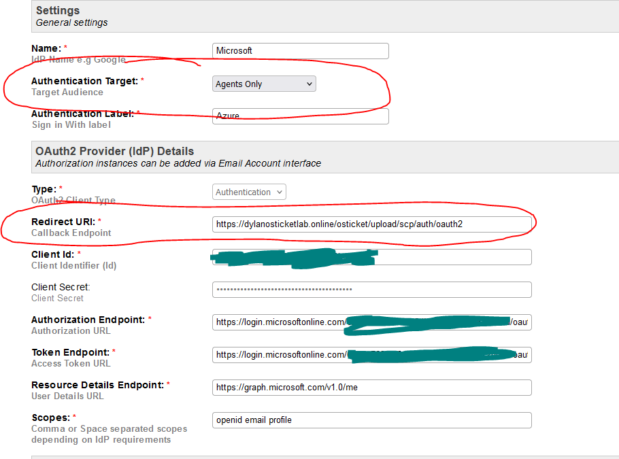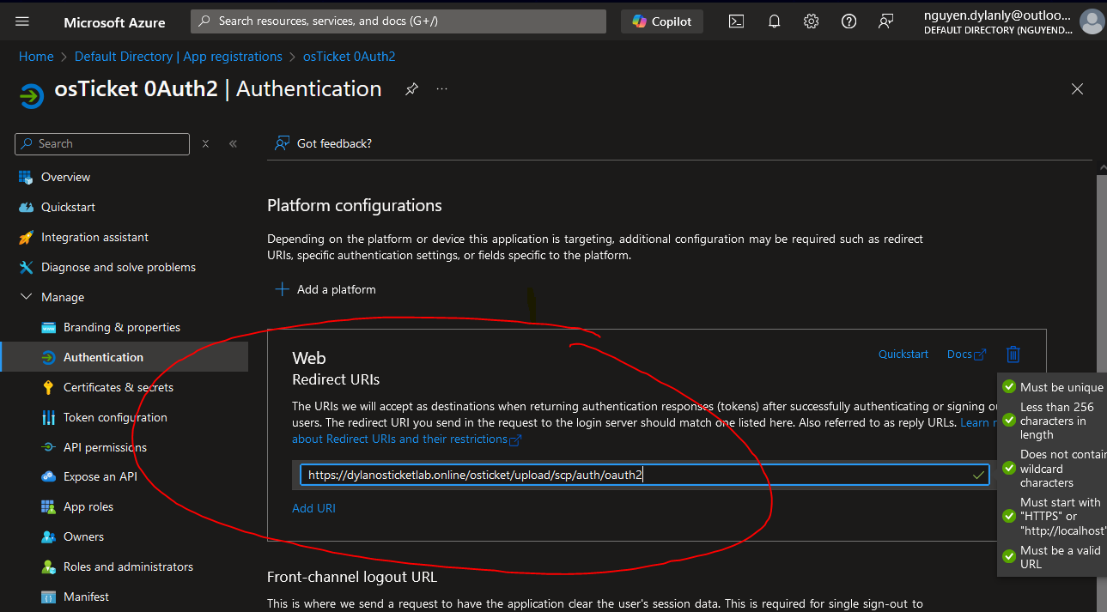

* 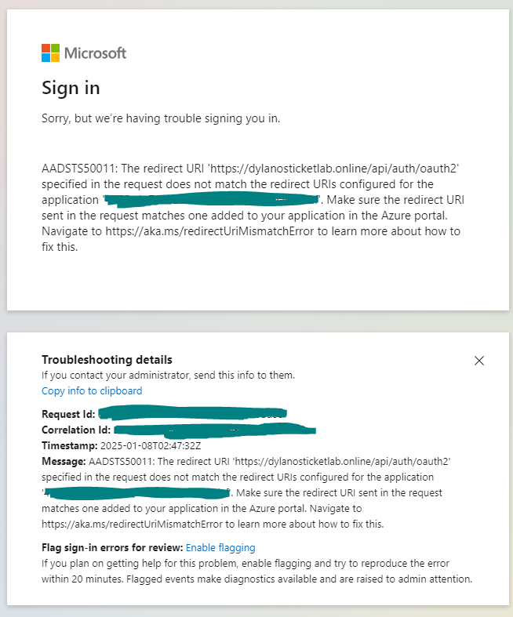Test Azure OAuth2 sign in. An error occurred so I will start to troubleshoot by checking Apache logs.

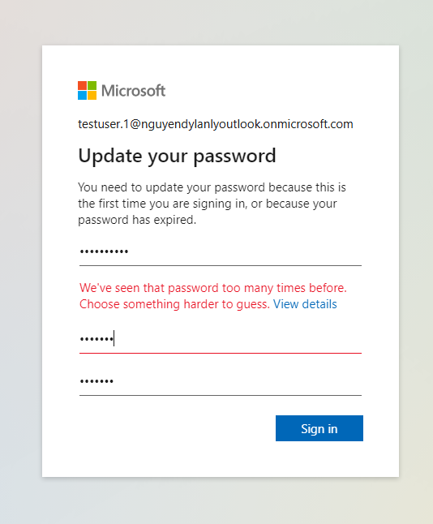

* 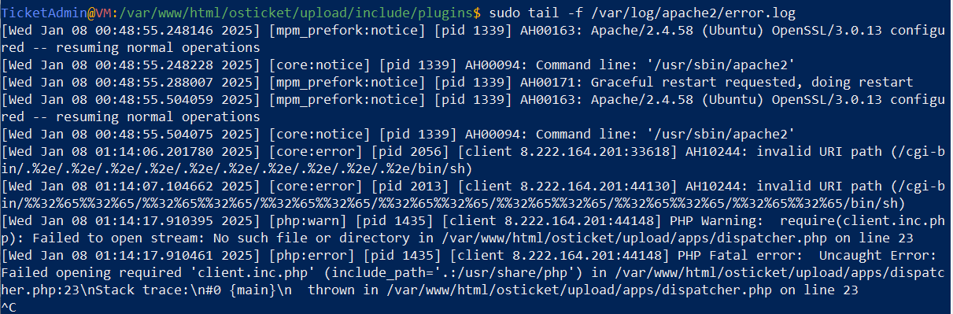sudo tail -f /var/log/apache2/error.log
* PHP Warning: require(client.inc.php): Failed to open stream and PHP Fatal Error: Uncaught Error: Failed opening required ‘client.inc.php’ shows that the *client.inc.php* file is not found in *dispatcher.php* and will not be able to execute the script causing a fatal error in Apache logs.
* The osTicket system relies on client.inc.php for client-related operations. The dispatcher.php file is a critical part of handling client requests (e.g., for authentication, including OAuth2 callbacks). If client.inc.php cannot be loaded, all dependent functionalities will fail, including OAuth2 authentication.
* Confirm the *client.inc.php* file is in my directory
* sudo find /var/www/html -name "client.inc.php"



* client.inc.php file exists in my system but the location is in the wrong path/location where dispatcher.php is having trouble includng it. I will run sudo nano on dispatcher.php to configure and update the correct path/location to client.inc.php
* sudo nano /var/www/html/osticket/upload/apps/dispatcher.php



* update require(‘client.inc.php’); to correct path/location 🡪 require('../client.inc.php');

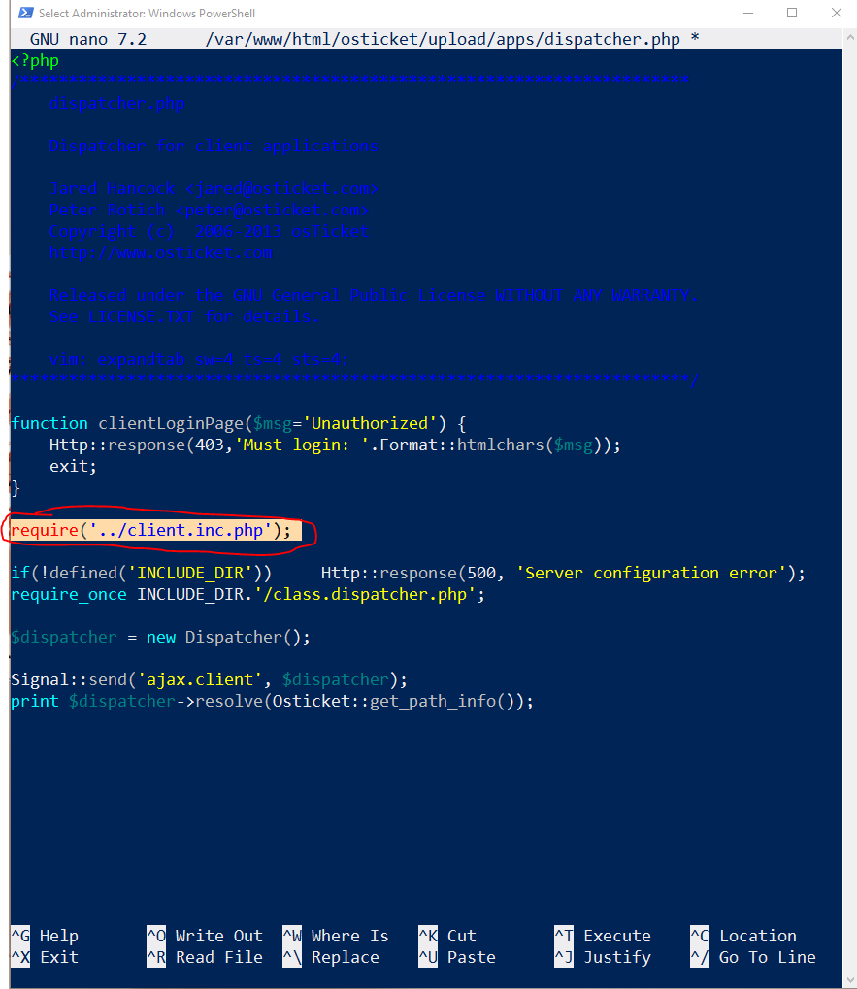

- sudo systemctl restart apache2

- Test with *curl -I* [*https://dylanosticketlab.online/osticket/upload/scp/auth/oauth*2](https://dylanosticketlab.online/osticket/upload/scp/auth/oauth2)

* Errors 404 still occurs, I will enable PHP log_errors to further see.

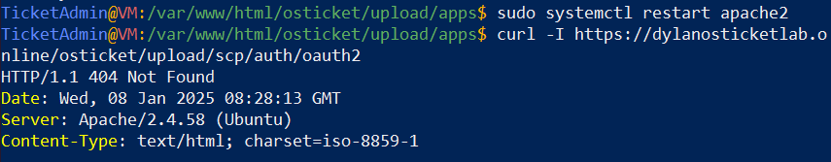

* sudo nano /etc/php/8.3/apache2/php.ini
* Change log_erros Default Value from Off 🡪 On
* sudo tail -f /var/log/php_errors.log

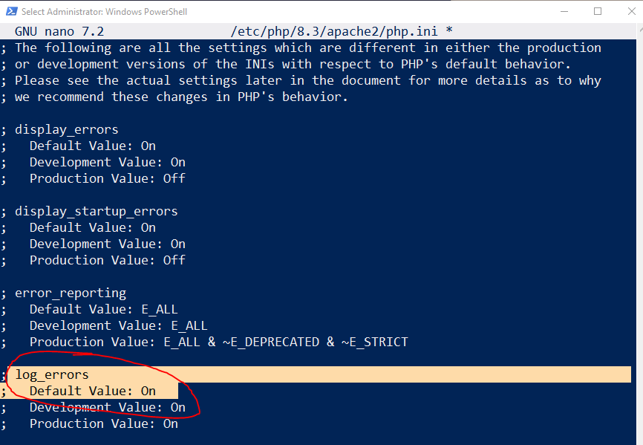

* Couldn’t find php_error.logs but may have a new fix I am going to try.
* Navigate to *php.ini* file to configure/update “include_path” setting. The include_path determines where PHP looks for files included via require or include statements. By default, it is limited to the current directory (.) and the system-wide PHP library path (/usr/share/php). Updating the include_path ensures PHP can locate additional files, such as client.inc.php in my osTicket setup.
* sudo nano /etc/php/8.3/apache2/php.ini 
* Update include_path line to include my osTicket directory from include_path = ".:/usr/share/php" to include_path = ".:/usr/share/php:/var/www/html/osticket/upload"

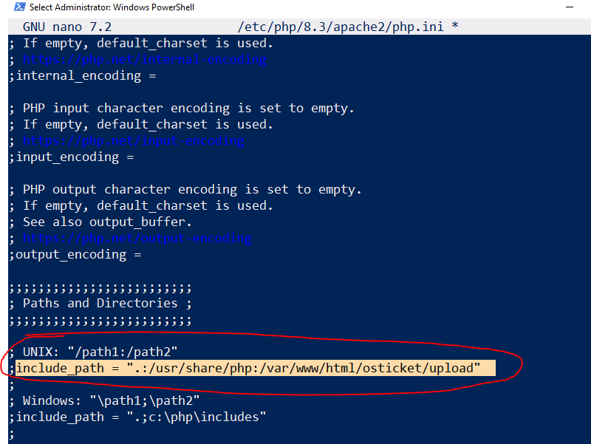

* After researching and troubleshooting the OAuth2 authentication for staff sign-ins in your osTicket lab, it seems the issues are likely due to routing or plugin registration errors. Despite setting up Apache, .htaccess, and the OAuth2 plugin correctly, the /scp/auth/oauth2 endpoint isn't resolving as expected. This could be caused by the auth-oauth2.phar plugin failing to register routes properly, incorrect PHP include_path settings or missing dependencies, or even routing errors within dispatcher.php. Solving these issues would require a deep dive into the plugin code and osTicket’s internal routing logic, which may not align with the goals of your lab at this time. I observed these errors while reviewing Apache error logs and testing the endpoint via curl commands.
* So the goal with OAuth2 Azure Staff sign in was to implement MFA (Multi-Factor Authentication) and password management policy in the Azure Microsoft Entra ID setup. However, due to errors that beyond my scope of technical skills I will opt for “Two Factor Authenticator (MFA)” and “Password Management Policies” plugins I had installed during the initial installtion of osTicket.

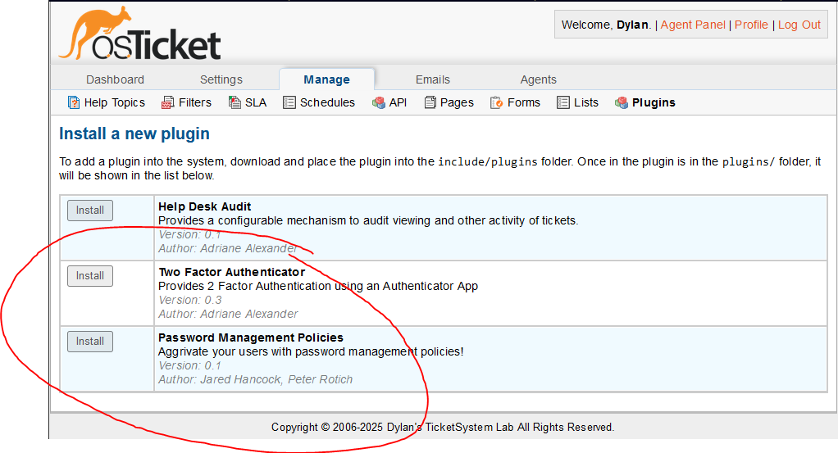

* Install Two Factor Authenticator > Status = Active > Save Changes

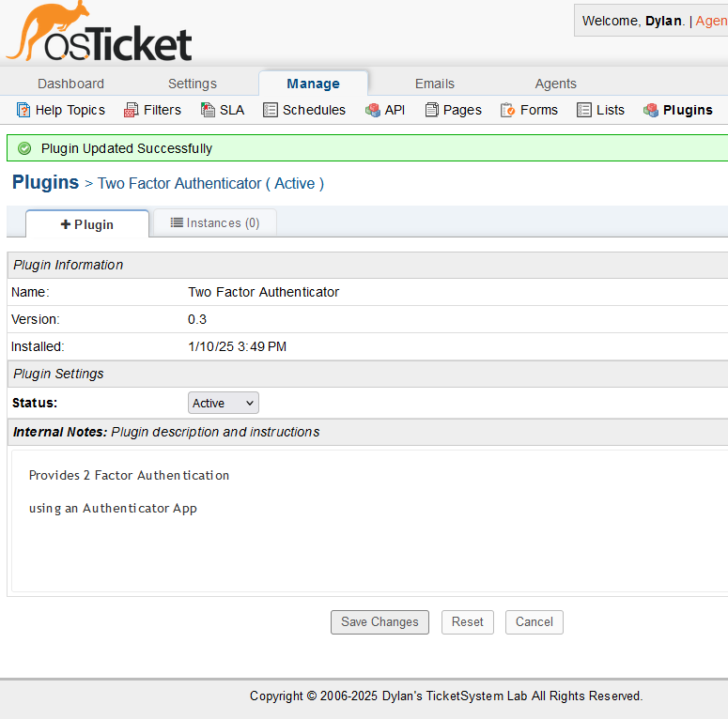

* Instances > Add New Instance > Name = “2FA for Staff” > Status = “Enabled” > Config Tab > Issuer = Dylan TicketLab > Save Changes & Add Instance

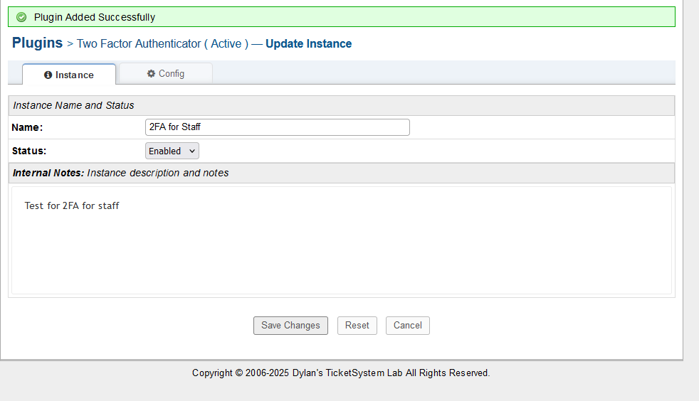

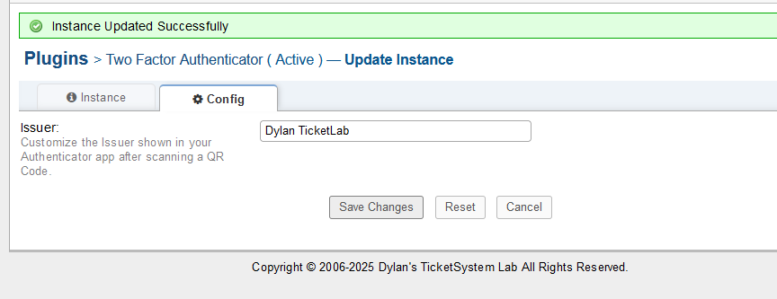

* Since OAuth2 Azure staff sign (Users) was not functioning, I will create users/agents via osTicket and enable 2FA (MFA) directly on the osTicket web app.
* Admin Panel > Agents > Add New Agent

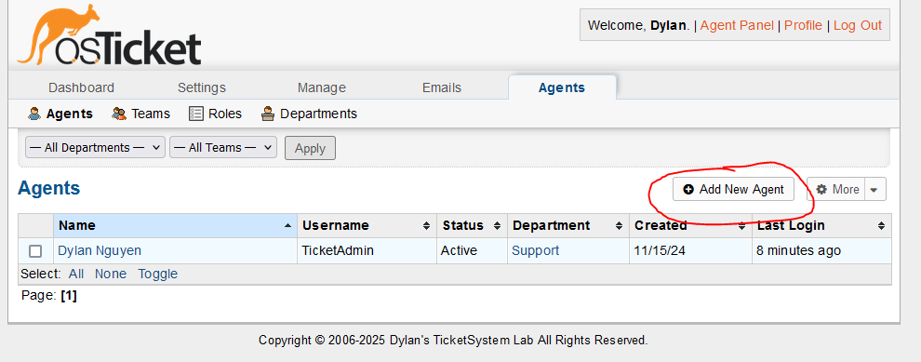

* Fill in required details > Set Allowed Access to Departments > Grant Permissions to given role > Assign Agent a Team > Create Agent

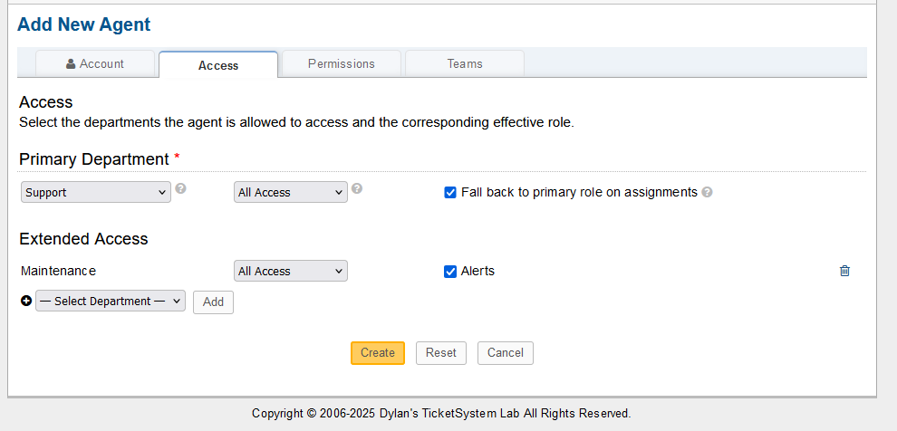

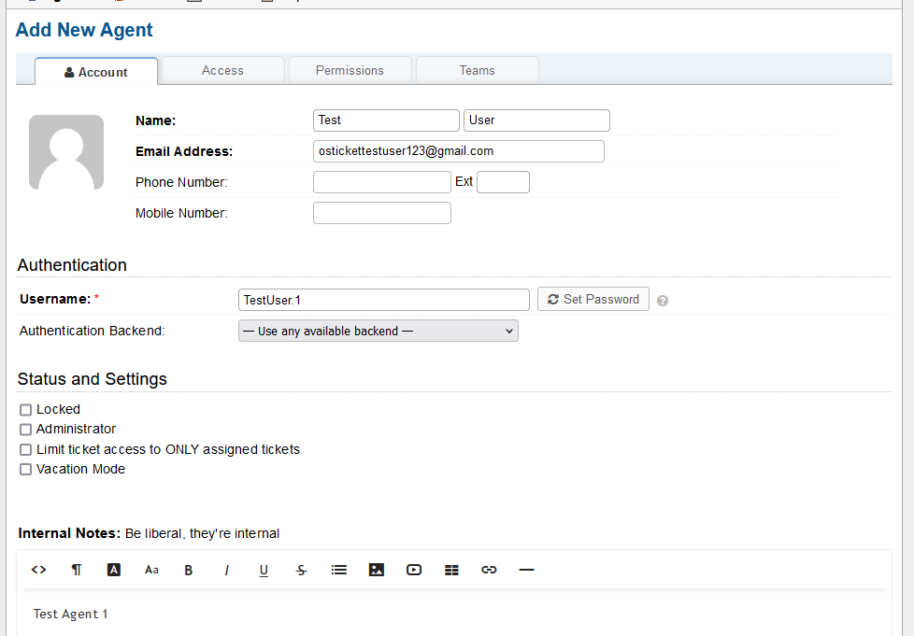

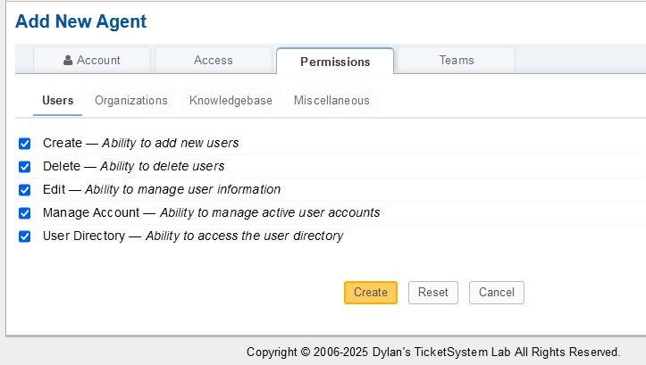

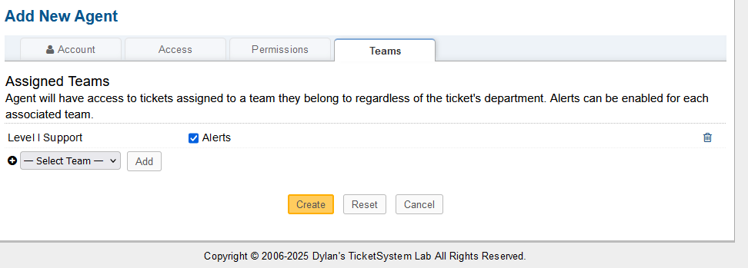

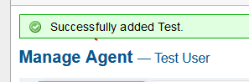

* Implement Password Policy plugin in osTicket
* Admin Panel > Manage > Plugins > +Add New Plugin > Install Password Management Policies

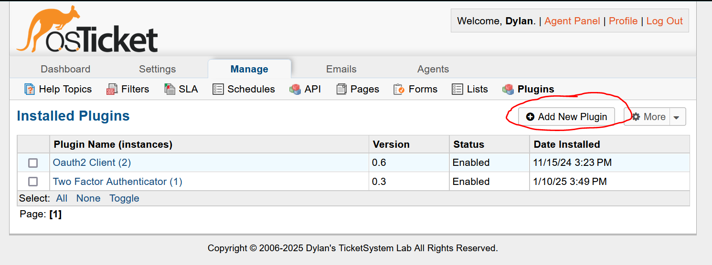



* Plugins > Password Management Policies > Status = Active > Instances Tab > + Add New Instance > Set Name > Status = Enabled

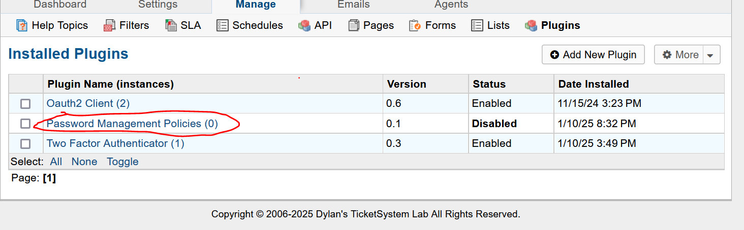

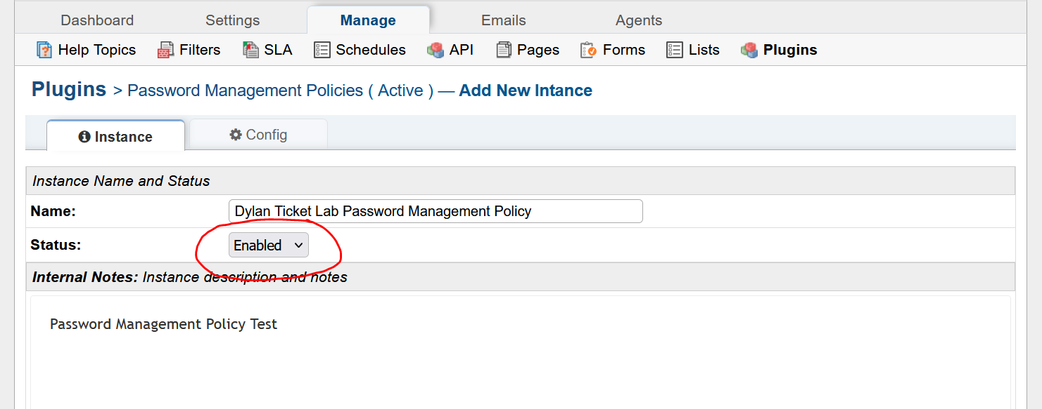

* Configure Tab > Configure Password Requirment Settings > Minimum Length = 8, Maximum Length = 40, Character Class Required = 3, Password Strength = Strong (80 bits), Enforce on login = Enabled, Password Reuse = Disabled, Password Expiration = 90 days > Add Instance

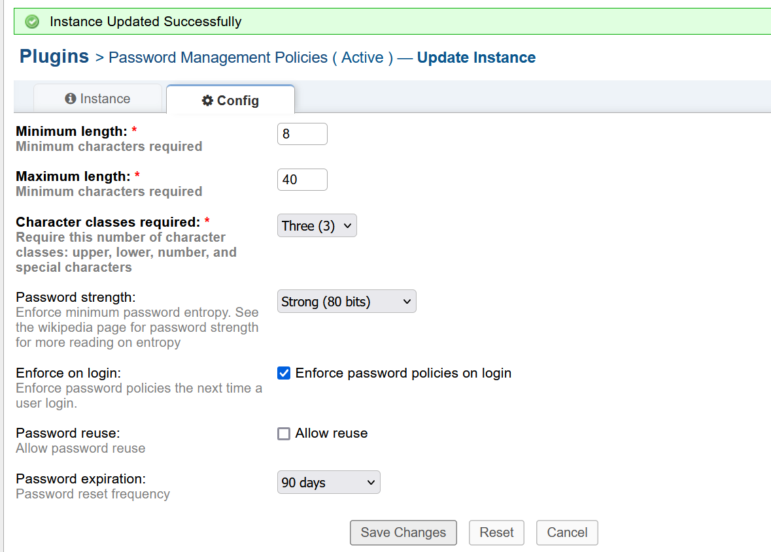

* Logout of osTicket and test Password Management Policy

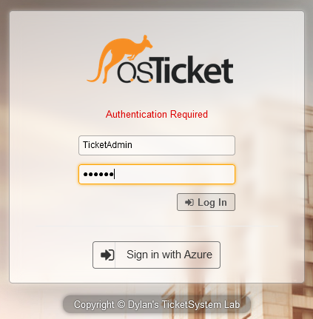

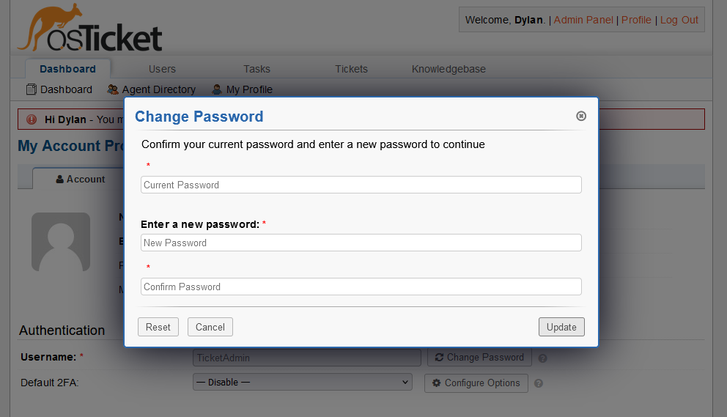

* Change old password to meet password policy requirement

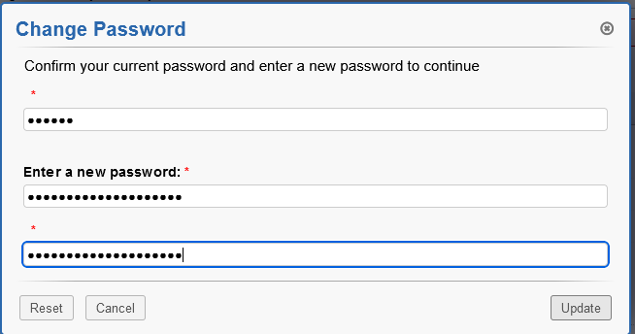

* Change password again incorrectly to see password requiement errors

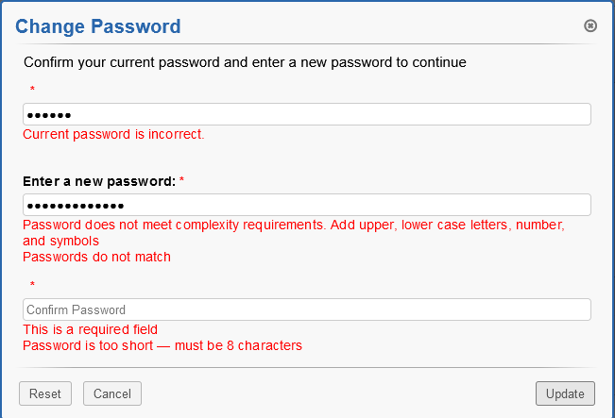

* Password Management Policy Implementation is successful!
* I will now enforce a policy to require agents/staff to turn on Multifactor Authentication (2FA) onto their accounts.
* Admin Panel > Settings > Agents > Configure Authentication Settings to enforce my Password Management Policy and enable Multifactor Authentication for Agents > Save Changes

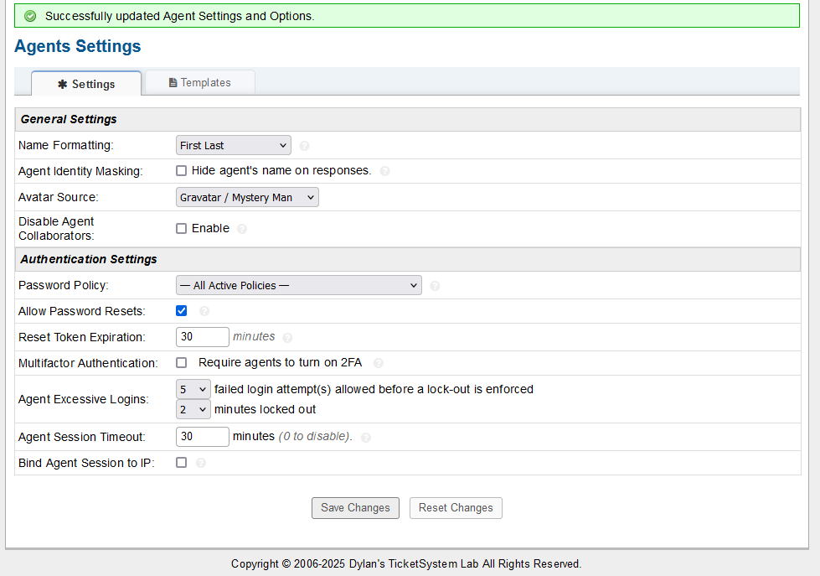

* As soon as I applied the MFA (2FA) changes, osTicket required me to configure and save Two Factor Authentication.

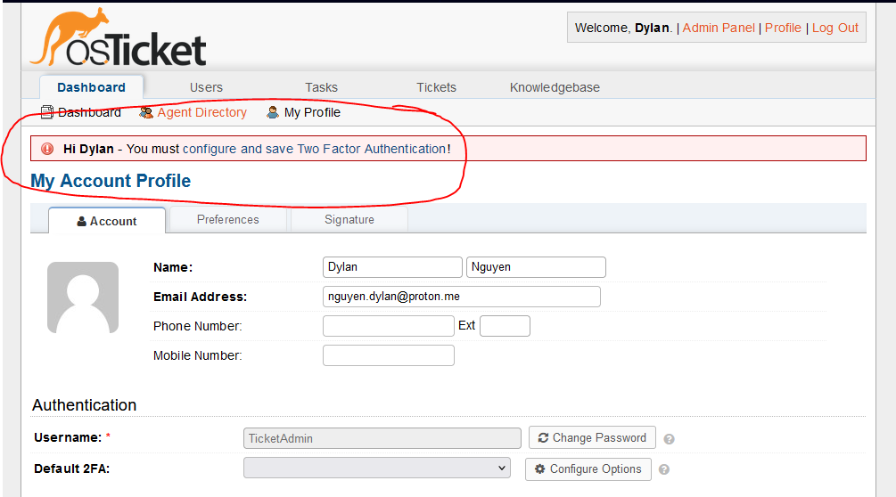

* On the Email option of “Manage 2FA Options”, email verifcaiton codes were not being sent and I could not navigate through the osTicket web app due to 2FA policy. I will attempt to trouble shoot through trying to get access back with the Authenticator 2FA option.

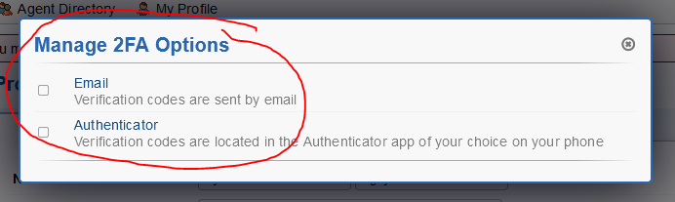

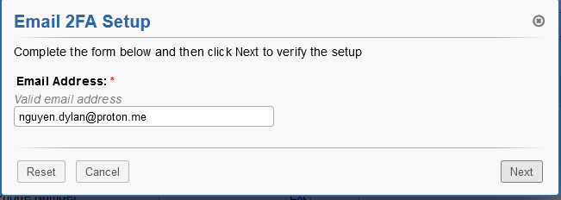

* (No verification email code received)
* Click Authenticator on Manage 2FA Options
* Scan QR Code of Authenticator application (Microsoft or Google Authenicator) of your choice and enter the six number code from Auhtenticator application

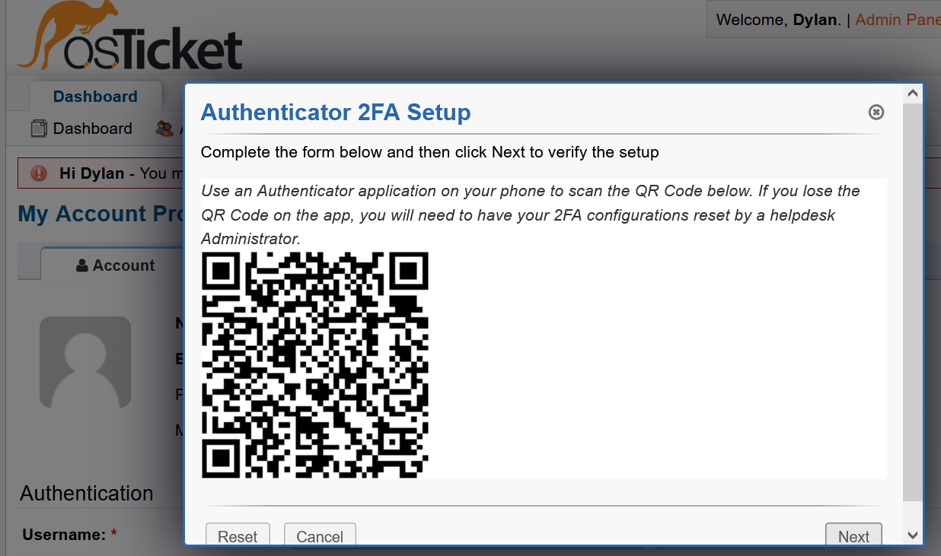

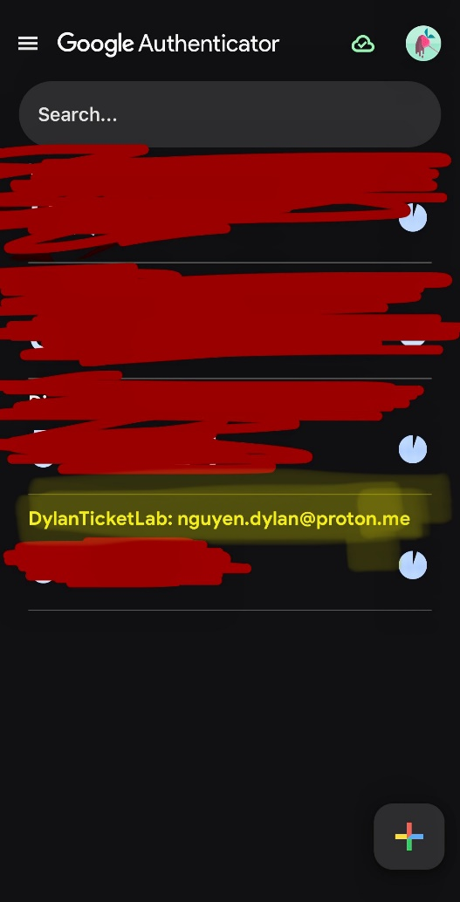

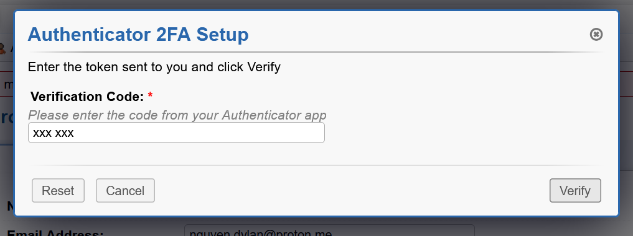

* Authenicator app 2FA is successful!

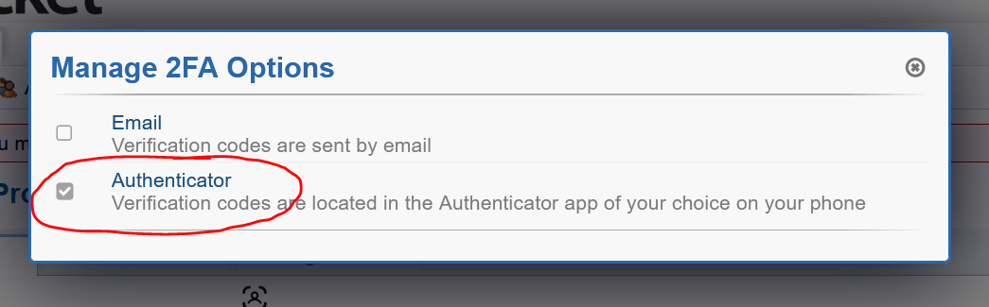

* Save changes in osTicket account profile

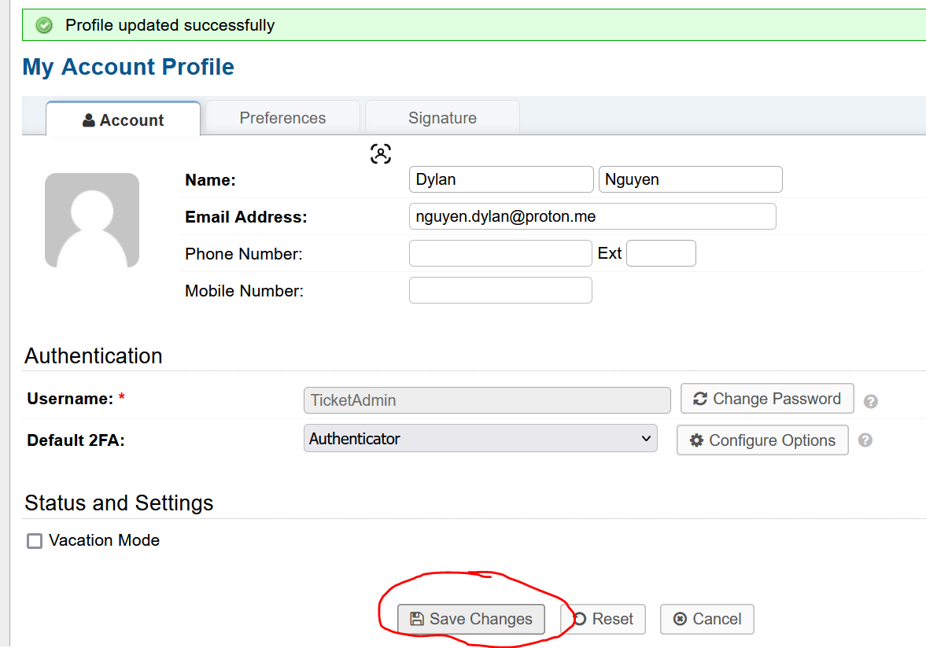

* Logout and see if 2FA (MFA) changes are applied on staff/agent login

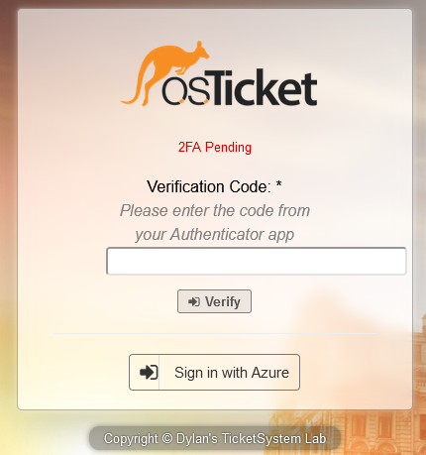

* Implementation of 2FA (MFA) with Authenticator app is successful!
* Now to test receieving tickets. I had my brother sent a test ticket at my osTicket end user web page <https://dylanosticketlab.online>.

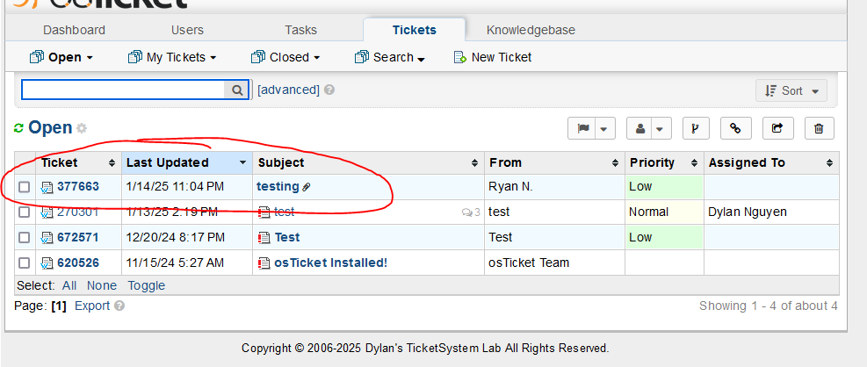

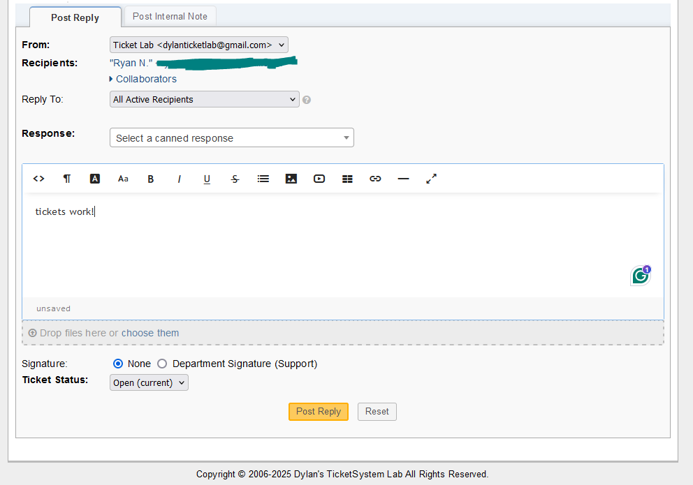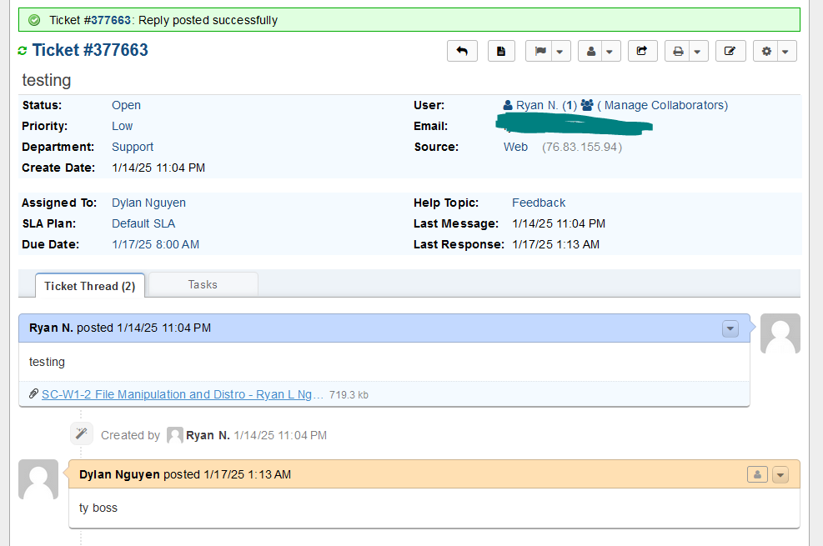

* Retrieving tickets through the osTicket web application works! However, my dedicated ticket lab email [dylanticketlab@gmail.com](mailto:dylanticketlab@gmail.com) is not receiving email via Gmail nor the sender is receiving emails when I respond a message back to the sender on <https://dylanosticketlab.online/scp> agent ticket panel. I will start to troubleshoot by checking Google Cloud Platform OAuth2 IMAP/SMTP configuations to ensure email settings are correct or needs to be changed/updated.
* Check OAuth2 Consent screen in Google Cloud Platform Console > Edit App > Scopes > Add Scopes

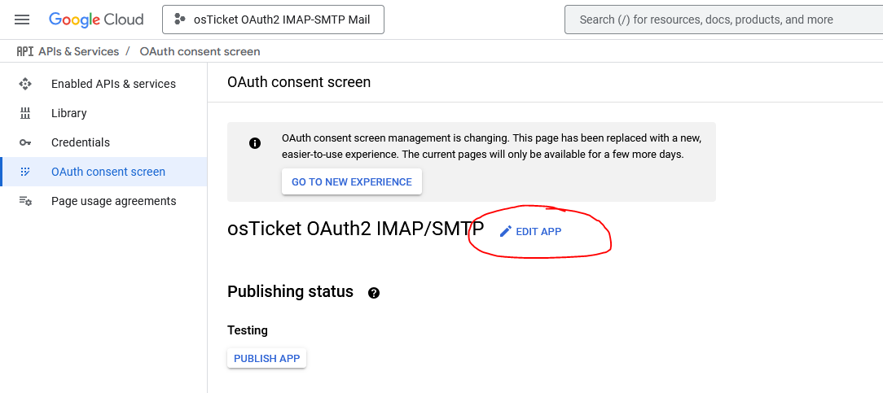

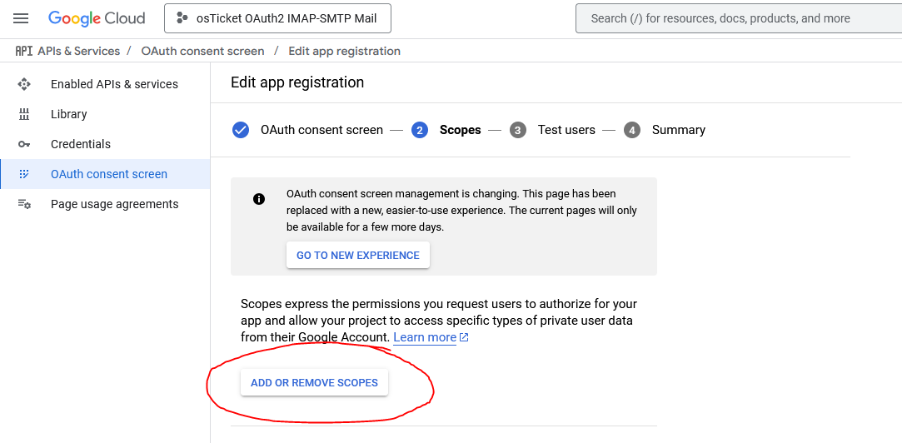

* Select and update scopes <https://www.googleapis.com/auth/userinfo.email> and <https://www.googleapis.com/auth/userinfo.profile>

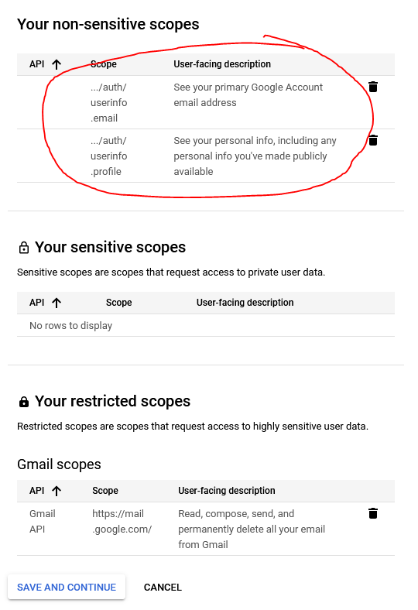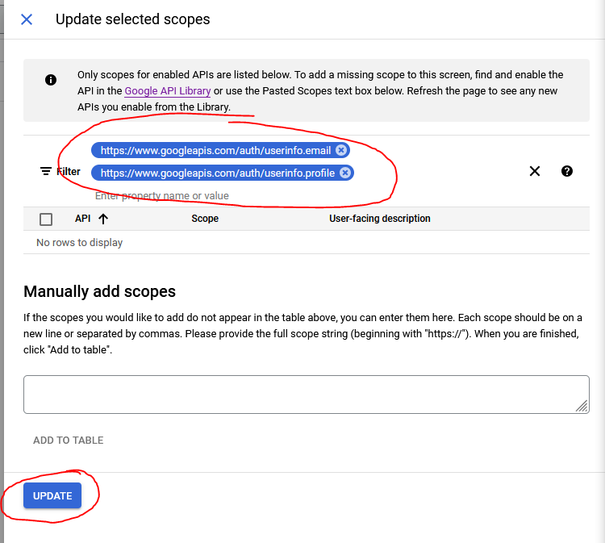

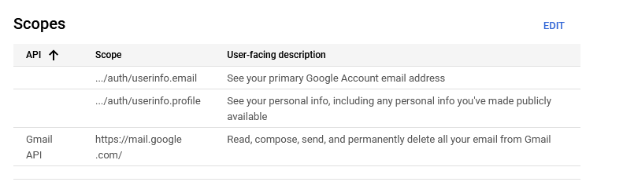

* After updating scopes in Google Cloud Platform, navigate to osTicket to apply scope updates in Admin Panel > Emails > Click default ticket lab email > Remote Mailbox > Authentication Configuration > Update Scopes > Submit > Allow dylanosticketlab.online access to my ticket gmail account

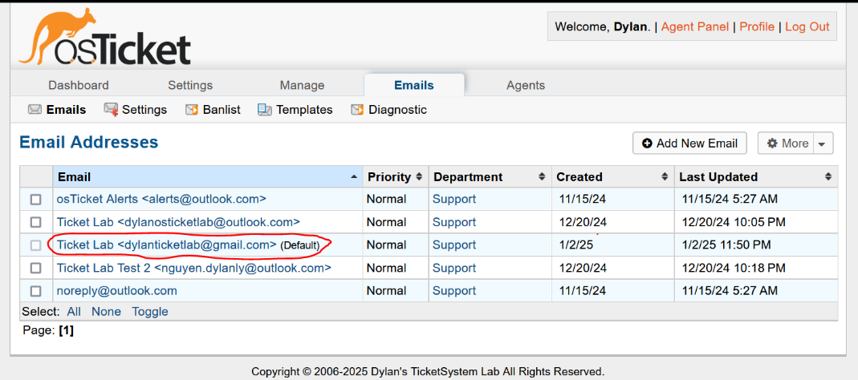

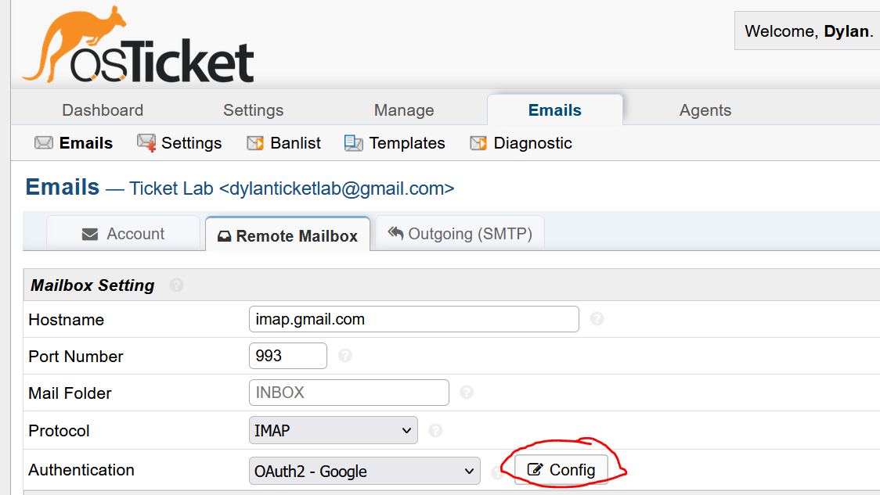

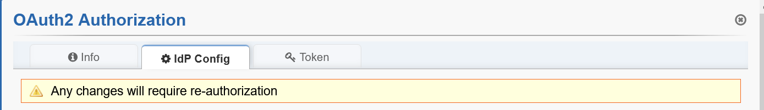

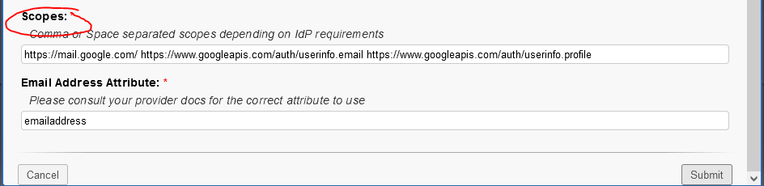

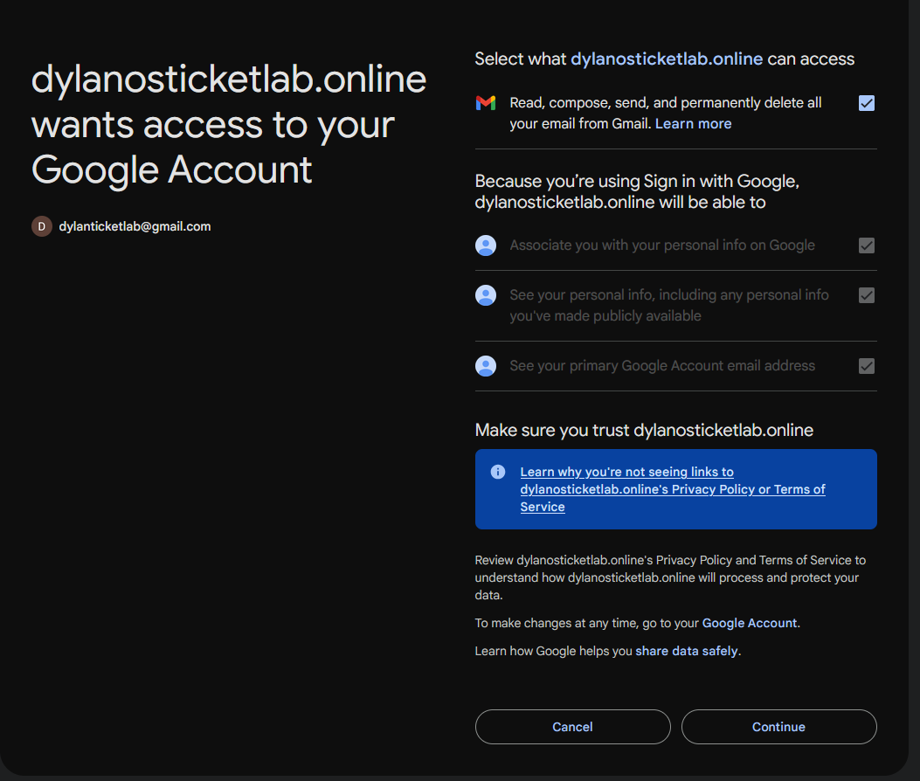

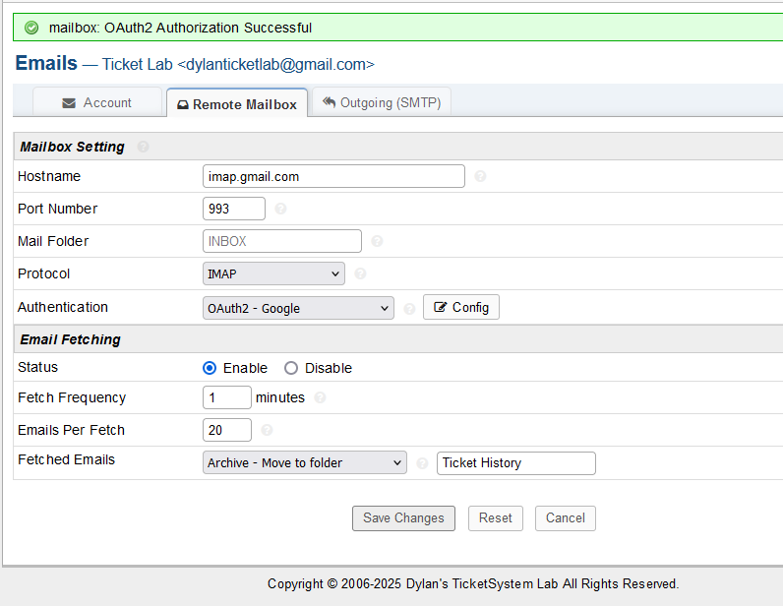

* Enable IMAP in Gmail > Settings > Forwarding and POP/IMAP > Enable IMAP Status > Save Changes

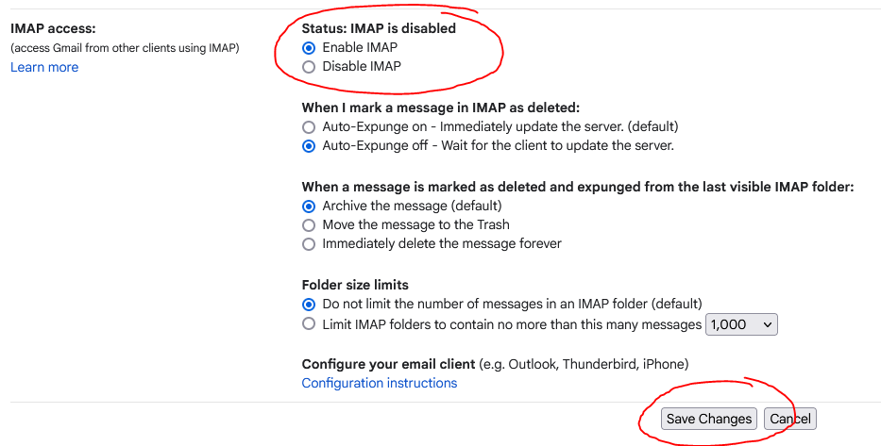

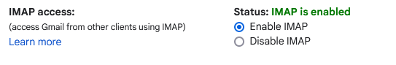

* Send a test email to check if emails are being sent/received via email inbox
* Admin Panel > Emails > Diagnostic > Test Outgoing Email with personal email
* SMTP/IMAP is now succesful! 2FA (MFA) should now be accesbile via email for staff.

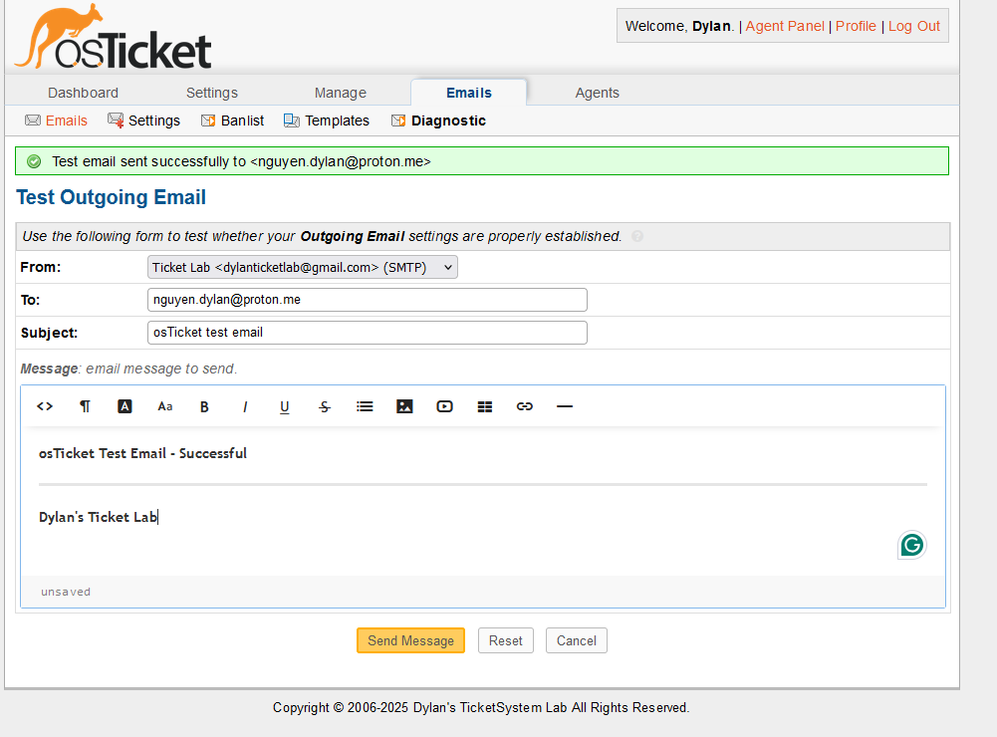

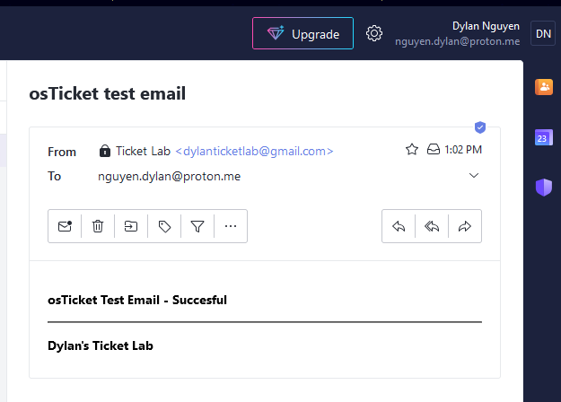

* Create a Standard & Critical SLA for my ticket lab
* Admin Panel > Manage > SLA > Add New SLA Plan > Set up SLA Name > Status: Active > Grace Period > Schedule: 24/7 > Add Plan

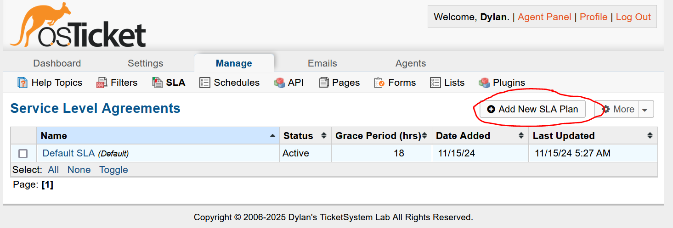

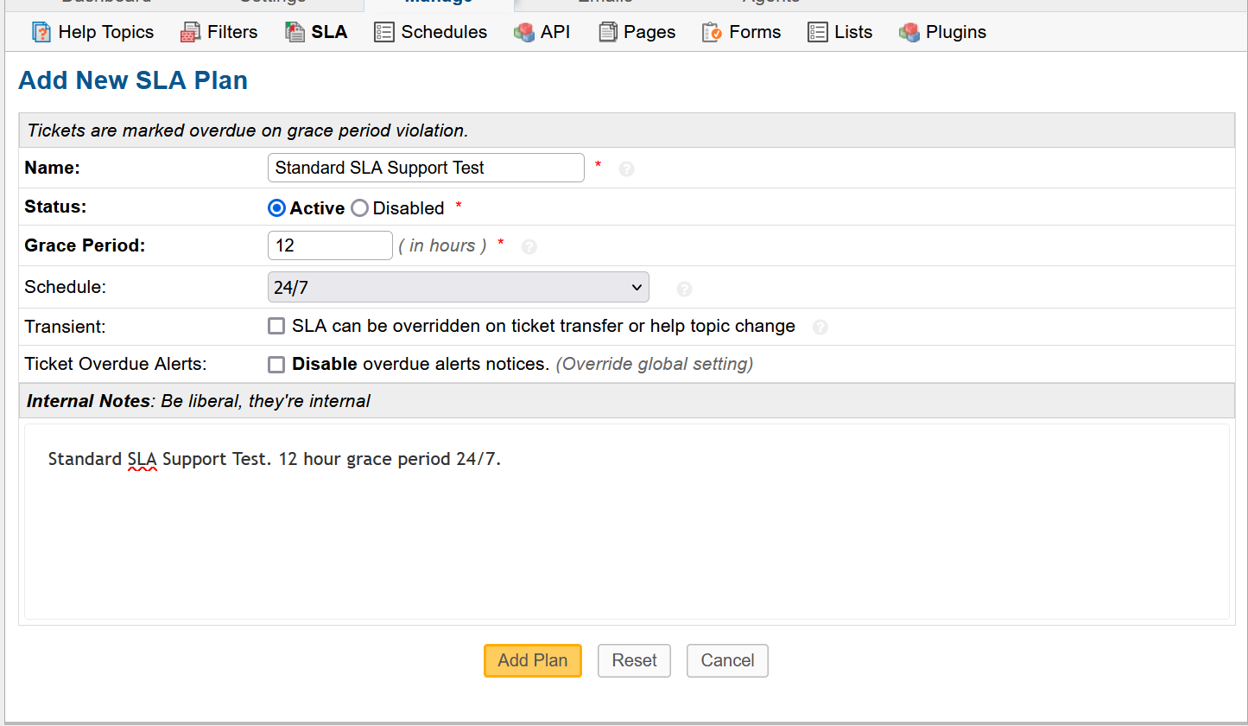

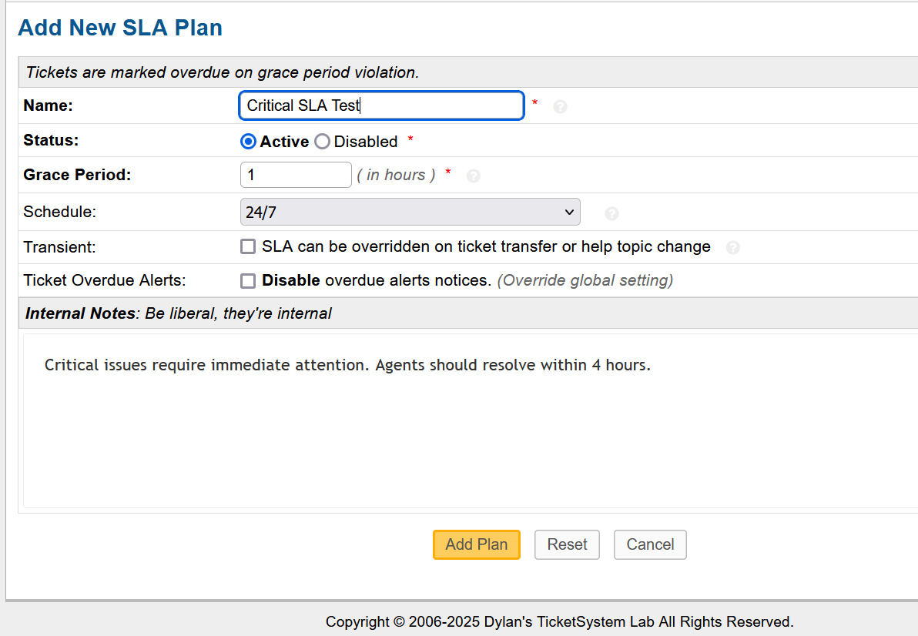

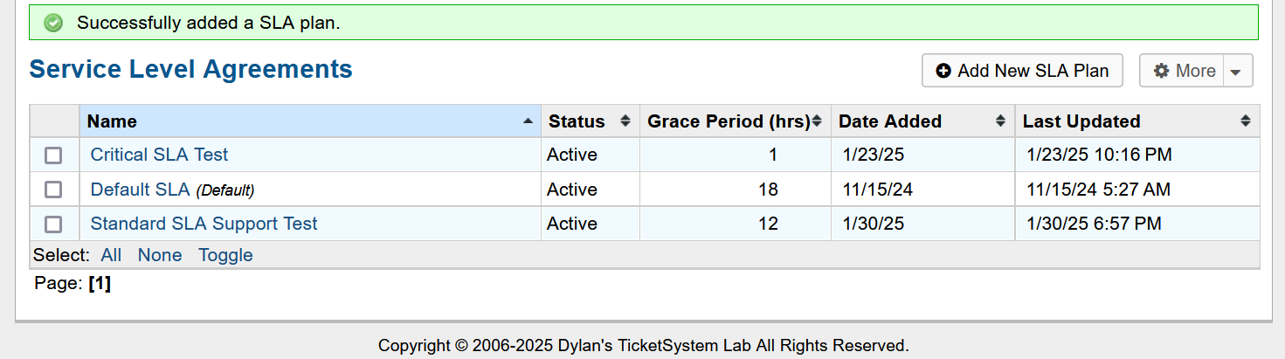

* Create a Level II Support Team
* Admin Panel > Agents > Teams > Add a New Team > Set Name > Status: Active > Create Team

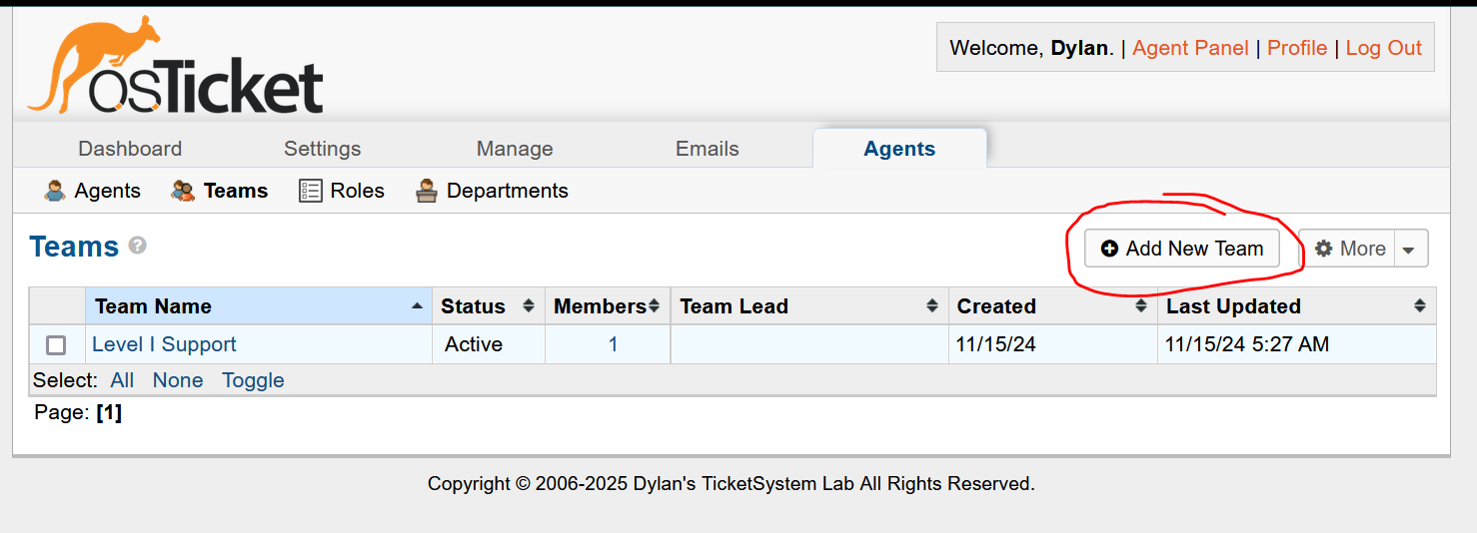

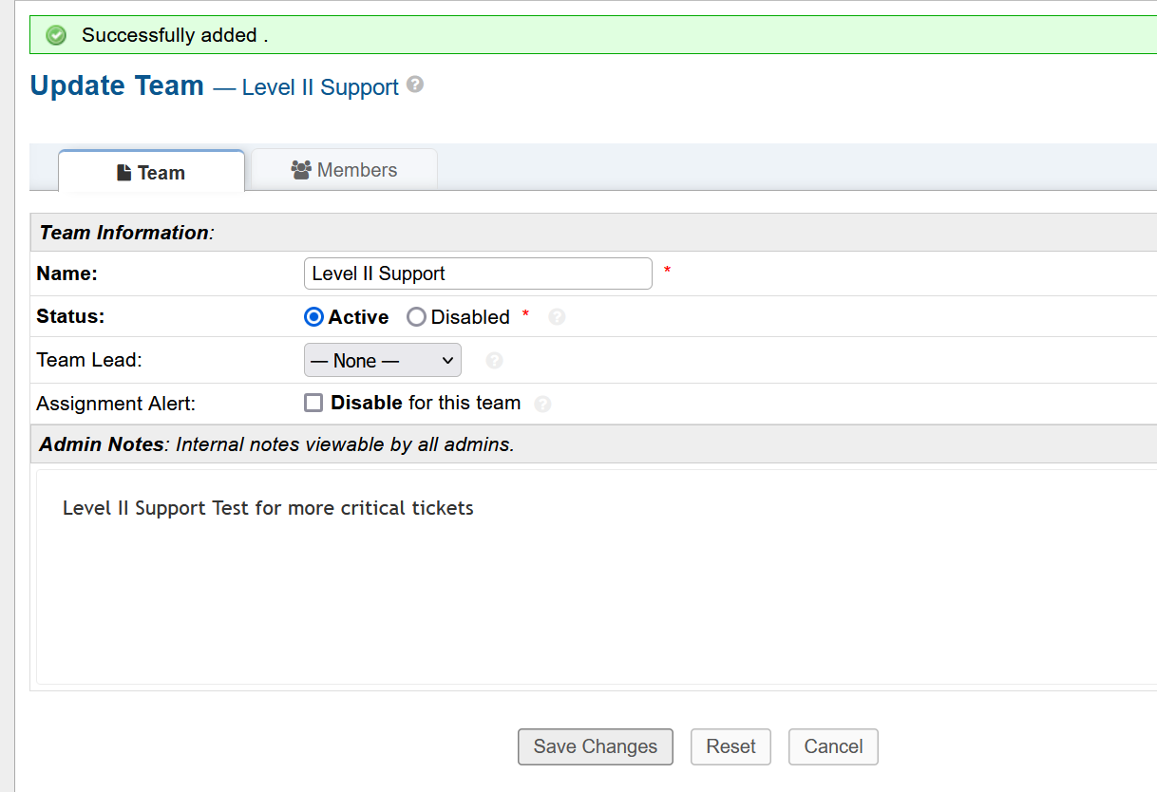

* Assign Departments, SLA Plans, Level Support Teams, and General Settings of Ticket Category Help Topics
* Admin Panel > Help Topics > Configure Ticket Options for Feedback, General Inquiry, Report a Problem, and Report a Problem / Access Issues

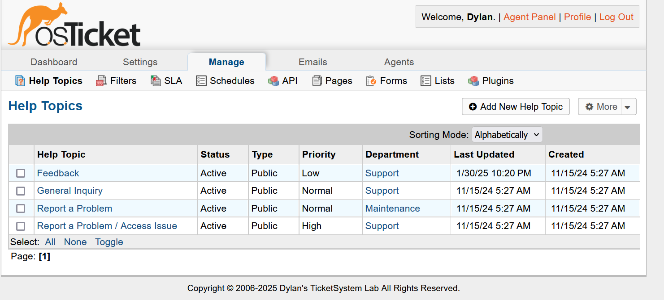

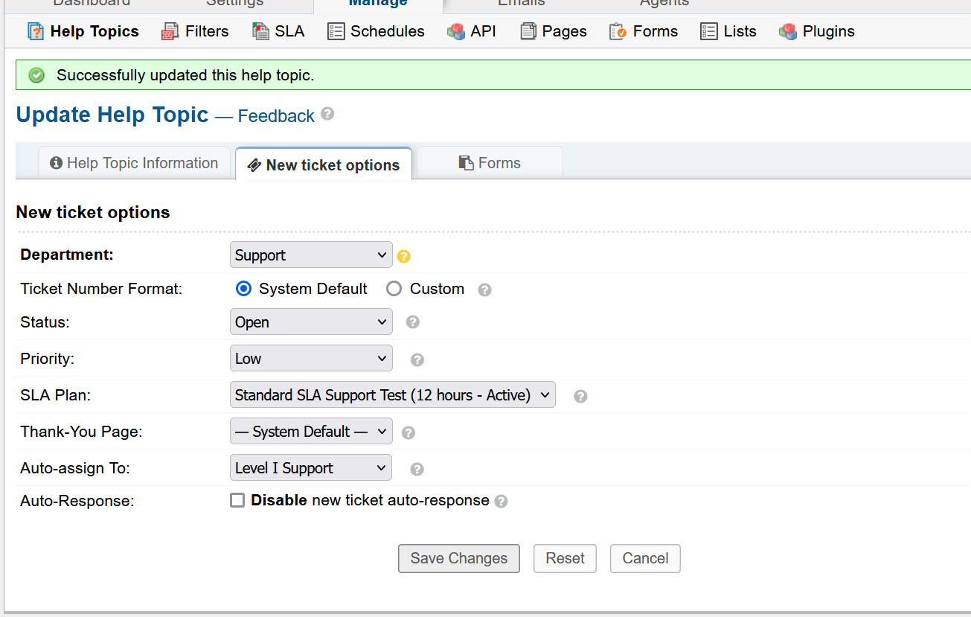

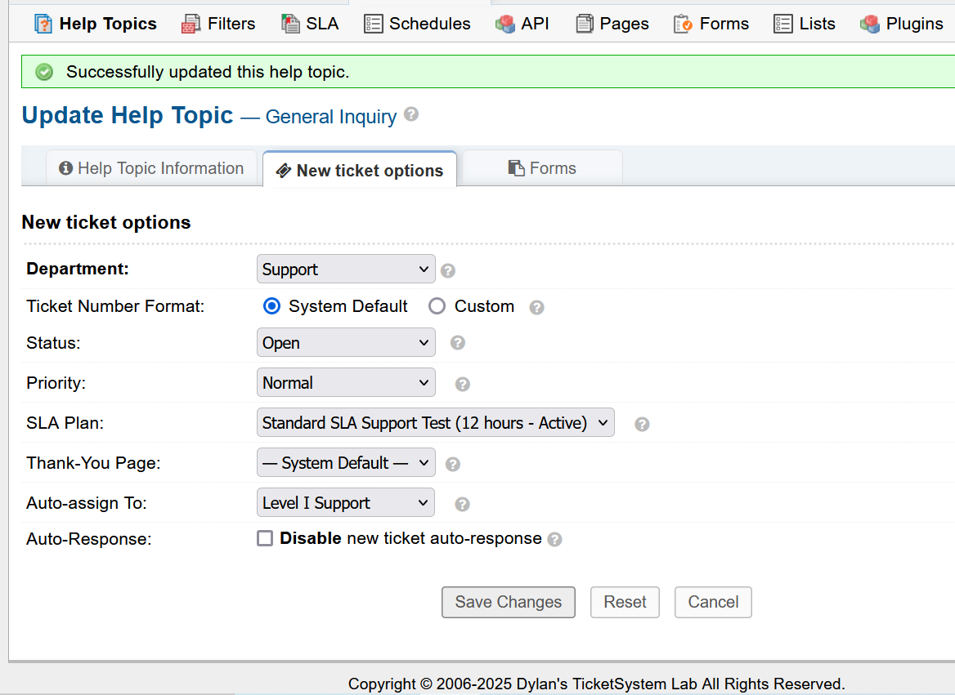

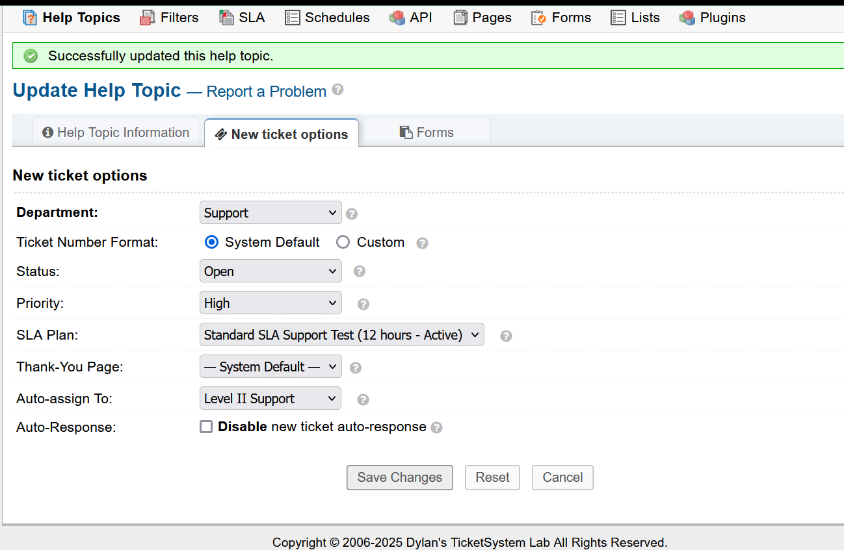

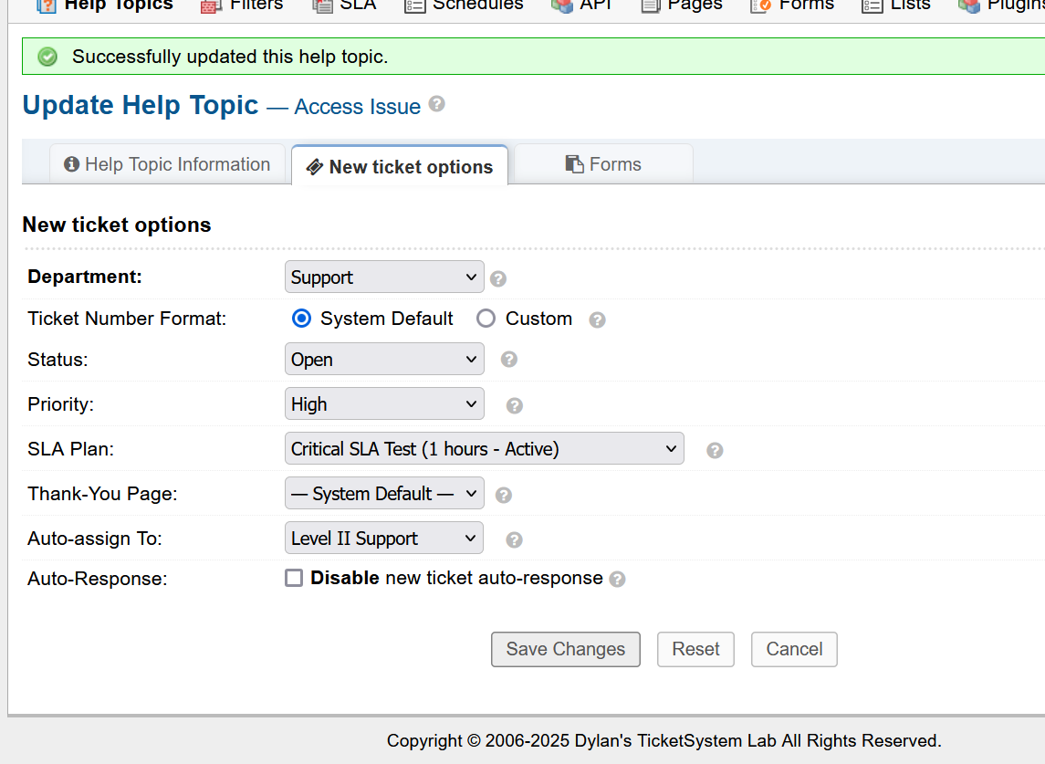

* Now to finalize my project with a password change to the Test User I created.
* Admin Panel > Agents > Test User > Set Password > Send the agent a password reset email > Update

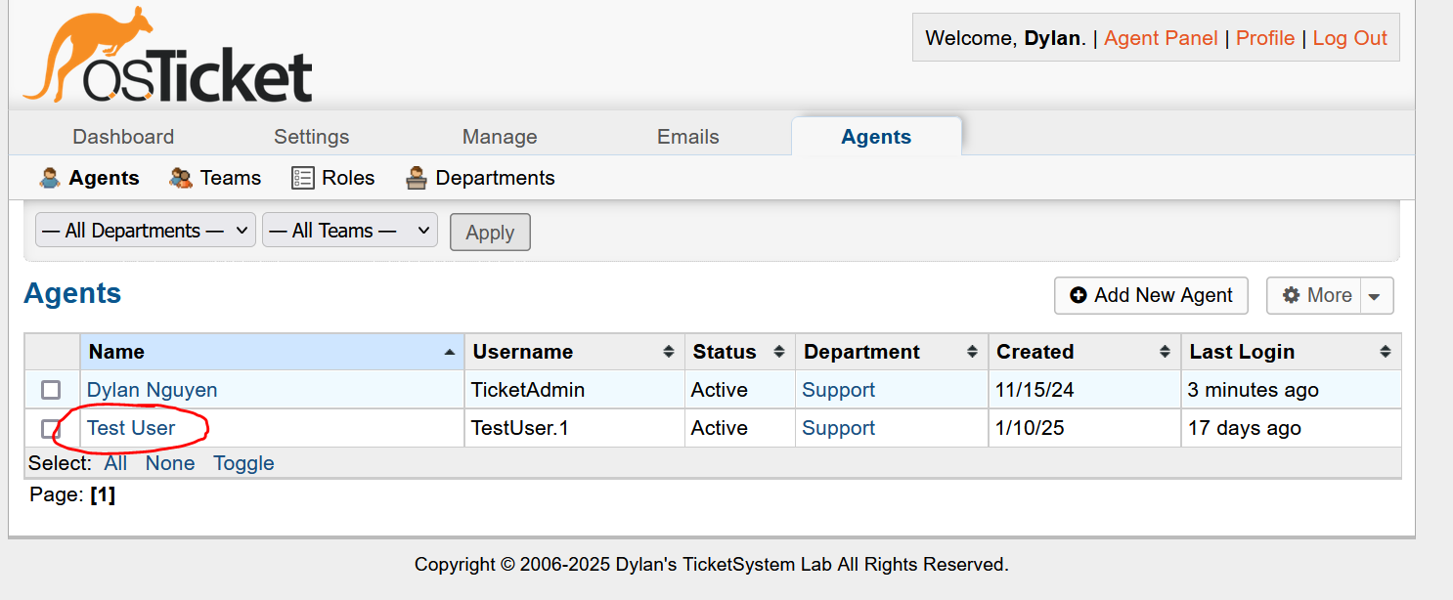

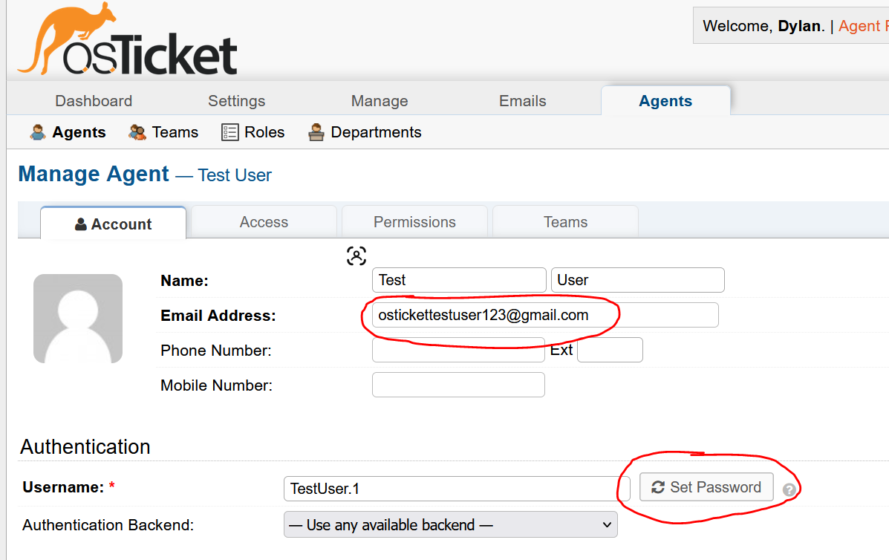

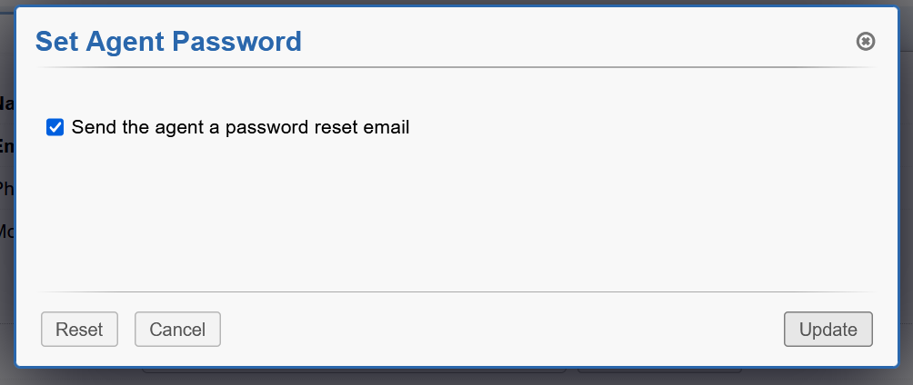

* Unfortunately, I forgot the Gmail password of the first test user and I am not on the device where I made the accout. So, I will create a new Gmail user.
* 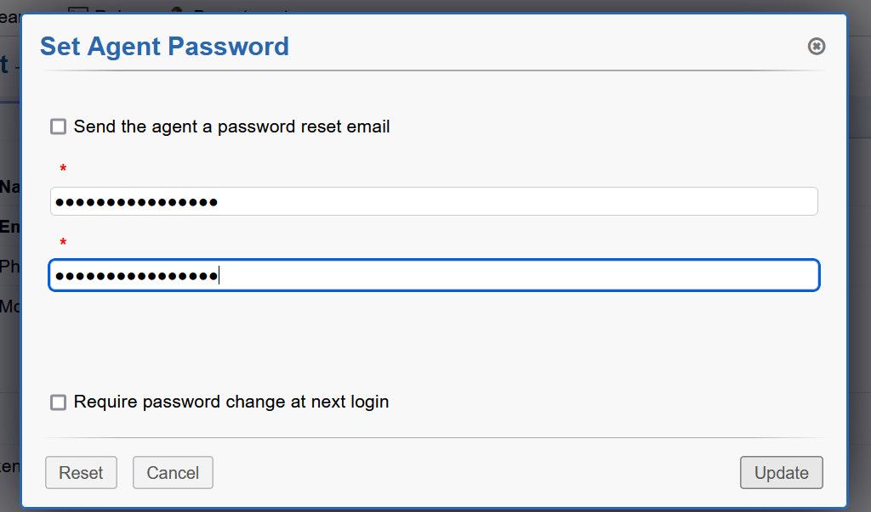Create new password for new created user then test.
* Test login, create password, and do MFA policy (will try Email 2FA for testing purposes)

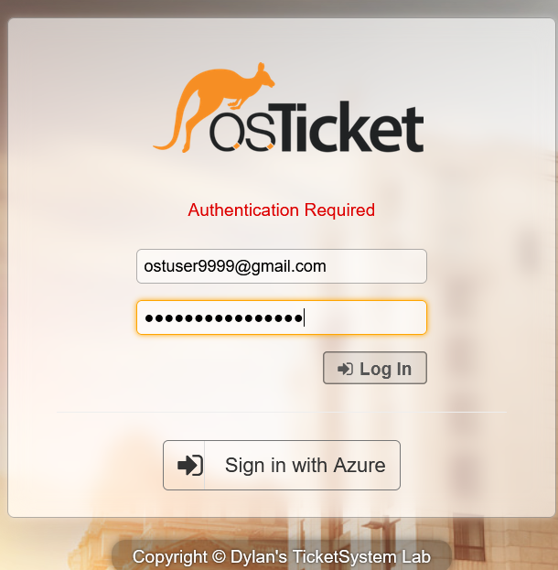

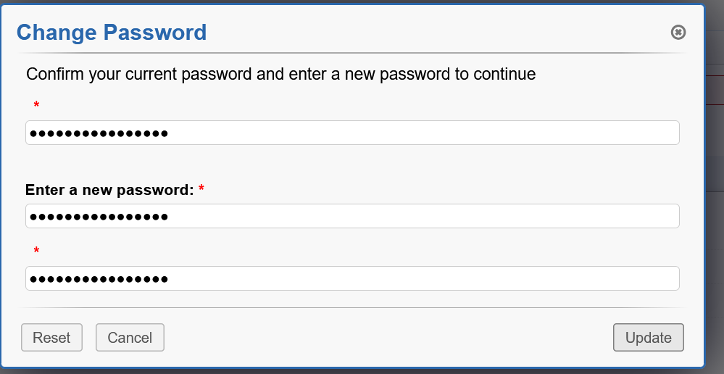

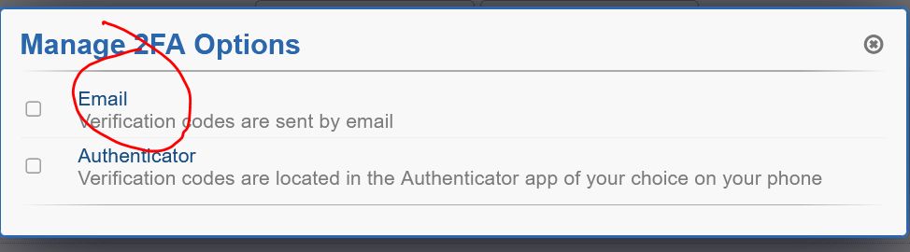

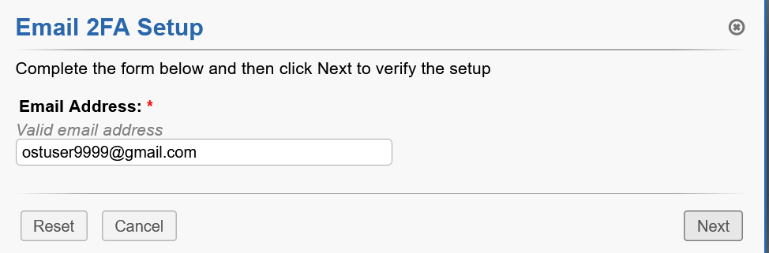

* Did not receive any mail. Started to troubleshoot and believe the problem is an outdated token in Oauth2 IMAP configuration. Will delete and renew.

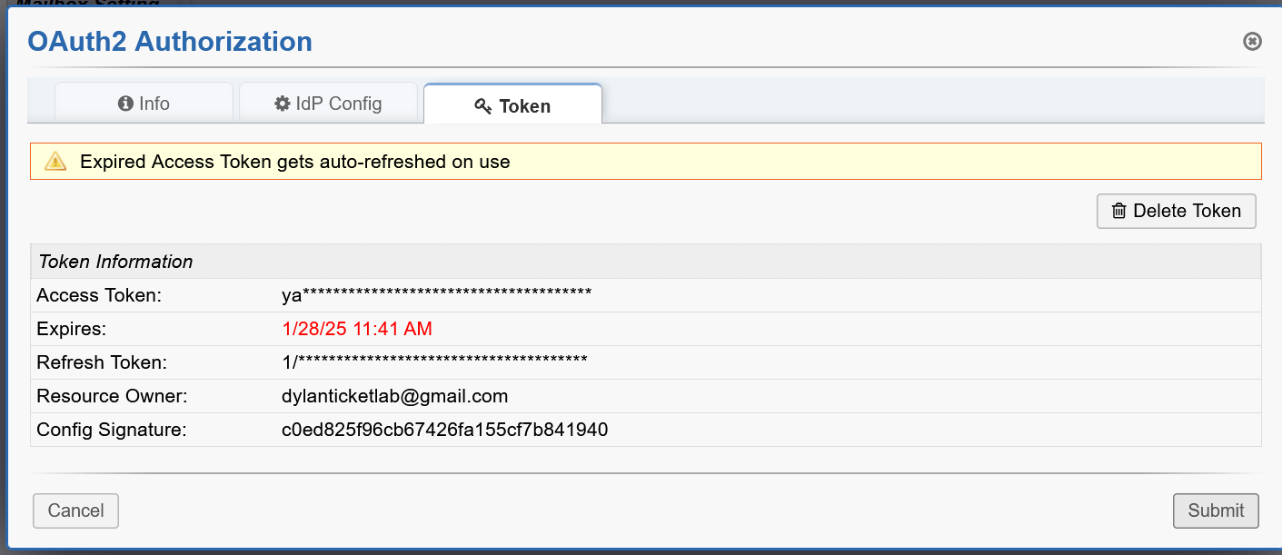

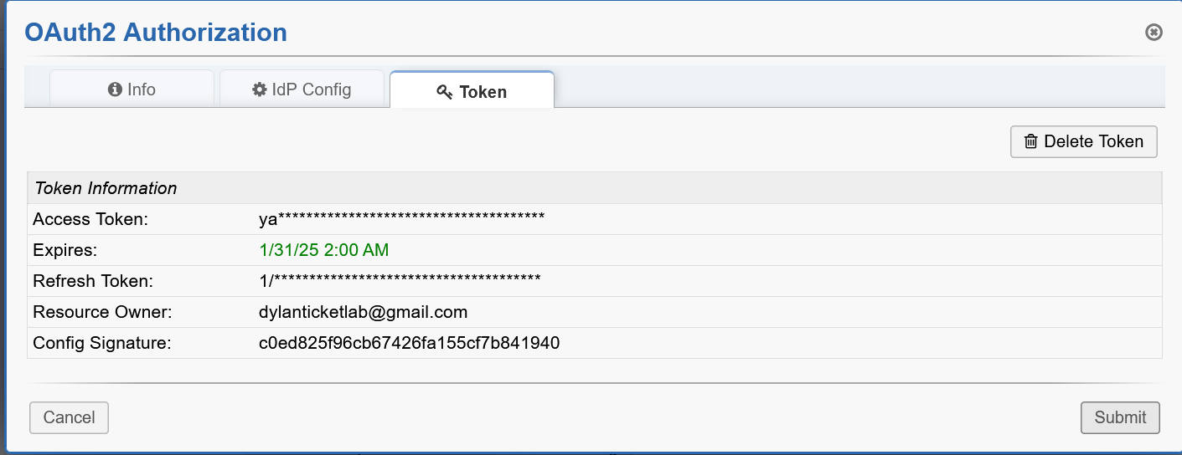

* Test MFA policy with email

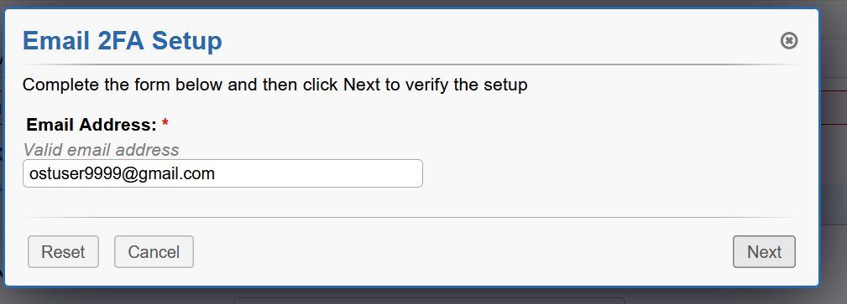

* SUCCESS!!!

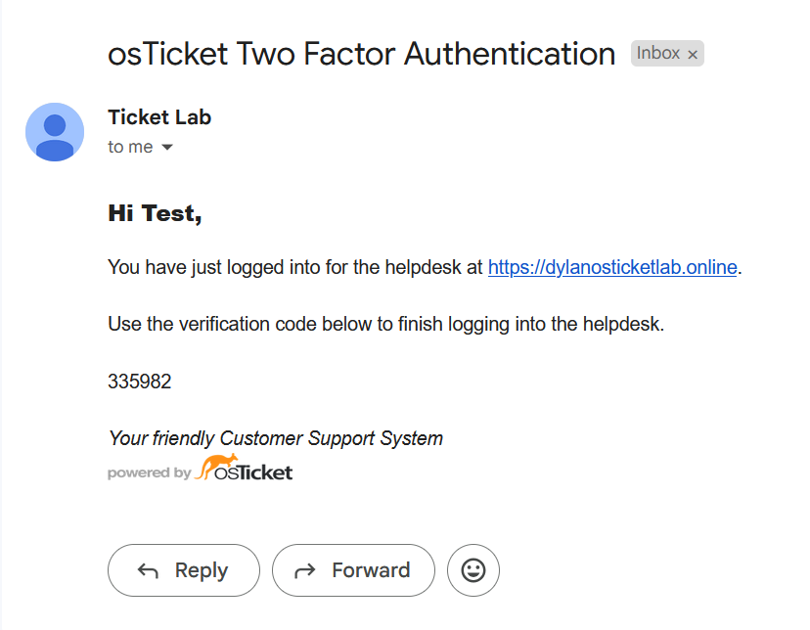

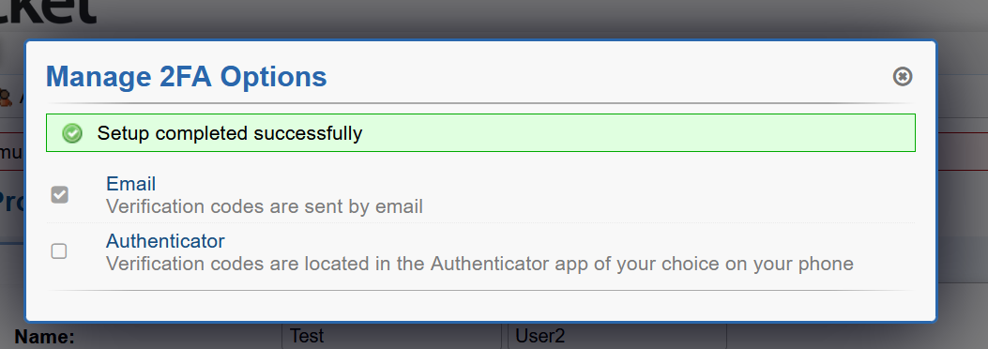

* Test password reset.

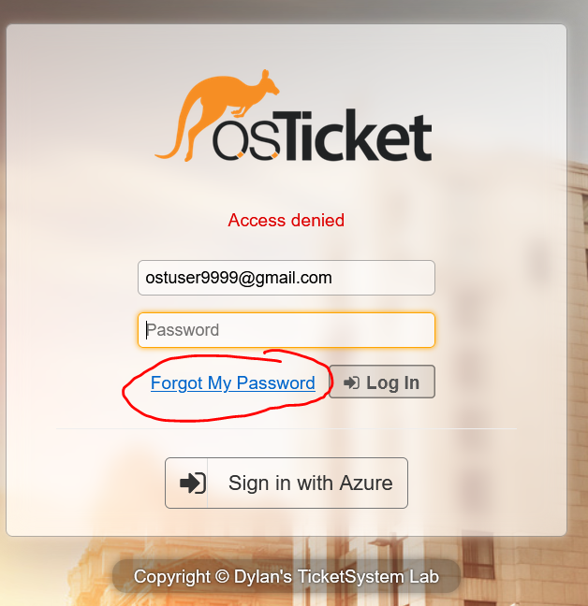

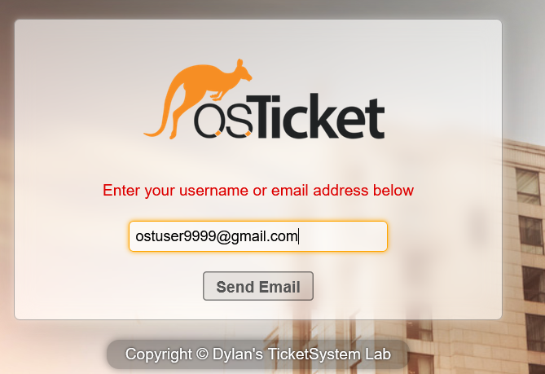

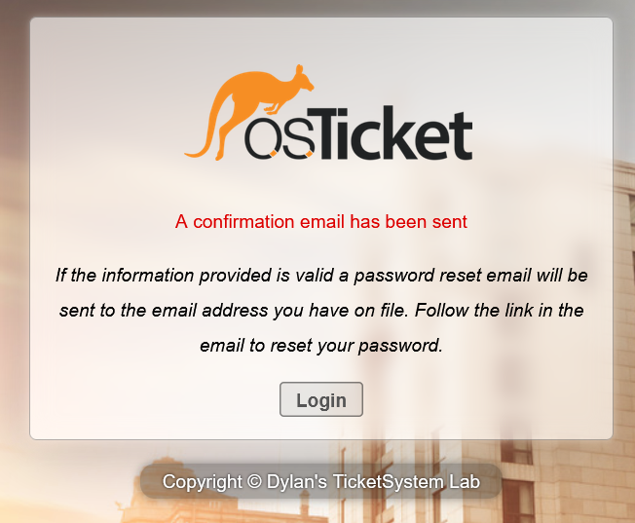

* Received password reset email

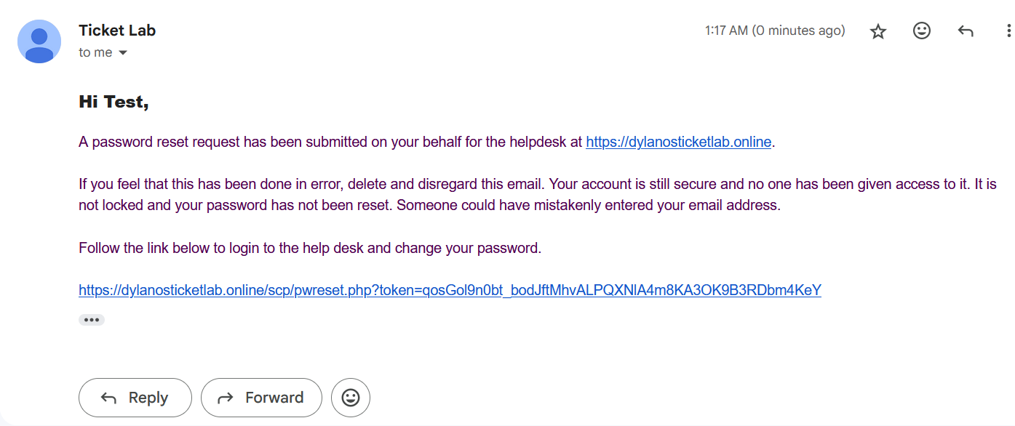

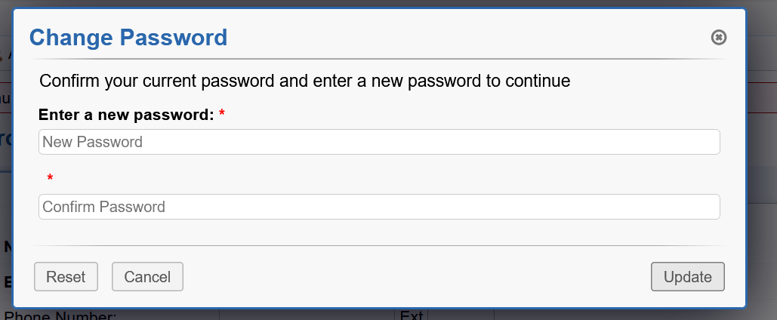

* Lastly, simulate a practical ticket workflow scenario via password reset request.
* Navigate to <https://dylanosticketlab.online> > Open a New Ticket > Fill Contact Information, Help Topic, and Ticket Details >

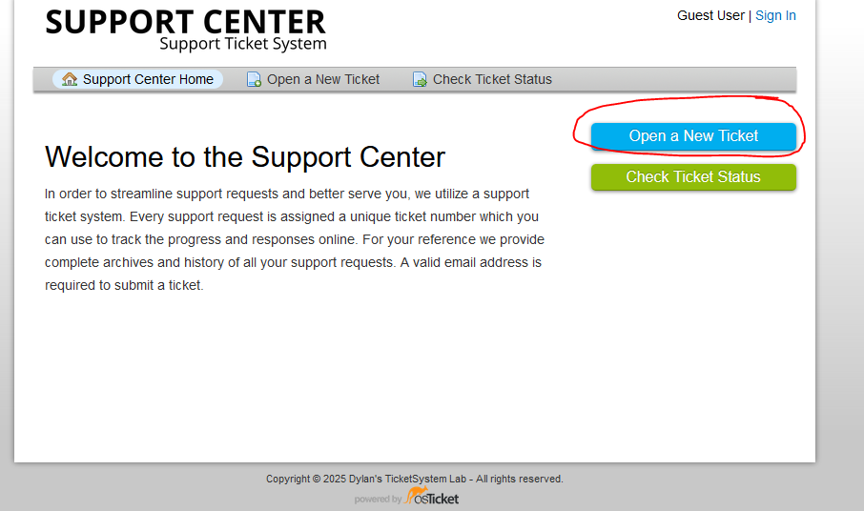

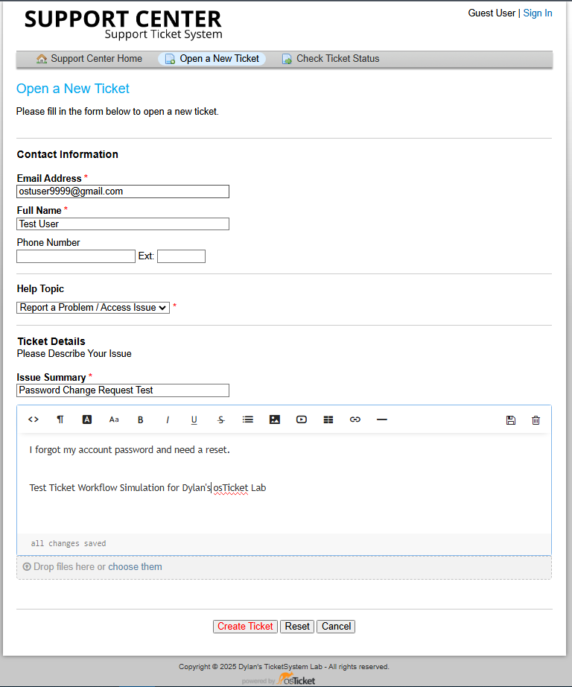

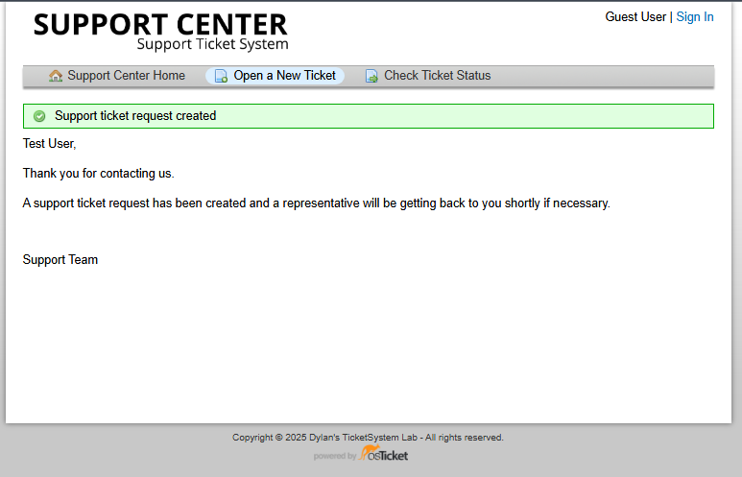

* Verify Ticket was received via osTicket Agent Panel and dedicated email

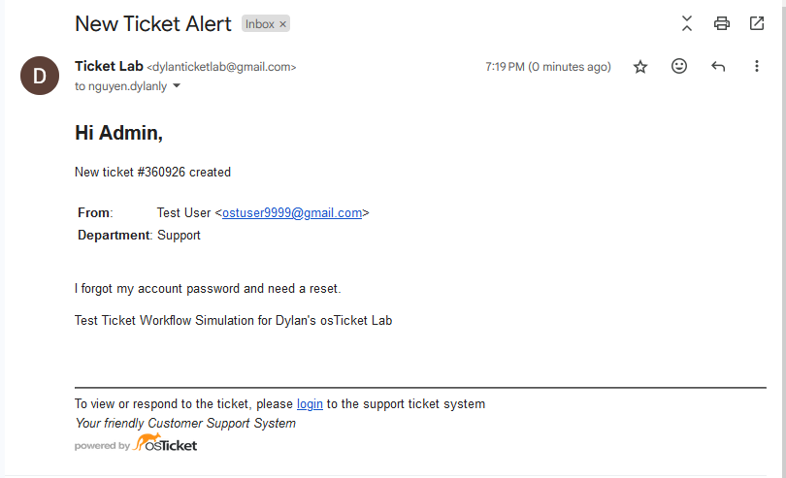

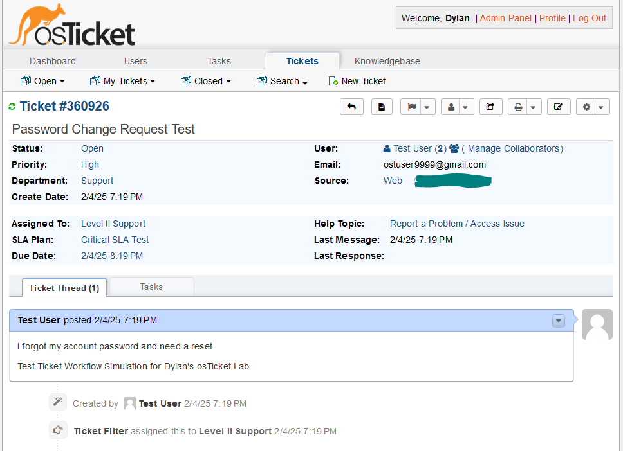

* Claim Ticket in Agent Panel, respond to Ticket’s request, send password change reset link, and wait for user to respond back to resolved ticket.

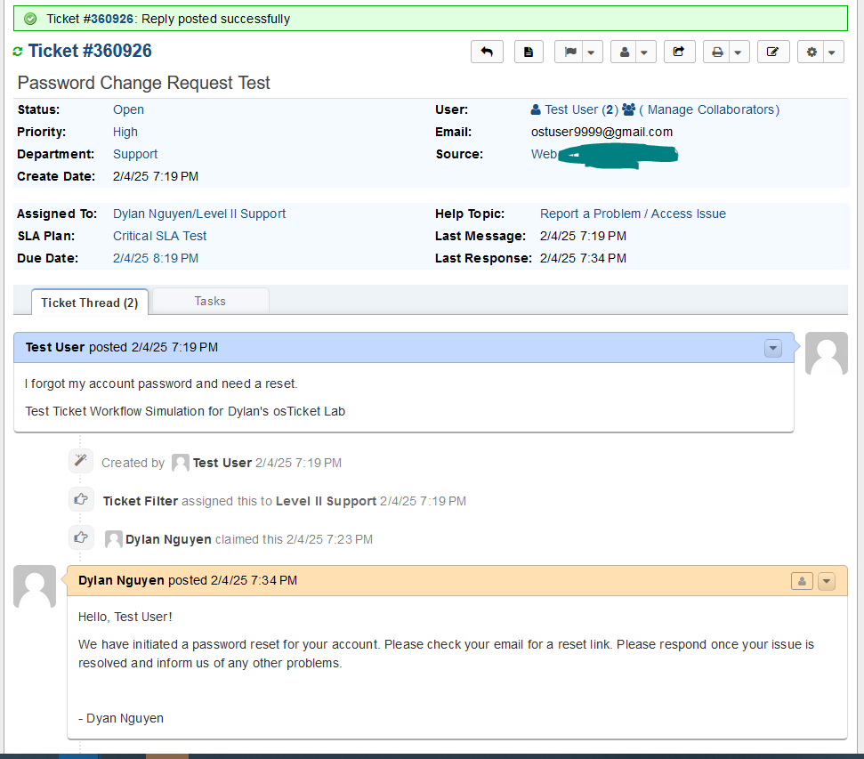

* Admin Panel > Agents > Test User2 > Set Password > Send Agent password reset email > Update

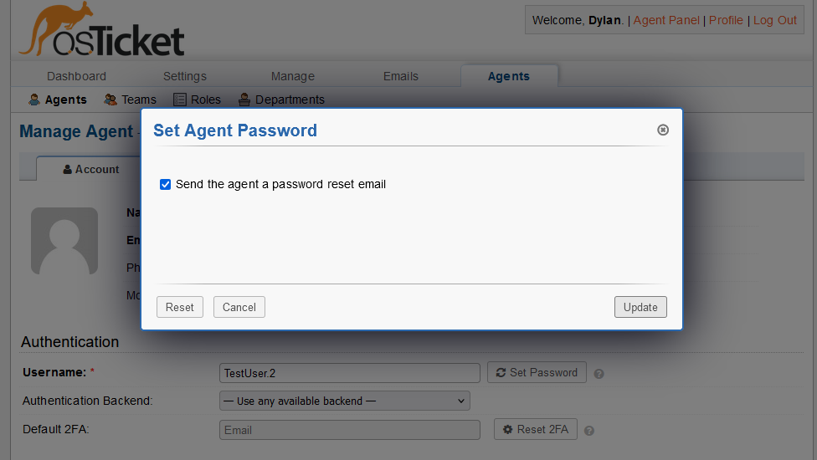

* Verify User received password change reset and applied it

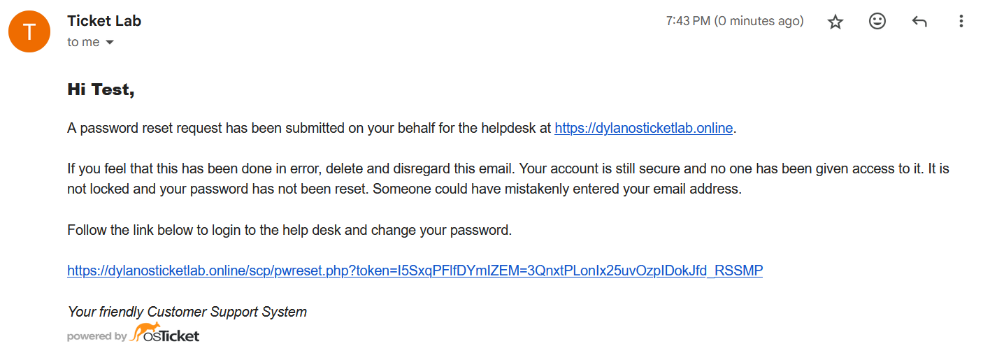

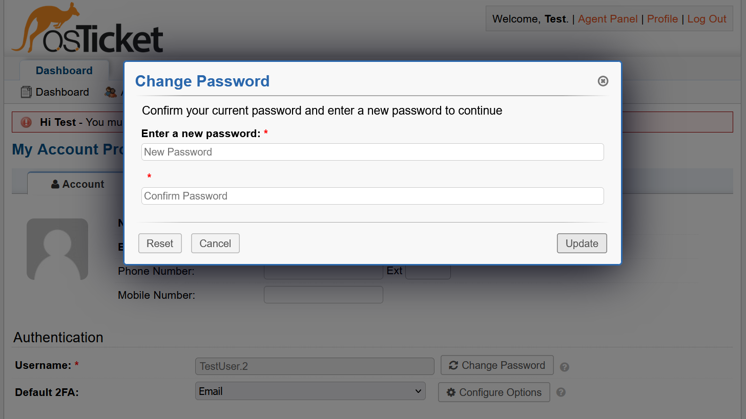

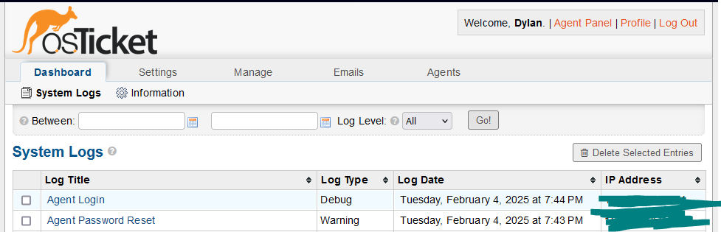

* Resolve Ticket test

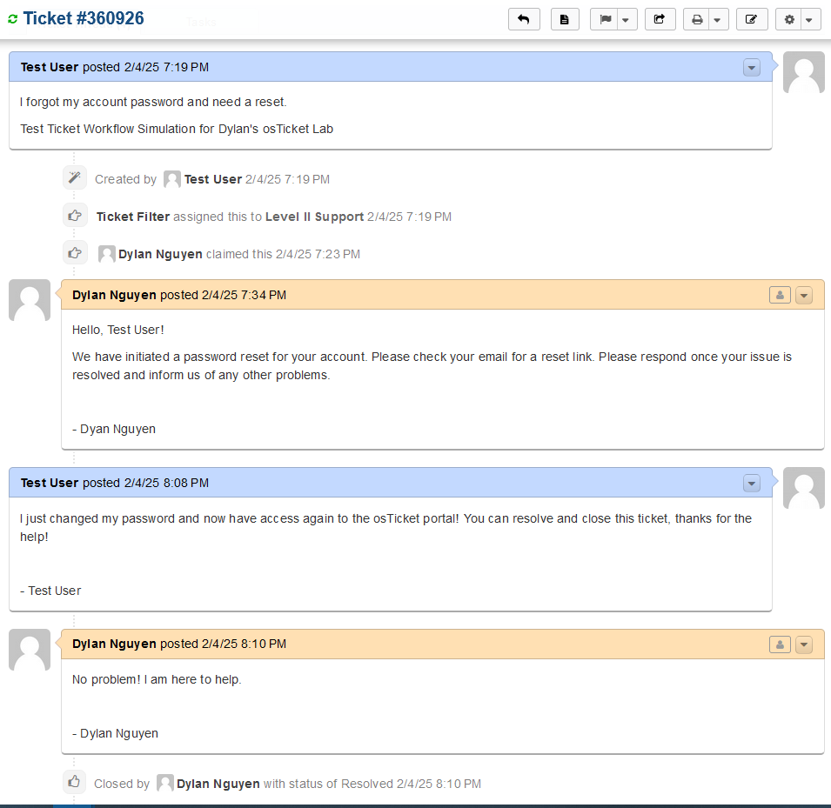

* My lab is done. Thank you